SPECIAL CITY COUNCIL MINUTES

The City Council of the City of Raleigh met jointly with the Wake County Commissioners on Thursday, May 20, 2004, at 4:00 p.m. in Room A of the Raleigh Convention Center, Raleigh, North Carolina, with the following present.

City Council County Commissioners

Mayor Meeker, Presiding Commissioner Chairman Gardner
Mr. West Mr. Bryan
Ms. Cowell Mr. Council
Mr. Crowder Mr. Gurley
Mr. Hunt Mr. Jeffreys
Mr. Regan Mr. Ward
Ms. Taliaferro Mr. Webb

Also Present

County Manager Cooke
City Manager Allen
County Attorney Ferrell
City Attorney McCormick
Various City and County Staff Members

CONVENTION CENTER – CONCEPT B - APPROVED

The meeting was called to order and County Manager Cooke gave a brief outline of the agenda. City Manager Allen expressed appreciation to all of the County team who has worked so closely with the City as well as the design team. He pointed out one of the critical elements was the hotel development and a contract has been approved. He pointed out the County staff has run a projection entitled “Original Model Updated for Forward Swap (January 2005 start date) and revised interest projection dated April 20, 2004. He presented Council members with a copy of that projection.

Dudley Lacy, Steve Schuster, John Muter, David Wiest and Andy McLean made the following PowerPoint presentation:

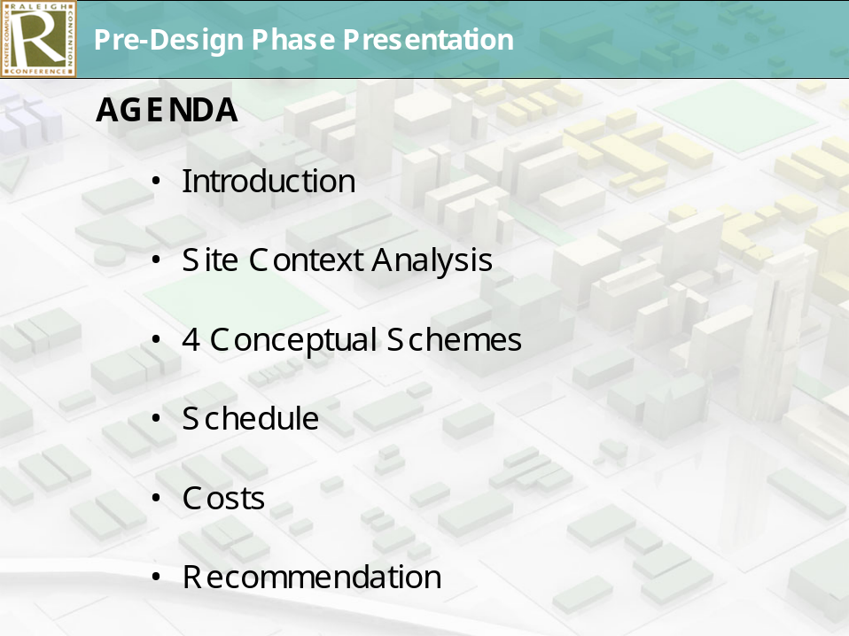

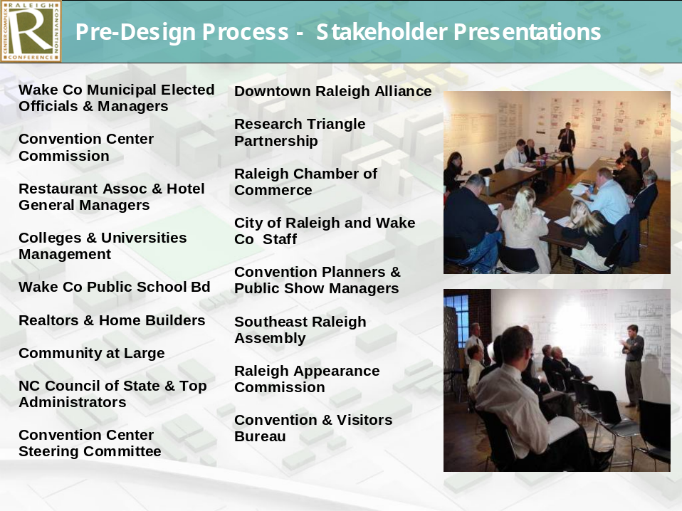

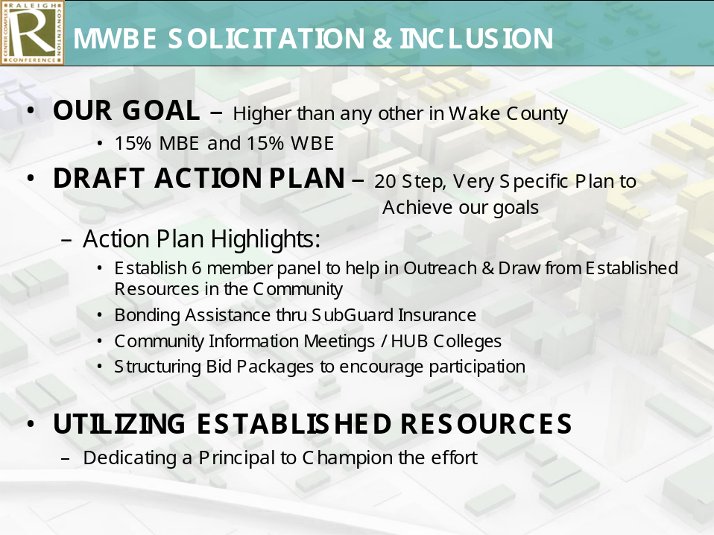

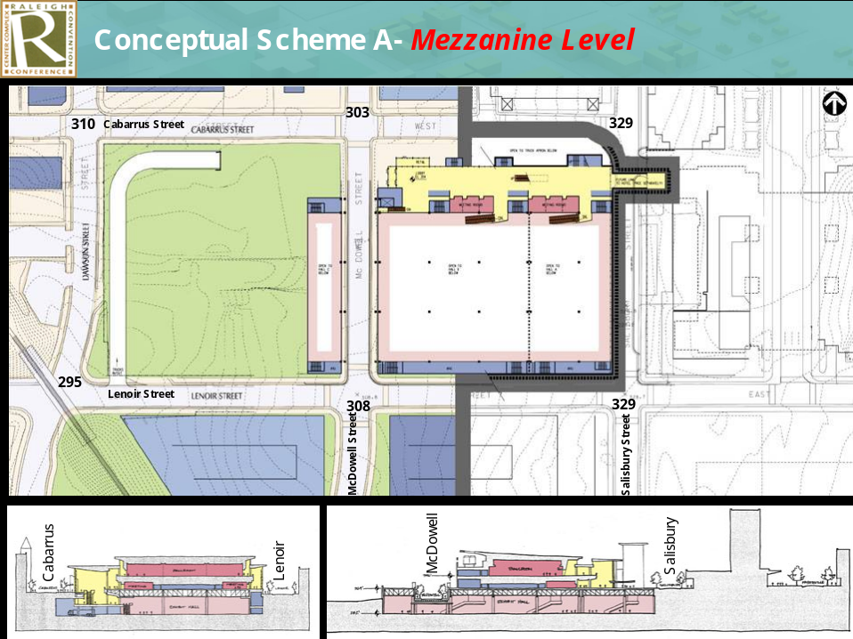

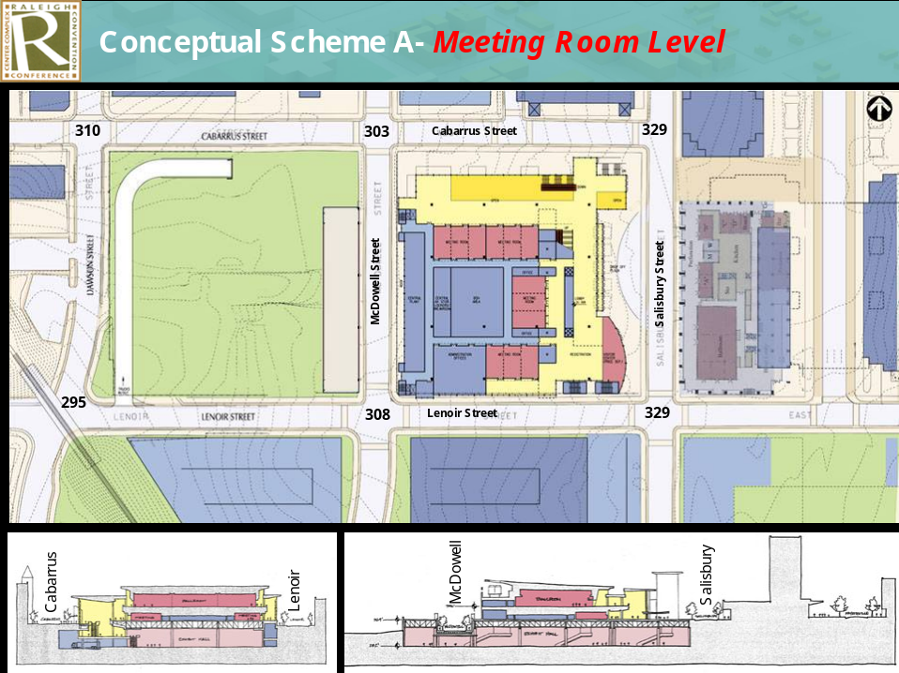

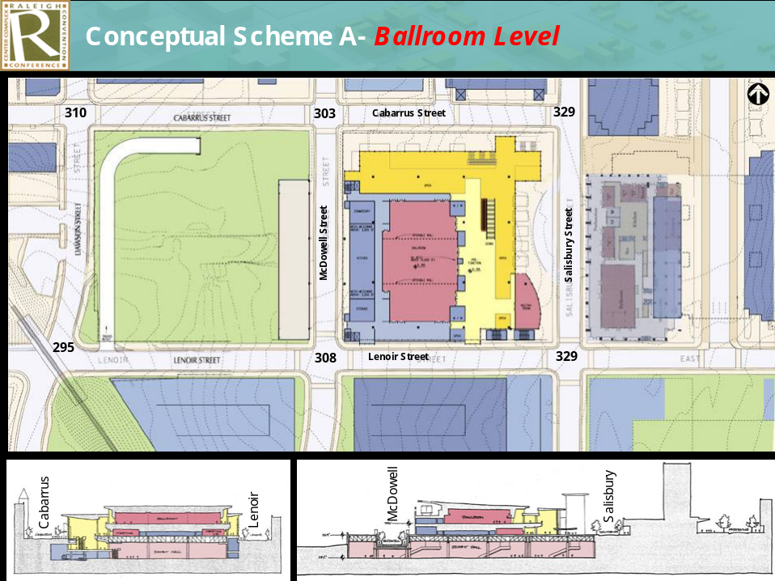

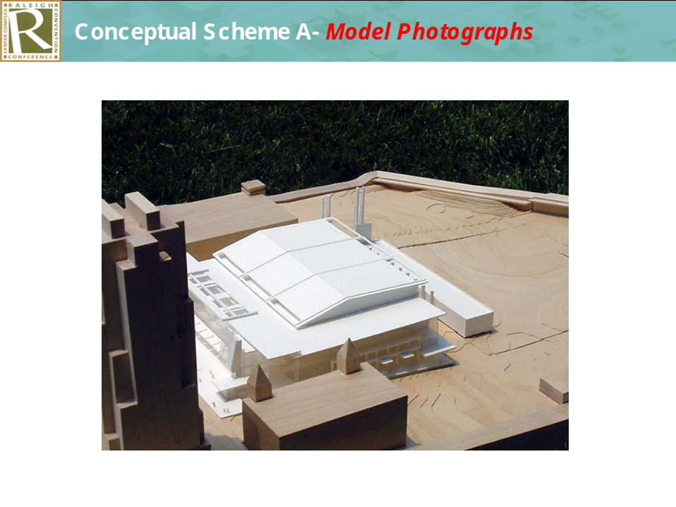

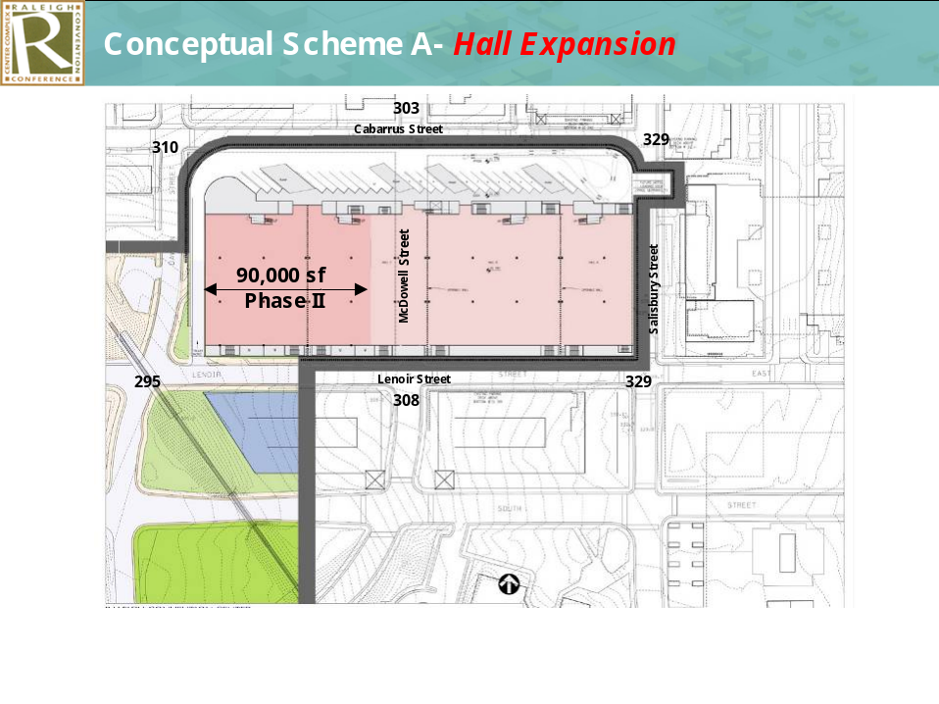

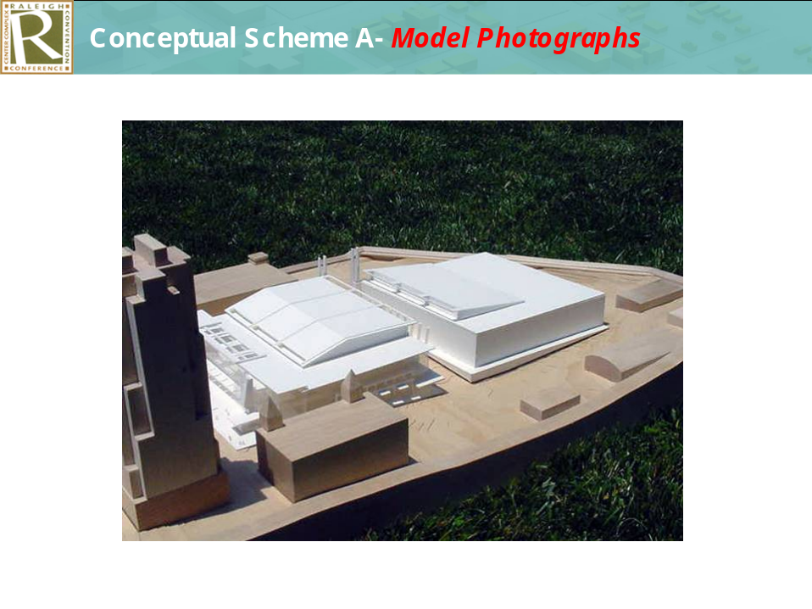

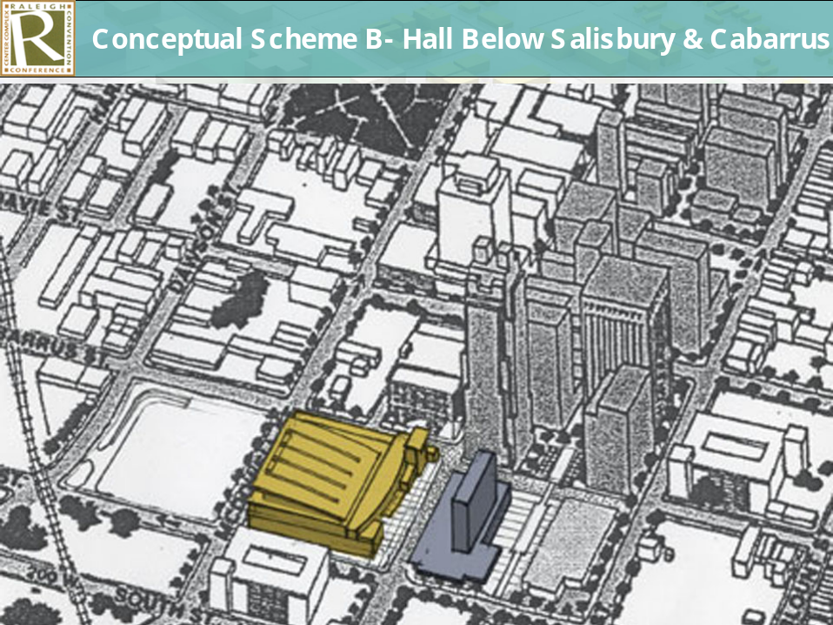

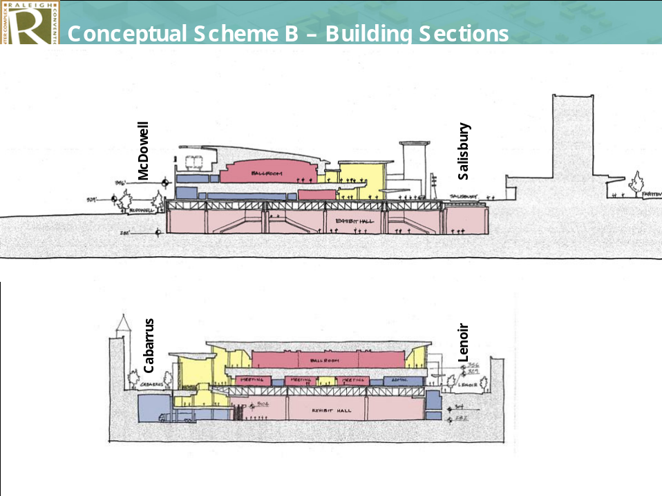

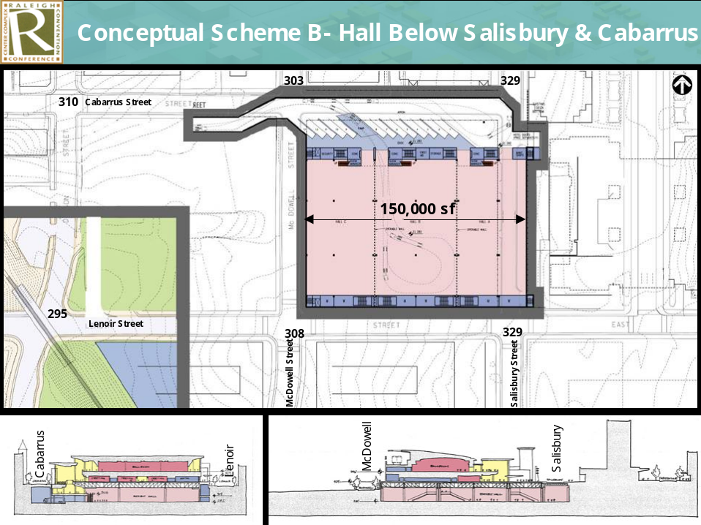

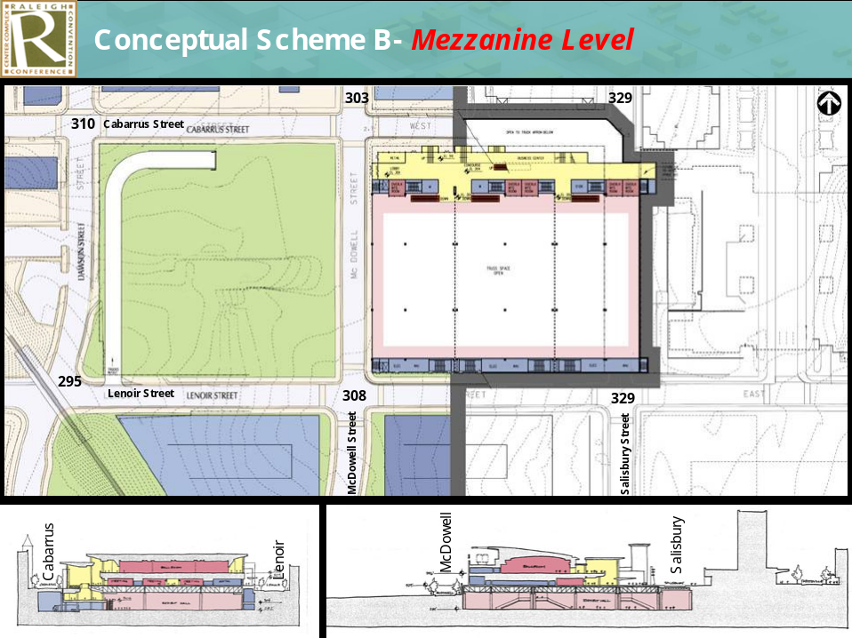

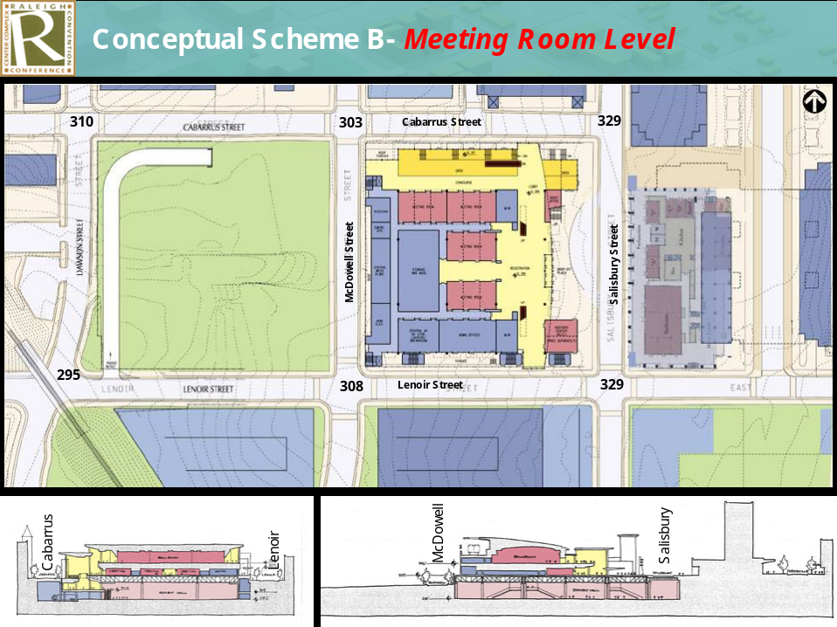

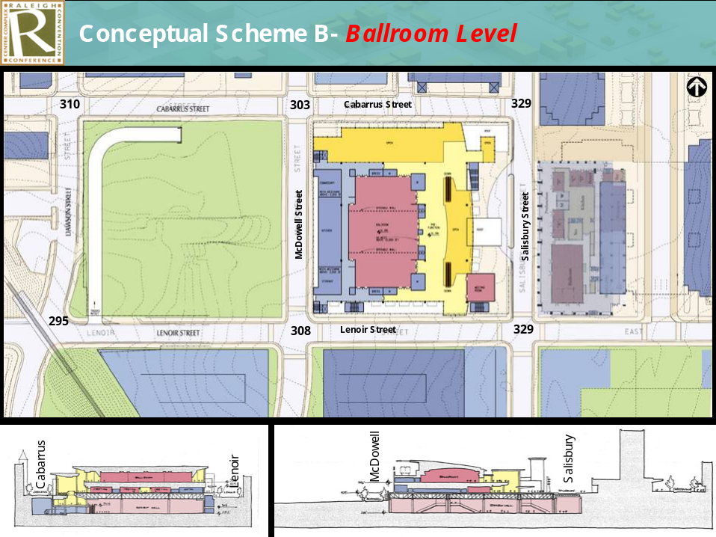

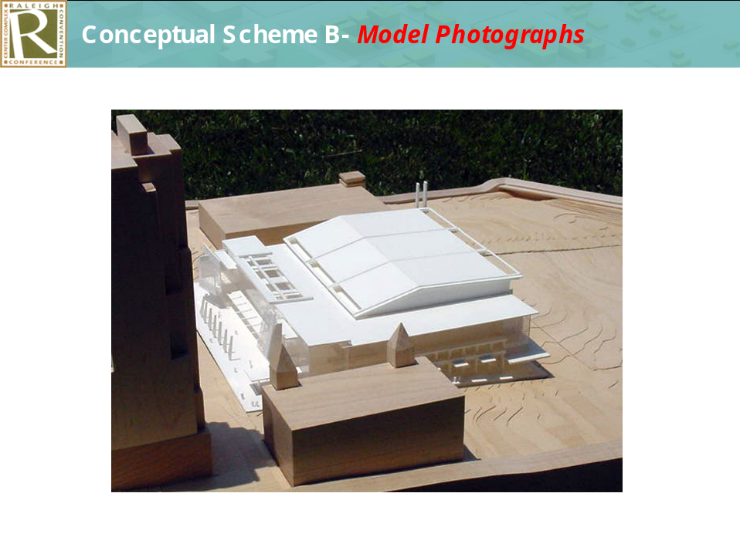

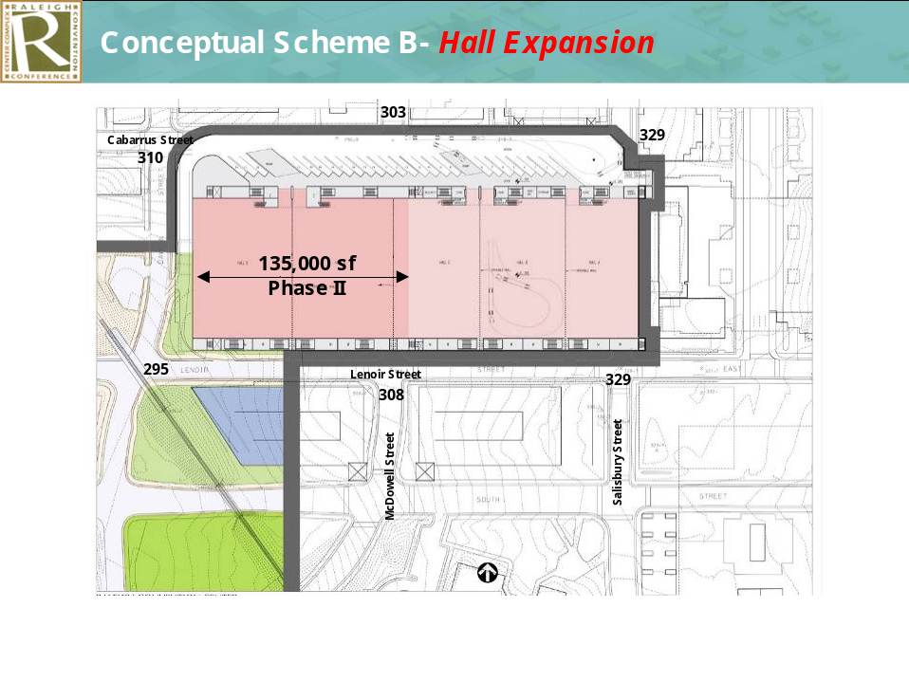

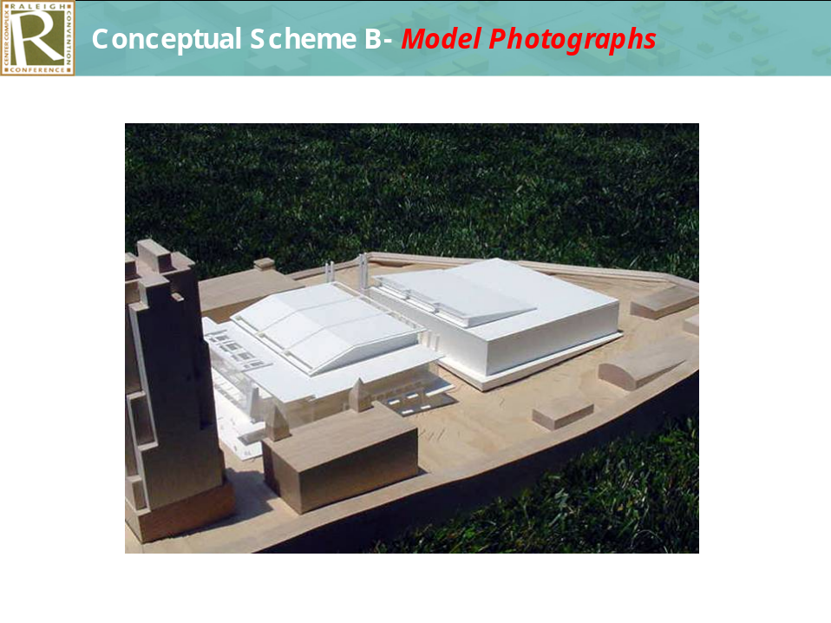

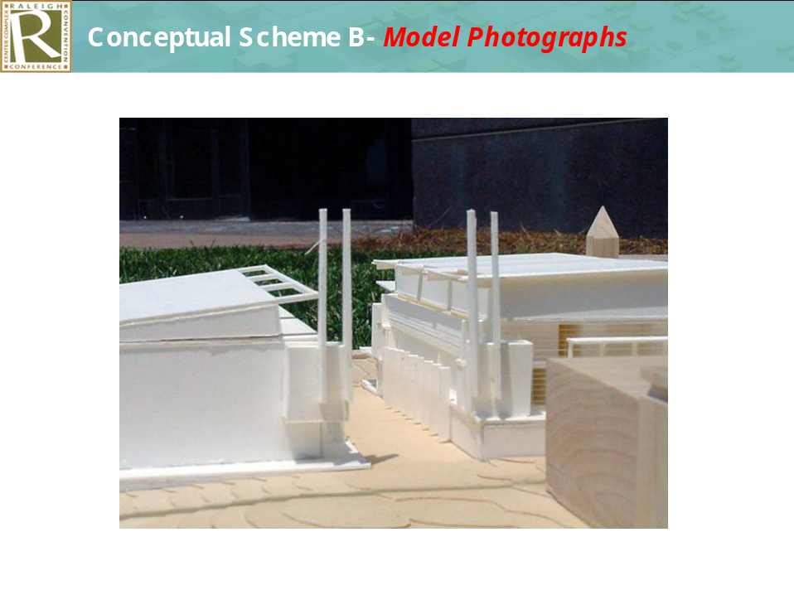

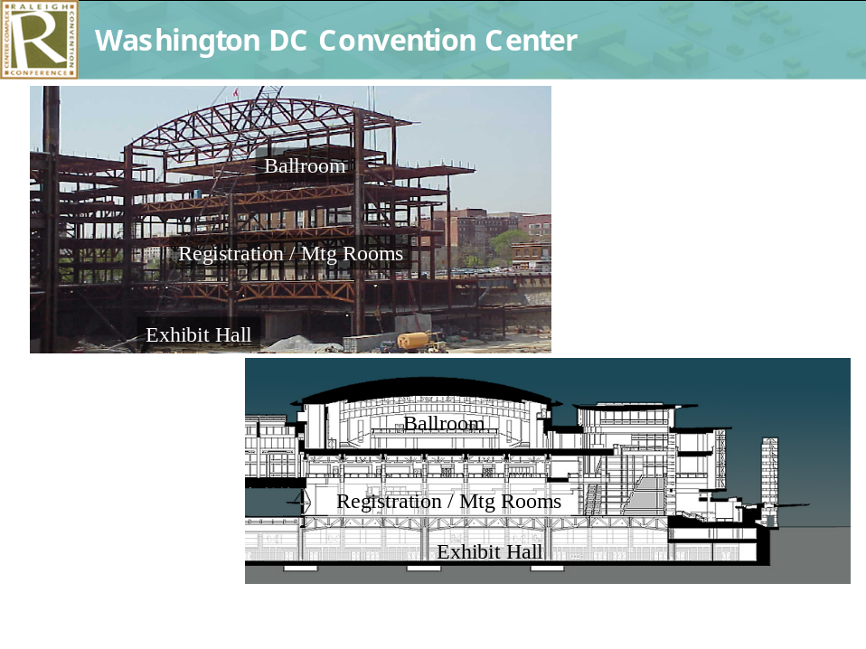

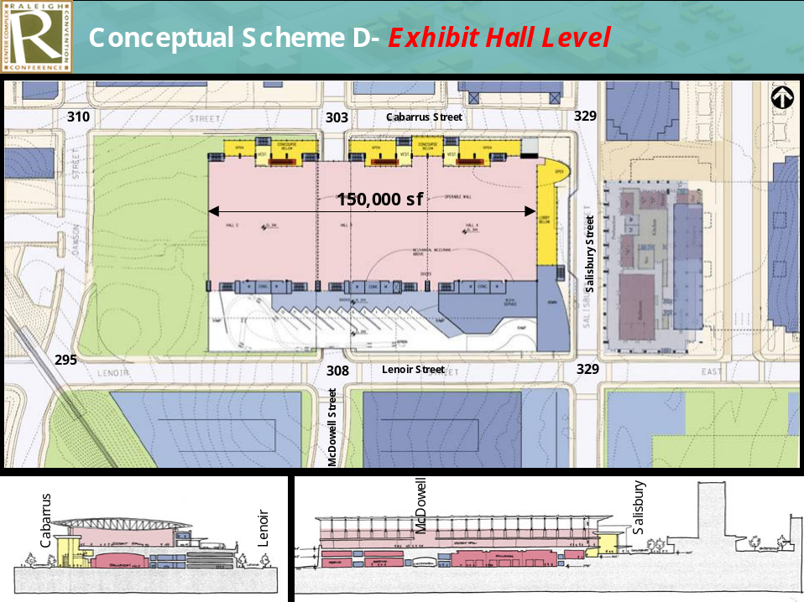

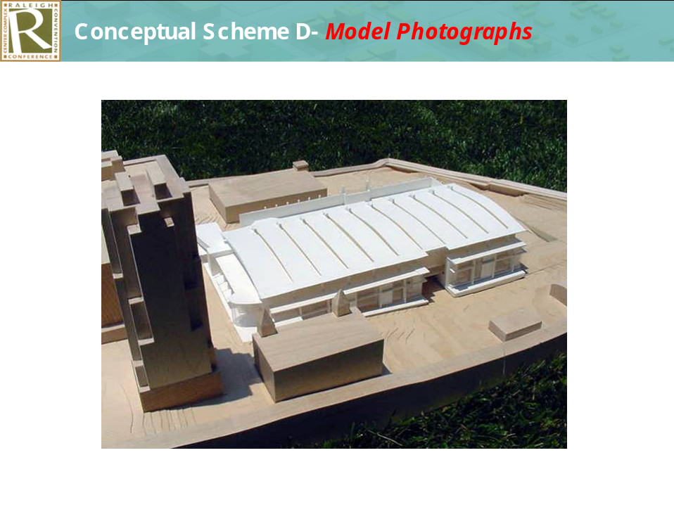

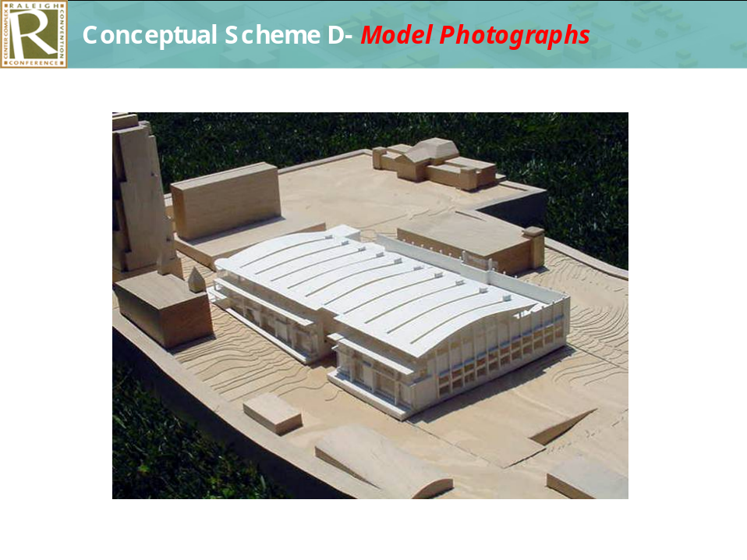

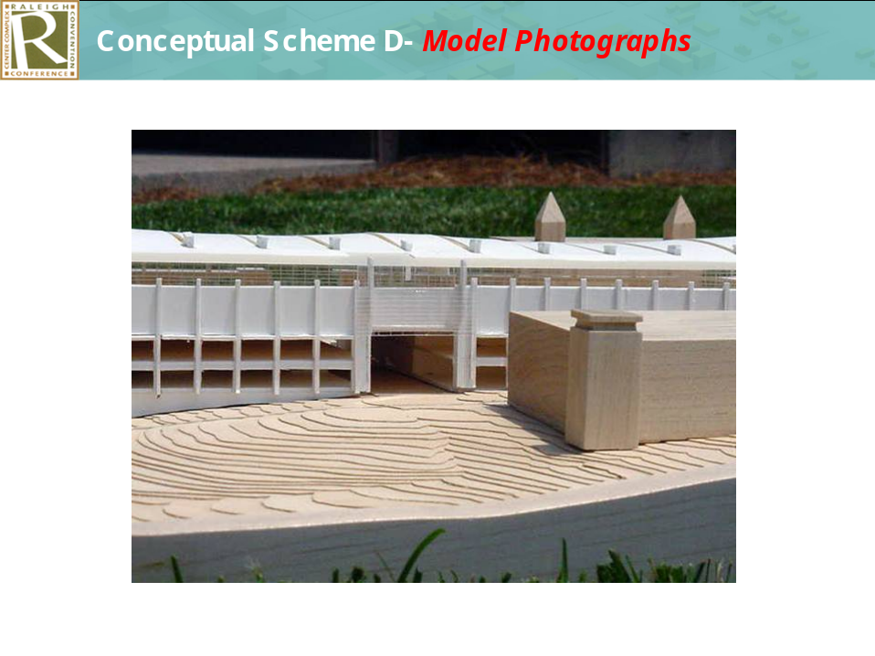

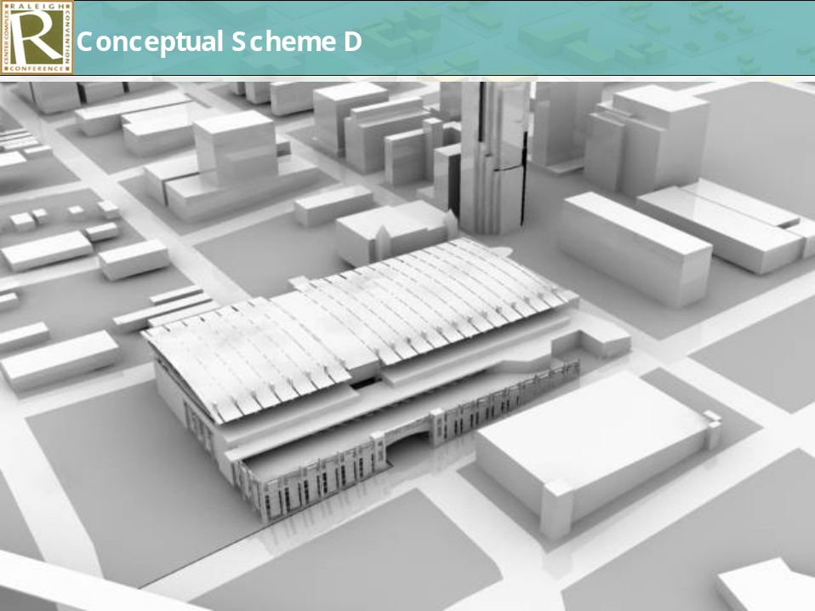

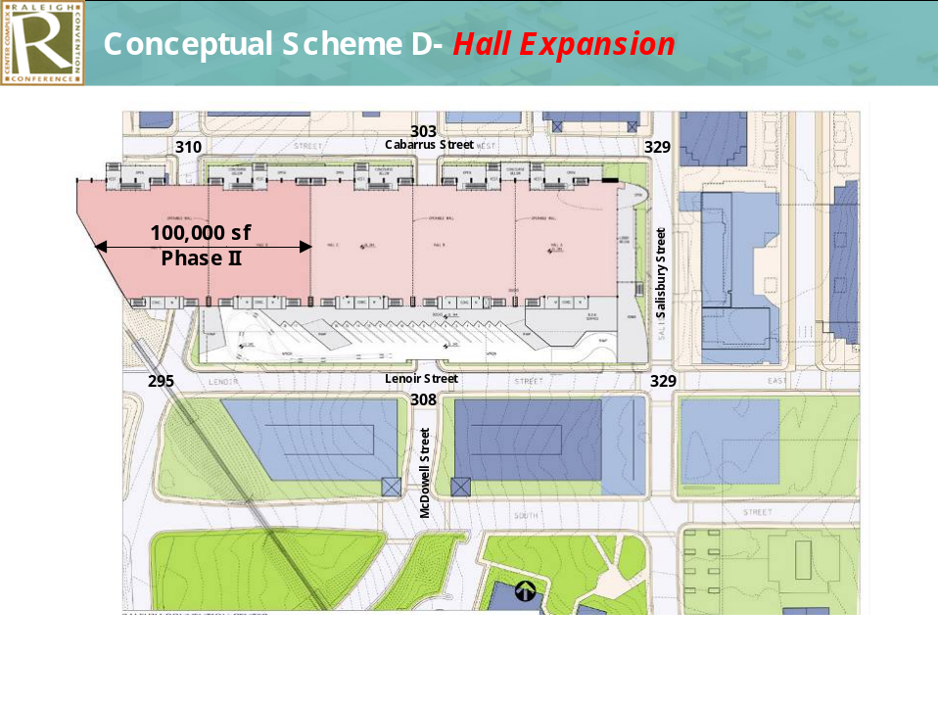

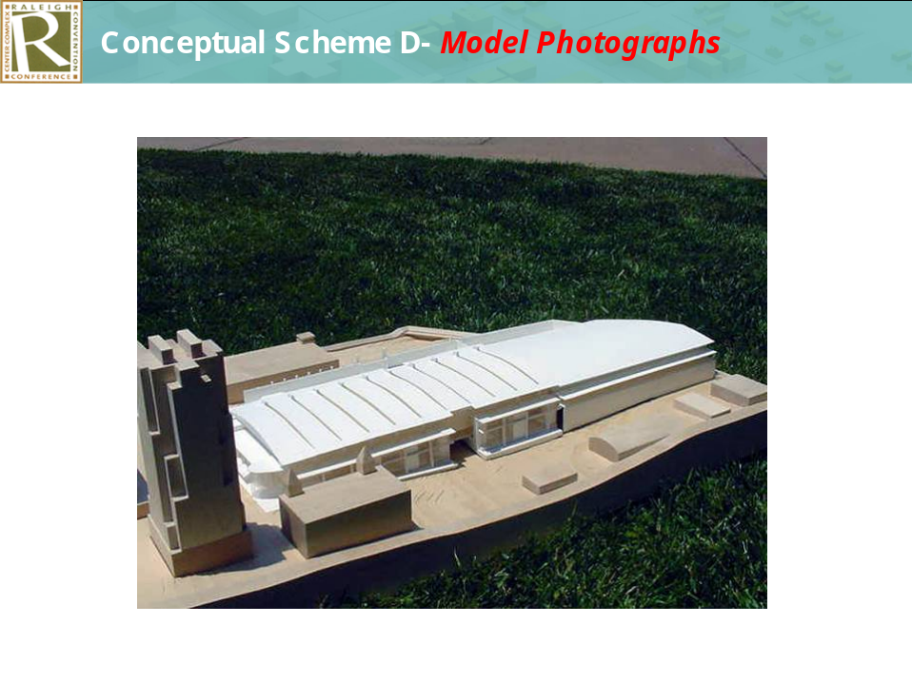

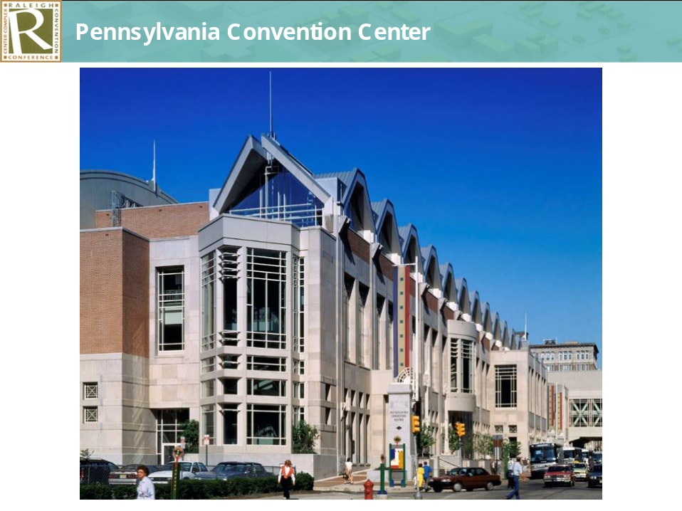

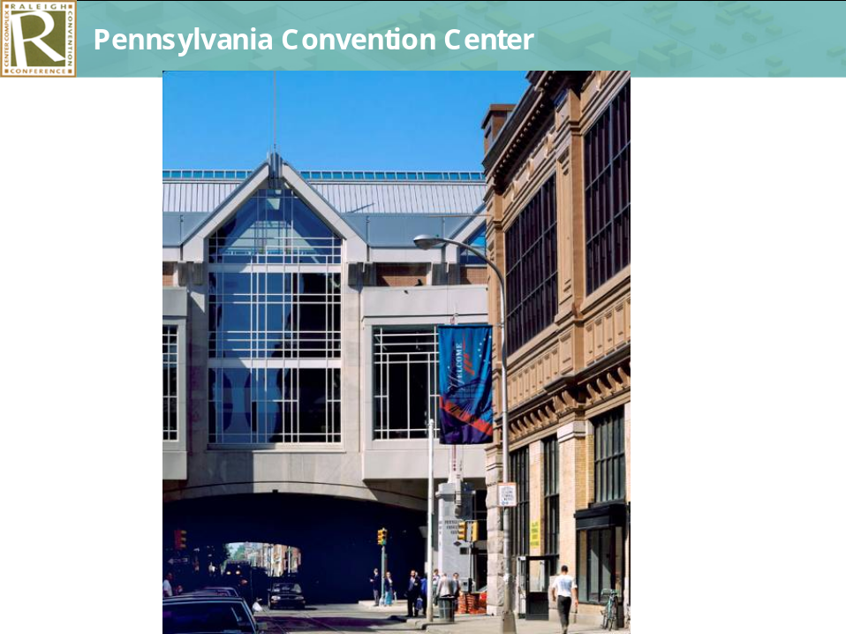

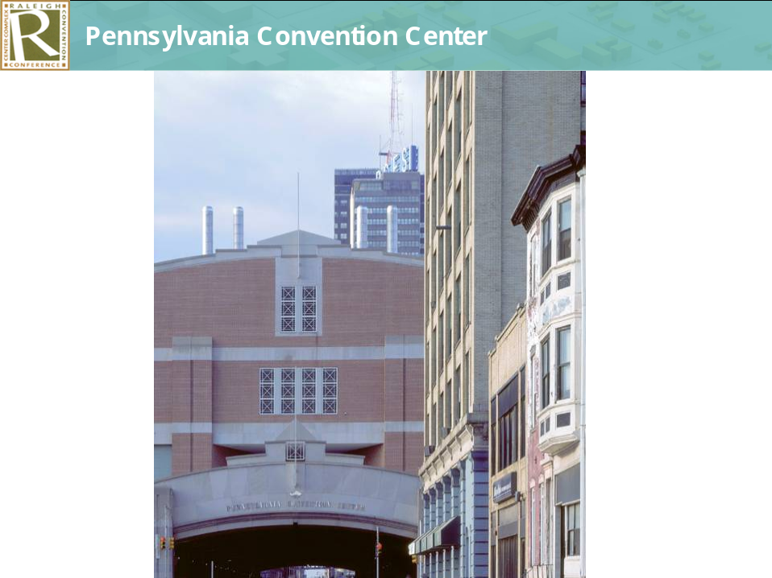

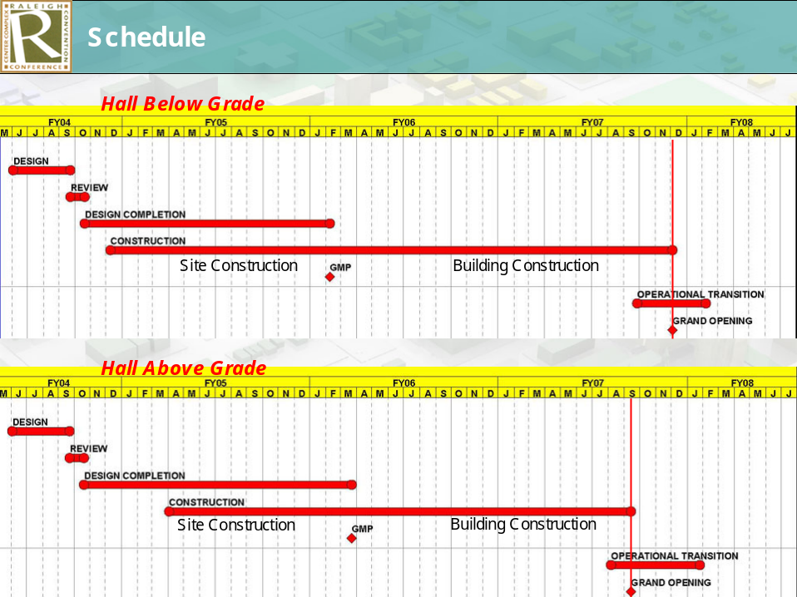

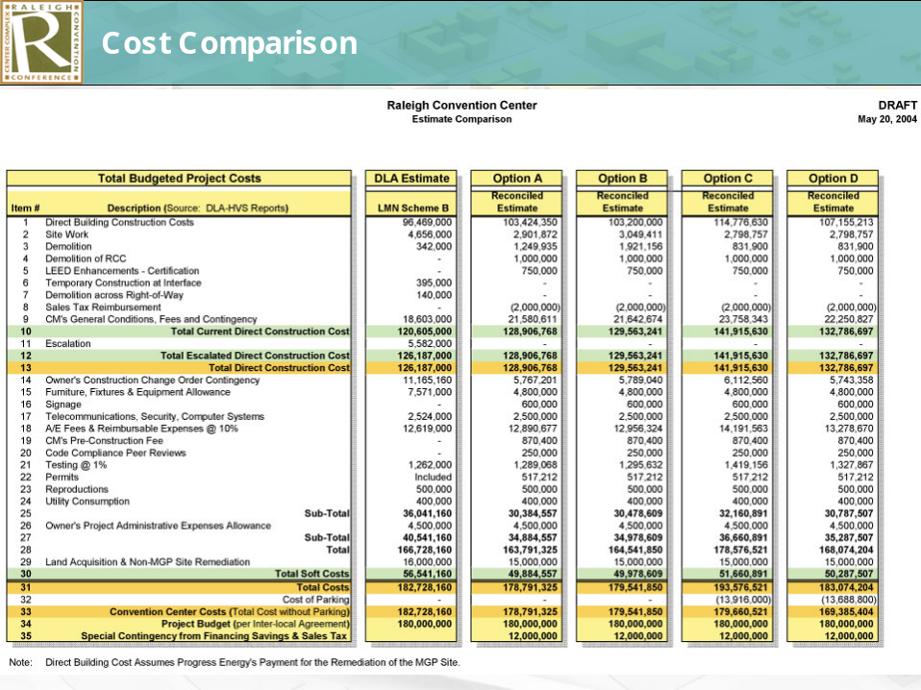

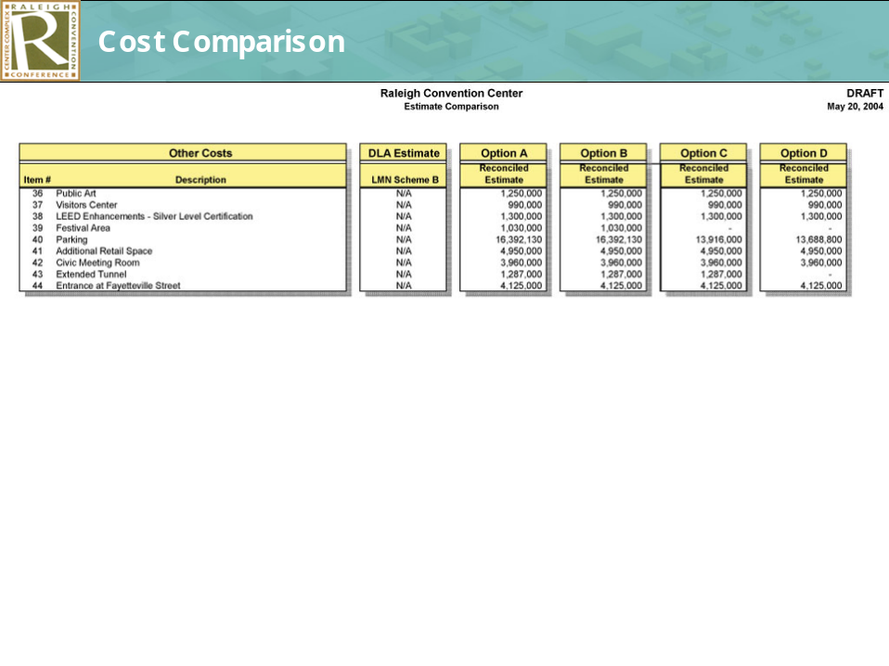

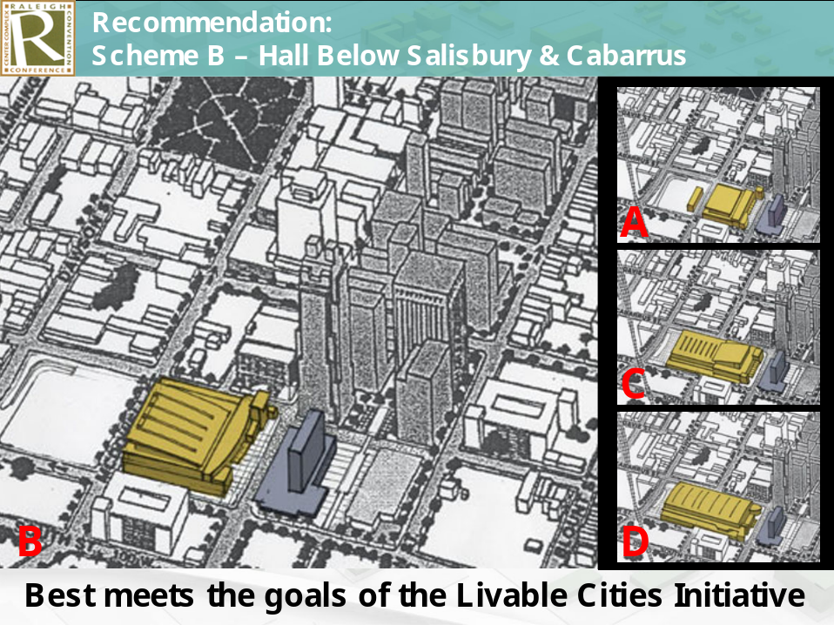

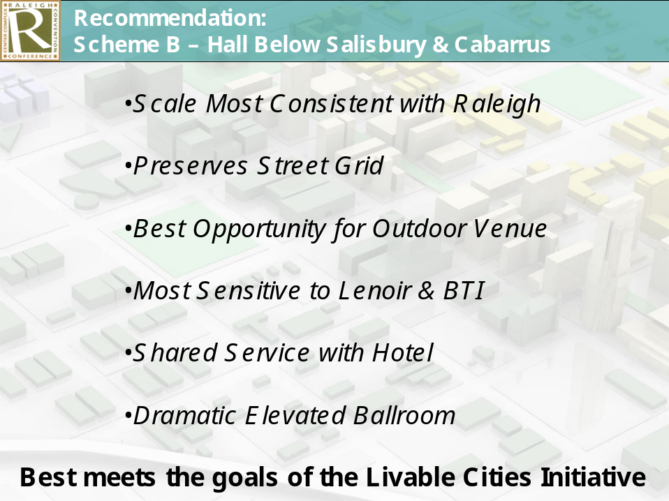

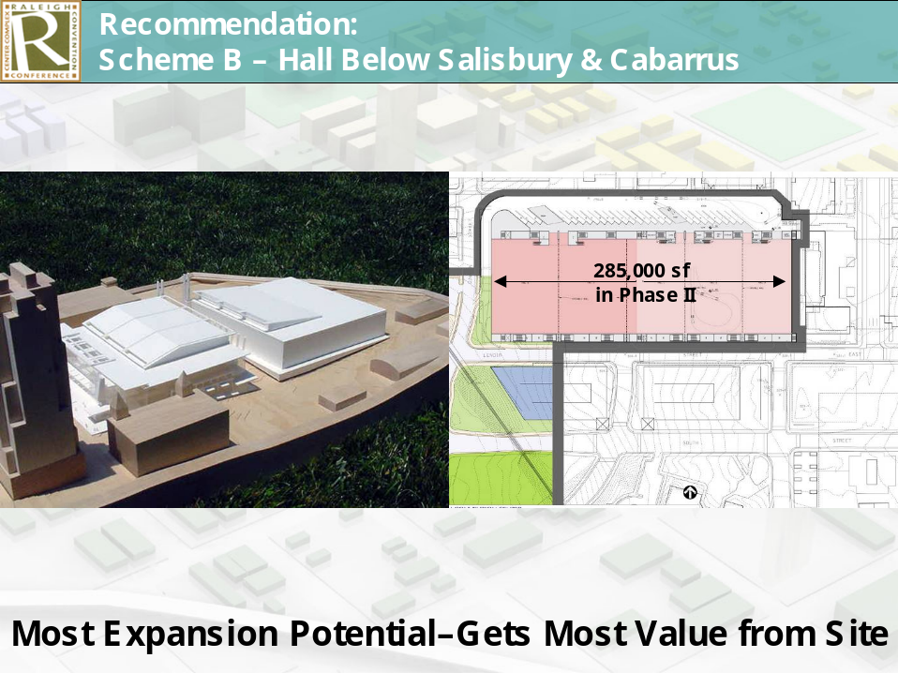

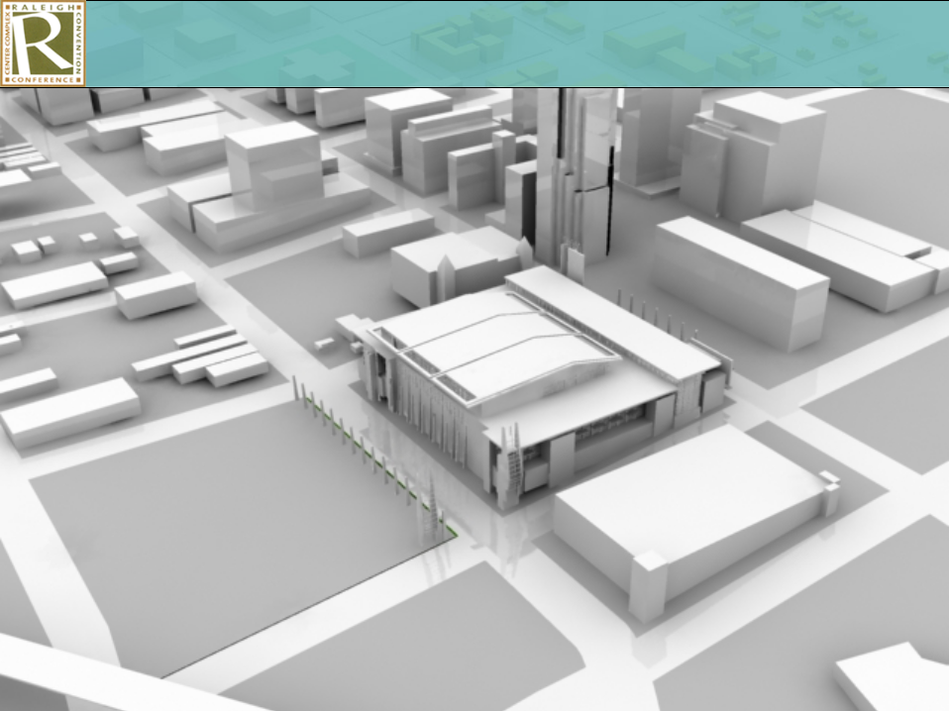

During and following the PowerPoint presentation points of discussion were as follows:

It was pointed out the renderings the group is seeing are not designs. The design phase is yet to come. What the group is seeing is concepts for architectural opportunities. It was pointed out by Mr. Muter that completion date for an above grade concept would be September 2007, below grade December 2007. He is confident that by the end of 2007 we would have a grand opening.

In making the consultants recommendation, Mr. Schuster pointed out another advantage of Concept B is that it doesn’t use the expansion block, it gives an opportunity for 135,000 feet of expansion for a total of 285,000 square feet, gives greater opportunity for flexibility and allows the next phase to respond to various needs.

The cost factor as outlined in the charts was talked about at length. Range of cost as outlined on line 33 of the Raleigh Convention Center estimate comparison as shown in the PowerPoint was discussed with City Manager Allen pointing out likely the schemes will exceed the $180 million. Mr. Gurley expressed concern that projections are taking credit for the savings in the financing in looking at the interest but glossed over the income decreases. The philosophy of the projection, the history of interest rates, self-adjusting interest balance was talked about. Mr. Hunt pointed out it looked as if the fixed interest rates save some $900,000 per year over the life of the loan. If you work backwards and use the debt coverage it looks like that will generate a new available amount of money to borrow and questioned if we are taking that amount and allocating it to the cost. The utilization of $10 million and how that could be used in debt coverage and $2 million in sales tax and how that figures into the financing philosophy was talked about. Mr. Hunt questioned the difference in demolition cost in the various schemes. Mayor Meeker questioned if there is any substantial difference in operating cost on the various schemes with it being pointed out that has not been investigated but some assumptions could be made that heating and air conditioning operating cost maybe less in the underground schemes with Ms. Taliaferro questioning however if the water or patching would be more with underground schemes. It was pointed out the proposal had taken that into consideration and feel there would be no water problems with the consultants talking about the types of walls, etc. Ms. Ward asked that the consultants talk a little bit more about the façade pointing out she had not heard anything about the design, water feature, etc. Mr. Schuster stated there is a water feature in the budget. He stated once a concept is agreed upon then they will look at the critical concepts and the façade, etc. would be addressed in that part of the work. Whether we have an estimate of cost savings over a time period utilizing green building concepts was talked about with Mr. Schuster pointing out that with the LEED approach there will be cost savings but it depends on the level of certification one is seeking. Mr. Council asked if there has been any comparison on cost and construction risks involved as it relates to underground versus over-ground. Mr. Schuster pointed out depending on the scheme the load capacity has to be considered. He talked about managed risk and contingency.

Mr. Council questioned if we know what is underground, that is do we anticipate any big surprises. Mr. Lacy pointed out a lot of geotechnical work has been done including a lot of drilling. We know where the water is, flow of water, rock etc. The City employed a geotechnical firm and the design team has hired a firm to evaluate that work. In response to questioning from Mr. Jeffreys, Mr. Schuster pointed out Green building concepts would be in the basic bid. He stated however if the City goes for a higher certification there could be additional cost. Mr. Jeffreys asked about the loading dock versus driving on the floor with it being pointed out how the different schemes handle that idea. Ms. Taliaferro asked about skyline view pointing out she was hoping that the group would see some visual concepts. Mr. Lacy pointed out they could probably create something that shows the mass but it is difficult not knowing the concept with City Manager Allen talking about work that had been done to try to develop skyline views by turning the models etc. Ms. Taliaferro pointed out she understands it is more about massing and she is in hopes that this building will make a statement in the skyline and questioned the possible view from Sanders Street as it relates to scheme B. The possible height and massing of the various schemes was talked about with Mr. Schuster giving some comparisons of possible heights. The Washington Center and comparisons were talked about.

Mr. Council indicated he understands the design team recommendation is scheme B. He questioned if they have a second choice. Mr. Schuster pointed out they tried to develop four schemes. He stated in their meeting they did do some straw votes and scheme B always came out very high such as 9 to 10 to 1 in favor of scheme B. Ms. Taliaferro questioned how the straw votes were done and what the group had before them. What different Council members and Commissioners had heard from different groups as to their desires such as height, exhibit space, meeting rooms, concern about columns in the meeting and exhibit space was discussed.

Mr. Hunt questioned if the current hard cost estimates are indicative of the current steel and concrete prices. When the estimates were made was talked about with Mr. Hunt questioning the amount of contingency that may have already been used. It was pointed out today’s prices would be about $3 million more depending on the scheme, exact day of bidding, etc. Mr. Hunt questioned the mechanism of the construction manager at-risk work in locking in construction cost. Mr. Muter pointed out those cost will be set on a certain date. City Manager Allen pointed out by design we are getting as far along as possible in the design before locking in the construction cost. That will save money on the construction manager at-risk price. Variables in the construction cost were talked about with Mr. Hunt questioning the drop dead date for the construction manager at-risk contract being awarded with it being pointed out it would probably be February 2006. Mr. Hunt expressed concern about that date and questioned if we wait so long in the process to set the contract price is not sure about the risk involved. Mr. Lacy talked about how the estimates are done along the way and the role of the construction manager at-risk.

Ms. Ward asked about entrances from building onto Fayetteville Street. Mr. Schuster talked about connection of this building to Fayetteville Street, the desires of some to have a plaza at the front door, the feeling that most people wanted Fayetteville Street opened all the way through and the fact that decision has not been made, but scheme B would allow that option. What the base price estimates include and discussions that have ensued relative to the options for Fayetteville Street was debated.

Other dialogue followed relative to disruption during the construction process of the various schemes with Mr. Lacy pointing out he does not feel under scheme B we would have to close McDowell Street during construction. Comments about what would happen to displaced dirt with the various schemes was touched on. Mr. Gurley questioned if the design team and the people involved in the straw votes took into account that option D is less costly. Mr. Schuster pointed out that when they were doing the straw votes they did not have the cost. They were looking at the opportunities that the various schemes would provide and allow. Ms. Taliaferro questioned how the underground scheme deals with unexpected findings such as rock, utility lines, water, whatever, with Mr. Schuster pointing out that is why more contingency is built into the underground schemes. He stated as we move forward with any scheme we would be able to reduce the risk as we receive more information. Ms. Cowell questioned the saving options and how they are calculated with the various schemes. The amount of parking spaces near the various schemes was talked about. The location of parking and the concept that parking a short distance away would encourage people to walk by the various amenities surrounding the building and the pros of that was discussed. Mr. Gardner questioned the interaction between the Convention Center and the hotel under the various schemes as it relates to pedestrian and truck event parking. How truck parking and parking in general is covered by the various schemes was pointed out. How the various schemes relate to the budget and the various concepts included in the various schemes was talked about.

Mr. Hunt expressed concern that we would not have a fix price contract until February 2006 with it being pointed out work on pricing making sure the project stays within budget is being done all along and the fact we will not be waiting until February 2006 to know the exact cost. Mr. Hunt expressed concern that by that time we would be off and running and couldn’t stop the project. He has concerns about not knowing the exact price until that time. He questioned what would happen if at that time it is way over budget with it being pointed out by Mr. Schuster that the design could be altered at that point. Mr. Hunt questioned how parking cost figures into the various models pointing out he did not think the original concept or thoughts included additional parking. How parking became part of the project was touched on. In response to questioning whether scheme B McDowell Street would have to be closed was touched on with Mr. Schuster pointing out there could be some short-term closing but not permanent closing.

Mr. Crowder stated he feels scheme B is the most sensitive, meets the criteria and concept best; therefore. he would move the group accept the design and recommendations for scheme B. His motion was seconded by Ms. Cowell.

Eric Tannery, Convention Center Commission, talked about their involvement and pointed out that group unanimously recommends approval of concept B. Mayor Meeker expressed appreciation for all of the work involved pointing out we have some of the best designers in the country and they have made a clear recommendation for scheme B. Mr. Gurley expressed concern that a recommendation was made without taking cost into account. City Manager Allen talked about the work of the design team as well as City and County representatives and how cost figured into their recommendation. In response to questions Mr. Tannery pointed out the Convention Center Commission did have some general cost estimates available when they made their recommendation. It was pointed out the County staff agrees with the recommendation. Ms. Taliaferro talked about the idea of keeping the skyline with the current scale but the desire to make a statement with this building. Mr. Council asked about holding action to give the City and County elected officials an opportunity to make sure they are comfortable that the recommendation being made is the best recommendation. He questioned the consequence of a one-week delay. City Manager Allen talked about the need to stay on the time schedule and pointed out any delay would move the project back by that same amount of time. County Manager Cooke talked about the amount of new information the group has received and the need for the elected officials to feel comfortable with their recommendation and the understanding additional meetings could be scheduled. The fact that the group employed some of their best designers, consultants, etc. in the Southeast and the Country and they have come together with a recommendation that is agreed upon by City and County staff was discussed. Mr. Hunt expressed concern about cost overage pointing out 8 months down the road when we end up with a construction cost of $40 million over budget he would question if the designers have thought about what they would delete. Mr. Lacy pointed out they did to some value engineering exercises and there would be three alternatives if there is cost overrun that have to be dealt with and includes reducing the scope and size, reduce quality, reduce complexity. He talked about C and D being reduced complexity but he hasn’t heard anyone talk about reducing quality so reduction in scope is what we would be left with. He stated they believe with the contingencies in place the knowledge we have at this point that they are comfortable with the recommendation that this is the option to go with. When the footprint of the building would be in place and the proposed schedule was talked about with it being pointed out utility packages hopefully would be in place in the January 05 – June 05 time frame with construction going up at that point. Mr. Gurley stated as he understands what has been said is that there are only three ways to affect the cost and it looks like the only hedge at this point would be reducing the complexity. Getting the concept approved and in place with the basics and coming back and adding the buttons and bows was talked about. Mr. Web talked about energy savings the group heard about while in Washington which is contracting of utilities and questioned if that was examined here as a cost opportunity. Whether there are companies available in this area to participate in that type opportunity was talked about as well as getting a company to guarantee the rates for a period certain. It was pointed out there are some tradeoffs and at this point nothing like that is being proposed.

The financials presented with various officials giving their understanding of the financials including fund balance, accumulative fund balance where the contingencies are built in whether the contingencies are accumulative, which contingencies apply to construction manager at-risk and which contingency needs will go up and down. Mr. Hunt had questions on the construction manager at-risk contingency and the bottom line on how the various contingencies relates was touched on. The motion to approve scheme B was put to a vote before the City Council which resulted in all members voting in the affirmative except Mr. Hunt who voted in the negative. (Mr. Isley not present) The Mayor ruled the motion adopted.

Commissioner Council moved that the County Commissioners approve scheme B. His motion was seconded by Ms. Ward. Mr. Jeffreys pointed out it would have been nice to have the information earlier as he hates to have to vote on it the night it is received. The motion was put to a vote by the County Commissioners which resulted in all members voting in the affirmative except Mr. Gurley and Mr. Jeffreys who voted in the negative. Mr. Gardner ruled the motion approved.

Mr. Web questioned the next steps with City Manager Allen pointing out the designers would be released to go schematic design; the next major point would be architectural design.

INTERLOCAL FUNDING – APPROPRIATION – DISCUSSION HELD

Commissioner Council pointed out he is receiving a lot of calls about prioritizing projects for the uncommitted interlocal money. He stated the group has been delaying doing that but he feels it is time to move forward. He is not proposing to commit any money just prioritizing the projects. Chairman Gardner pointed out the County Commissioners adopted a resolution relative to how to move forward and send it to the City. Mayor Meeker pointed out discussions have been occurring between City and the County as to how to proceed. The County is proposing prioritizing projects of $10 million or more. The City feels all projects should be prioritized regardless of the amount requested. Mr. Council pointed out the County has appointed a four person committee and he feels the issues could be resolved by the Committee meeting with City official representatives. Mr. Bryan pointed out the County had adopted the philosophy of wanting to look at the projects that would have the most significant impact and that is why they put the $10 million figure into play. The difference in the philosophies was talked about with Mr. Council pointing out he feels some of that could be sorted out if the group would go ahead and meet. He stated judging the projects based on economic impact it will have on the community regardless of size could be done and he feels the priorities would probably come out the same way. Mr. West pointed out projections should be based on merit and if we exclude some of the smaller projects he has concerns. How to proceed from this point was talked about. Ms. Taliaferro stated she feels that the projects should be prioritized so that the applicants could know whether they have support or not and could move on with their planning with the group agreeing that some steps should be taken. Mayor Meeker pointed out a joint meeting could be held and discuss whether the group was going to look at all of the projects or certain projects. Mr. Jeffreys indicated as he understands we are talking about $17 million over the next 10 years. He stated he is not sure we should fool anyone into thinking that they are going to get money until we know what our needs are on the Convention Center. He pointed out we are in a very unstable market as it relates to fuel, steel, concrete and we do not know the exact cost of the Convention Center so he does not feel the group should promise anyone anything they can’t deliver. Mr. Council stated he wouldn’t argue that point, he is not suggesting spending any money or making any promises that any group will receive money. He just feels the applicants should be put in priority order as to how funding will occur if funding is available. How long it would take for the groups to get their proposals in or their proposals updated was talked about. Mayor Meeker suggested all applicants be given 30 or so days to submit new applications, support or update existing applications. Once these are received the group could meet to receive all presentation and a second meeting for further discussion. It was agreed to let the staff work up a process to notify and publicized the process is going to be open to receive applications. The staff could recommend a process for reviewing the applications and to let the public know process is being reopened. Dialogue took place concerning the difference in the funding philosophies between the City and the County with Commissioner Gardner talking about the process and his feelings about funding of projects in various locations. The fact that the City and the County receive $1 million in discretionary funds and how those funds could be utilized was talked about. The fact that the City and County’s discretionary funds could go to small projects and how the two groups utilize there funds now was talked about. Funding for Exploris was touched on.

ADJOURNMENT

There being no further business, the meeting was adjourned at 6:15 p.m.

Gail G. Smith
City Clerk

Gh/scc5/20/04

