SPECIAL CITY COUNCIL MINUTES

The City Council of the City of Raleigh met in a joint session with the Wake County Board of Commissioners in Room A of the Raleigh Convention Center on Tuesday, October 12, 2004 at 8:00 a.m., with the following present.

City Council Members County Commissioners

Mayor Meeker Commissioner Chair Gardner
Mr. Cowell Mr. Gurley
Mr. Crowder Mr. Brian
Mr. Hunt Ms. Ward
Ms. Isley Mr. Webb
Ms. Taliaferro Mr. Jeffries
Mr. West

Mayor Meeker called the meeting to order and the following discussion took place.

CONVENTION CENTER RECOMMENDED SCHEMATIC DESIGN – PRESENTED

City Manager Allen explained the agenda and presentations that would be made at the meeting.

Dudley Lacey introduced the team who are present and also reviewed the July 13, August 10 and September 14 presentations. The purpose of today’s meeting is a presentation of the design team’s recommended schematic design of the new Convention Center.

Steve Schuster, Clearscapes, pointed out the design teams and others have had approximately 80 meetings with the various stakeholders and told of that work. He stated they are highly confident that the building works and is one that is efficient and allows serving the needs of the staff and the public who will enjoy the building. He pointed out they have been working with the hotel developers to make sure that they will be able to operate as one facility. He pointed out a meeting had been held with meeting planners and convention center representatives and received their endorsement that the space works. They feel the massing works, and the materials being proposed work. He talked about the last presentation in which the design team heard that the entrance was too busy and questions as whether the roof form is correct and pointed out, changes have taken place.

Scott Sickeler explained the different renderings of the four sides from various vantage points. He pointed out we are basically talking about a two-story building with a basement which will be 100-feet tall. He talked about the thought processes and the changes that they have made since the last presentation which they feel makes the building friendlier, inviting and approachable. He talked about the roof shape pointing out the roof of any building has many responsibilities including shedding water and multi-massing to match up with the Livable Streets context and talked about what the pedestrian will see, etc. He presented a photomontage illustrating how the building will impact the City’s skyline. The roofline approach they are using has to span some 180-feet. They feel it is uplifting and reaches toward Fayetteville Street and provides screening for the cooling towers and reaches for opportunity.

The team explained changes which they feel simplifies the entrance and mirrors the classical look of other civic buildings in the area.

Ken Luker presented models, talked about scale and relationship with the surrounding buildings, accommodation of a second phase addition which will help strengthen that gateway into the City, similarities and how the proposed building draws inspiration from the Capital and the BTI Center, and a different vision along McDowell Street and introduced the possibility of a shimmer wall in that facade. He stated those two facilities have a frontal approach down Fayetteville Street. The new convention center does not have that frontal approach so the four corners become the focus.

Thomas Sayer talked about the use of materials and the various art elements such as the proposed tower which the design team feels is very important. He talked about the public art program which they will design a program for. He explained how the pieces might be identified and the challenges as it relates to funding. In response to questions from Mayor Meeker, Mr. Sayer pointed out the tower is proposed to be in front of the meeting room and explained the movable stainless steel spires which will be lit at night. The tower would be 80 to 90 feet tall and explained how it would be seen. He pointed out the tower is not included in the final design because of budget constraints. Ms. Taliaferro talked about the concept of the building being a work of art and the possibility of utilizing individual arts rather than a tower as an art piece. Ms. Ward pointed out we need to have a focal point and she feels the tower speaks to that. She feels the tower is very impressive and would have the desired impact. It was pointed out right now the art opportunities are outside the project. The tower is not before the group now as it is outside the budget.

The group presented animations showing how the center would look as one is approaching by automobile and how the facility would appear at night when lit.

Mr. Lacey went over the total budgeted project cost and other costs as outlined below.

Raleigh Convention Center October 12, 2004 Schematic Design Presentation

Schematic
Total Budgeted Project Costs Design Pre-Design Difference
Reconciled Reconciled Schematic Design
Item Description (Original Source: DLA-HVS-Report) Estimate Estimate Pre-Design

1 Direct Building Construction costs 111,713,969 103,200,000 8,513,969
2 Site Work 3,007,101 3,049,411 (42,310)
3 Demolition of On-Site Structures 1,265,474 1,921,156 (655,682)
4 Demolition of RCC with Temporary Façade 1,054,959 1,000,000 54,959
5 LEED Certification Included in Item #1 750,000 (750,000)
6 CM’s General Conditions, Fees and Contingencies 21,673,098 21,642,674 30,424
7 Total Direct Construction Cost 138,714,601 131,563,241 7,151,360
8 Owner’s Contingency (3% at Schematic Design 4,171,938 5,789,040 (1,617,102)
9 Owner’s Project Reserve 3,429,174 10,258,151 (6,828,977)
10 Furniture, Fixtures & Equipment Allowance 4,320,000 4,800,000 (480,000)
11 Signage 540,000 600,000 (60,000)
12 Telecommunications, Security, Computer Systems 2,250,000 2,500,000 (250,000)
13 A/E Fees & Reimbursable Expenses 15,491,043 13,156,324 2,334,719
14 CM’s Pre-Construction Fee 870,400 870,400 -
15 Code Compliance Peer Reviews (Not Applicable) - 250,000 (250,000)
16 Testing 1,295,632 1,295,632 -
17 Permits 517,212 517,212 -
18 Reproductions 500,000 500,000 -
19 Utility Consumption 400,000 400,000 -
20 Owner’s Project Administrative Expenses Allowance 4,500,000 4,500,000 -
21 Land Acquisition & Non-MGP Site Remediation 15,000,000 15,000,000 -
22 Total Soft Costs 53,285,399 60,436,759 (7,151,360)
23 Total Costs 192,000,000 192,000,000 -
24 Original Project Budget 180,000,000 180,000,000 -
25 Special Contingency from Financing Savings & Sales Tax 12,000,000 12,000,000 -
26 Total Project Authorization 192,000,000 192,000,000 -

Notes: 1. Direct Building cost Assumes Progress Energy’s Payment for the Remediation of the MGP Site.
- Direct Building Cost includes $250,000 for water features.
- Total direct construction costs (line 7) includes 43,827,730 for Design Development contingency.

Other Projects Costs SD Pre-Design Difference
Item # Description Estimate Estimate

27. Interior Art 750,000 1,250,000 500,000)
28 Vertical Element at Southeast Corner 500,000 - 500,000
29 Shimmer Wall at Western face 650,000 650,000
30 LEED Enhancements – Silver Level Certification 1,300,000 1,300,000 -
31 Festival Area 1,030,000 1,030,000 -
32 Water Feature Enhancements 1,000,000 - 100,000,000

John Muter, talked about the budget pointing out how they have reviewed the different elements and studied current trends and pointed out while they cannot predict the future they feel they have a good handle on the tonnage of steel, concrete, etc., they will need to utilize. He talked about escalating costs and areas impacting the budget as follows:

CONSTRUCTION INDUSTRY PRICING INCREASES:
- Nationwide overall 8.5% increase just in last 6 months
- UNC Systems acknowledge a 15% increase on projects currently in design
- Structural Steel up 45% from this time last year
  - We set aside $3,000,000 in contingency in the event the prices did not drop back
  - We have now moved this to cost of work to reflect an unchanged market
- Roofing up 35% in past 6 months
- Aluminum and Glass for curtainwalls has increased 15% and is expected to jump another 3-5%
PROJECT SITE IMPACTS
- Soils Composition and Ground Water studies have required Design Modifications
- Shoring requirements have gone up $2,560,000 (50.3% increase)
BUILDING FINISH UPGRADES
- Strong Stakeholder and Public Opinion regarding Lobby Finishes
- Resulted in upgrades to level of finishes in Lobby and Public Spaces
+Stone -Drywall
+Brick -Paint
+Millwork
+Higher-end Curtainwall

He talked about how and what materials have increased. He stated however we have a lot more information and can project budgets closer. He stated he feels really good about the numbers, we have good data, we have contingencies and he feels good about the proposals.

Mr. Lacey talked about how they made the projections pointing out they looked out into the future. He talked about the finishes and materials that are not important to the operation of the building but are important. He presented the following cost reduction options.

Item Estimated Value
Program Cost Reduction

1 Reduce Building Area by 5000 sf 1,300,000
2 Delete Exhibit Hall under Salisbury 6,000,000

Quality Cost Reduction

3 Substitute Concrete for Granite Pavers 426,500
4 Delete Granite Curb & Gutter 32,750
5 Raise Building 2 feet 400,000
6 Substitute Concrete for Unit Pavers 289,000
7 Reduce Planters 152,000
8 Substitute Stone for 25% of the Glass 554,680
9 Change Curtainwall Specifications 792,666
10 Reduce Interior Brick 50,000
11 Reduce Interior Stone 840,000
12 Reduce Floor Stone 50,000
13 Reduce Fabric Panels 45,000
14 Change Floor Tile Specifications 25,000
15 Reduce Terrazzo 125,000
16 Reduce Carpet Quality 287,553
17 Reduce wall guards 37,875
18 Delete Stand-by Pumps 50,000
19 Change Large Copper Feeders to Aluminum 200,000
20 Use Original Light Fixture Budget 750,000

Increased Risk Cost Reduction
21 Elimination of Subcontractor 1% Bond 1,210,000
Total 13,618,024

Mayor Meeker stated as he understands the project as designed can be built within budget. The design team is comfortable that we are within budget. Mr. Muter stated they have done $12-$14 million in value engineering to get to this point. They feel comfortable about the amount of contingencies pointing out they may be conservative. He talked about historical data and again stated they feel good about the numbers.

Mr. Hunt stated he is having a hard time imaging how we could still be in budget with all of the escalating cost, etc. Mr. Lacey again talked about the value of engineering pointing out they had value engineered such things as the soil retaining wall, HVAC loads and recalculations, reduction in ceiling height and reduction in tonnage of steel. He stated nothing that has been value engineered out that would affect the quality or appearance of the building. Mr. Muter pointed out these are all things that one would not see. He talked about their negotiations and how they went about the value engineering. Mr. Jeffries had questions about going under Salisbury Street and discussion followed about height, location of unsuitable materials, underground waterflow, etc., pointing out all of these things were taken into consideration in the value engineering and as well as making sure we do not create an unsafe scenario. Other points of discussion related to the LEED rating and how that was figured into the budget projections and whether the design team has done a cost benefit analysis of going to a higher LEED rating.

Mayor Meeker stated as he understands items 27 through 32 on the page entitled “Raleigh Convention Center October 12, 2004 Schematic Design Presentation” are not included in the budgeted amounts. The opportunity to look at those through public/private partnership funding, naming opportunities, etc., was talked about. Ms. Ward pointed out she feels the elements in Items 27 through 32 would have a real impact. Mr. Hunt questioned if the civic meeting room is in the budget with Mr. Lacey pointing out it is not and that possibility is sort of off the table. They talked about the height of the rooms following the value engineering with it being pointed out the ceiling in the meeting rooms would be 15 feet. Mr. Webb questioned when we look at implementation or inclusion of the options with Mr. Lacey pointing out when funds become available or when this group gets comfortable going into the contingency.

Ms. Ward talked about the shimmer wall on the western face pointing out she feels that would add a lot. The elevation along McDowell Street and the option of doing something magical was discussed. The shimmer wall which would be wind operated and that concept was discussed. Mr. Crowder pointed out that is a face of the building which need some type magic.

David Weiss presented the following schedule progress.

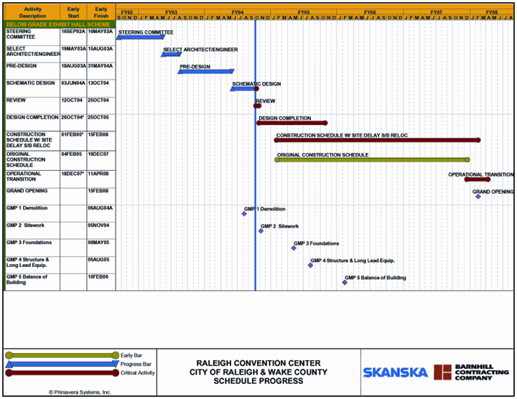

It was pointed out GMP #1-demolition has been approved and we are currently on schedule but not without challenges.

Finance Director Perry James presented notes on the financing model as follows.

Notes on 10/12/04 Convention Center Financing Model
Model updated for actual results through 6/30/04.
• Key update items:
o Total debt issuance adjusted up by $10 million to $245 million, netting out $210
million in project cash flow (S 190 million budgeted for convention center; $20
million budgeted for hotel funding)
o Model incorporates the $55 million variable rate issue and the economic impact
of the $190 million forward starting swap due 1/05
o Actual interlocal tax funds and interest income received through 6/30/04
o Interest income projections scaled back to a flat 3% over the entire term of
financing (previously 3%-S years; 5% after that)
• Results as compared to original model:
Accumulated fund balance at 6/30/04 exceeds original model projection by
$187,897
o Full budget of convention center met by model
o Model’s goal of having the minimum accumulated fund balance exceed the
largest annual debt service amount is met.
Continued Elements of Original Model
- Tax projections from FY 2005 to end of model remain the same as original model [ County current projections now exceed original estimates by approximately $14 million].
- “Other expenses” remain the same as approved by interlocal agreement and are eligible to be used in July, 2005.
- City retains right to withdraw up to $1 million per year from fund balance accumulation to spend on items approved as “other expenses”. No withdrawals have been made.
- Future expansion debt service is modeled the same as estimated in original model.
Elements of Conservatism in Model
- Build in debt service reserve—good credit strength plus allows flexibility with cash flow
- Tax projection estimates already exceeding original projection; however model keeping original estimates
- Early low variable rates producing lower interest rates than projected
- Other expenses include items that can be reduced or changed if needed (capital reserve, etc.)
- Model incorporates debt projection for expansion facility which could be changed
- Annual $1 million withdrawals (to extent available within model) offer flexibility if needed for early operations
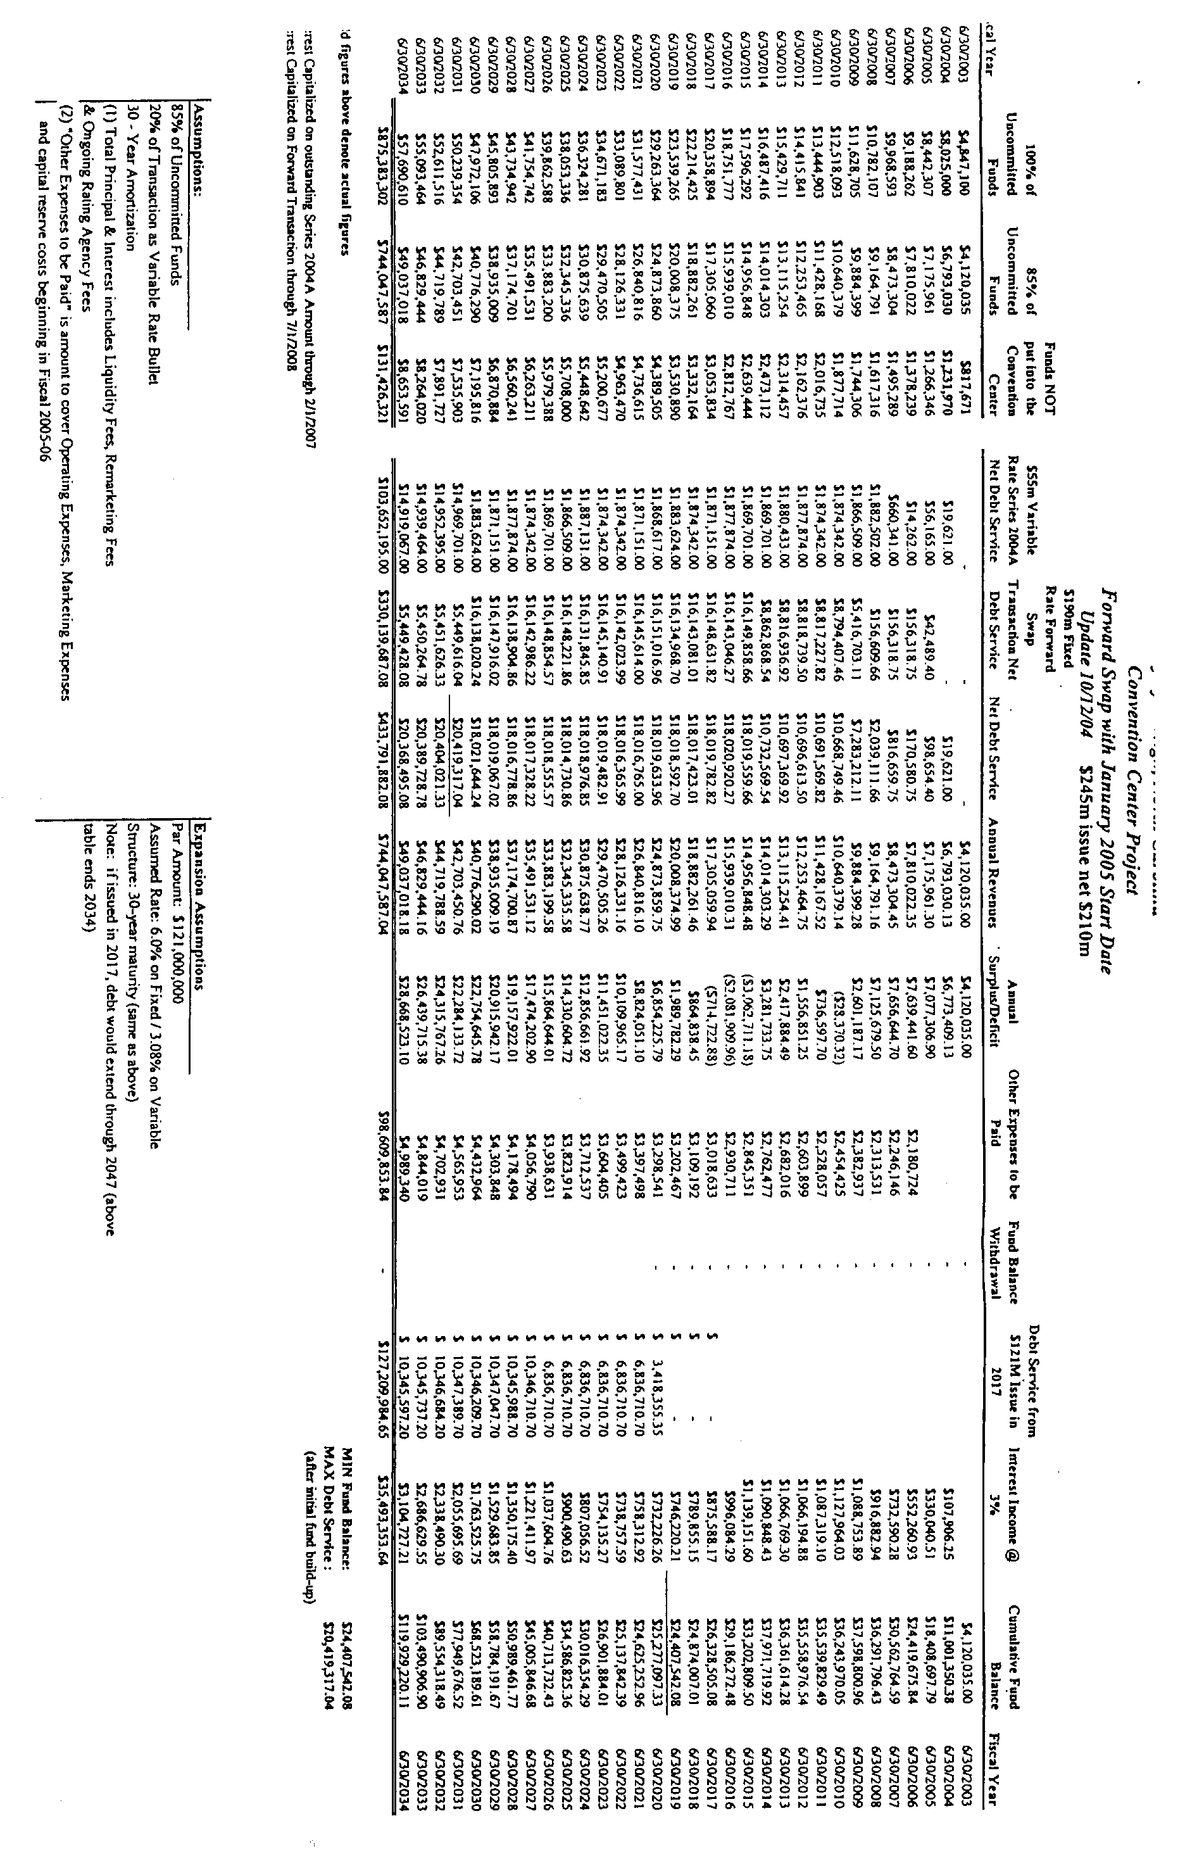

He explained the information.

Mr. Gardner asked about the $1 million of interlocal funds that goes to the City pointing out that should be separated out. He talked about his interpretation of the interlocal agreement and how that money plays into financing the proposed convention center and how the financial models should reflect that money.

The interrelationship between the headquarters hotel and the convention center and how the meeting and public spaces to coordinate, provide easy access from one facility to the other and under street connections.

A representative of Stormont Noble talked about the headquarters hotel pointing out their success rest a lot in the hands of this group and the convention center. He pointed out they are offering 80% of their room nights to support the center. They talked about the nearing or completion of the schematic drawings and the work the City is doing in evaluating a parking garage underneath their site and Fayetteville Street. They talked about their floor plans, site plan, etc., and how the integration between the two facilities work. In response to questioning they pointed out they would need 200 parking spaces that they would have control over and another 200 that they could utilize. City Manager Allen pointed out the City is looking at the opportunity to maximize the underground parking by utilizing the space under the hotel and the existing convention center and the hope to be able to come up with a parking space of 700 to 1,000. He pointed out construction of that facility would not come from the interlocal funds but from the City’s parking management funds.

The work in planning in the area for the southend, the communications, coordination and dialogue on how to relate the hotel and the convention center to the City in general, talked about planning being done relative to the hotel tower, etc., was discussed. The concept of restaurant and bar, tenant retail space, lobby drop-off area, entrance to proposed parking deck, how they are lining up the hotel space to match with the convention center schematic drawing, shared service loading dock area, pedestrian flow, number of rooms which is 400 and what is being done to integrate with the convention center to make it a seamless project was talked about. In response to questioning from Mr. Webb, it was pointed out the building design is not to the point of façade details. However it is believed there is a lot of opportunity to be a good neighbor and coordinate the exterior designs. Mr. Crowder questioned the drop off for the hotel and how that would relate to the possibility of extending Fayetteville Street to the area. He pointed out the possible underground parking would eliminate some of the large streetscape trees and asked how that would be addressed. Mr. Gurley asked about future expansion of the hotel. It was pointed out the hotel will be built in such a way that would have expansion capabilities off of the north end for another 100 rooms. Ms. Ward questioned if the hotel would have some type water feature or something that is easy on the eye with it being pointed out they are looking at options. In response to questions, it was pointed out the hotel completion date is planned for December 2007. Construction would start in May 2006, however that is contingent upon the parking garage being completed as that would be the pad for the hotel. The hotel will be open when the convention center opens.

Mr. Crowder again talked about the underground parking and the possible result in a sparse design at the street level because of constraints put on the type of trees, etc. City Manager Allen pointed out Kimley Horne is in the process of a study on parking configuration, etc. He stated the Council had authorized administration to move forward to choose a design consultant and that issue will be on the next City Council agenda. He stated the critical path schedule allows for coordination. Tenant retail space in the hotel with the hotel was questioned with the hotel representatives pointing out that is a possibility. They will be looking at something that would be pedestrian friendly.

Mr. Schuster pointed out the schedule calls for the Council and Commissioners to make a decision on Thursday. He asked for any questions and pointed out at the Thursday’s meeting they will have several of the stakeholders to offer endorsements. He stated they feel they have a good balance. Mayor Meeker pointed out the Convention and Performing Arts Commission gave some positive feedback.

Mr. Crowder complimented the group on the work that has been done. He stated however on the McDowell side of the building he feels we have taken a step backwards. It is large, austere and pretty brutal. He stated if we could not come up with the money for a shimmer wall or something of that nature, he does have concern. He stated the bookends or the change of design on the front gives it more human scale. He feels the roofline needs some additional work as he feels it is a little squashed, may be we could tilt some up more, some down. He talked about the color of materials pointing out we must coordinate with surrounding areas. He stated he feels whatever we do to balance the budget, it is really imperative that the exterior of the building be done extremely well as we can add to the interior later. Ms. Ward pointed out she feels the shimmer wall will add a lot and that would be very important. She stated there are a lot of corners that can be cut but she feels we should do the best on the exterior. She stated the design team has done a good job. Ms. Taliaferro talked about the exterior pointing out in the initial renderings the front stairway was open and she feels it is important to have that openness.

Mr. Gardner pointed out he feels pretty good about the front. He feels the designers have done an admirable job simplifying the facades making it a friendly and usable center. He feels it can be one of the best in the nation as far as user friendliness, materials, etc. He suggested that may be we should get some consensus that the group is comfortable with the schematic design but as far as the budget numbers, etc., he is not ready to move forward. He stated however he does not want to slow the process down as far as the design but he feels we should make sure we understand the numbers. Mayor Meeker talked about the possibility of approving the conceptual design but continue to work on the budget. He stated if the group is comfortable, we could sign off on the conceptual design and not have a meeting on Thursday, but in a couple of weeks have another meeting to look at the budget numbers, etc. Ms. Taliaferro pointed out she thought part of the meeting was to hear from the public and she is comfortable with what she is seeing but it is always important to hear from the public. It was pointed out we have had some 80 public meetings already. After brief discussion it was agreed to meet on Thursday and if there is any public comment or any questions about the schematic design, those could be handled but hold off on budget discussions and decisions until later on. Mr. West commended the group for the balance and the extended public process.

Adjournment. There being no further business, Mayor Meeker announced the meeting adjourned at 10:00 a.m.

Gail G. Smith
City Clerk

Jt/SCC10-12-04

