COUNCIL MINUTES

The City Council of the City of Raleigh met in regular session on Tuesday, October 19, 2004, at 1:00 p.m. in the City Council Chamber, Raleigh Municipal Building, Avery C. Upchurch Government Complex, 222 W. Hargett Street, Raleigh, North Carolina, with the following present.

Mayor Meeker, Presiding
Mr. West
Ms. Cowell
Mr. Crowder
Mr. Hunt
Mr. Isley
Mr. Regan
Ms. Taliaferro

Mayor Meeker called the meeting to order and invocation was rendered by Reverend Sean Park, Charisma Church. The Pledge of Allegiance was led by Council Member Hunt. The following items were discussed with action taken as shown.

RECOGNITION OF SPECIAL AWARDS

RALEIGH TELEVISION NETWORK – CELEBRATION – ANNOUNCED

Phillip Poe, Chairperson of the Telecommunications Commission, introduced Jayne Kirkpatrick and Ashraf Malik. He explained Ms. Kirkpatrick is Director of Public Affairs and has responsibility for the Cable Network. He stated he was pleased to announce that tonight the all new digital TV network will be officially introduced and a celebration is scheduled between 5:00 and 7:00 at the studio. Mayor Meeker will be flipping the switch on the new equipment. He stated they are celebrating the upgrade from an all analog to all digital studio. Everyone will be seeing the difference in the quality of the service. They are also celebrating a new identity Raleigh Television Network which includes four channels: Channels 10, 11, 18 and 22. He gave information on the type of programming on the four channels. He stated Raleigh Television Network has a lot of new programs initiated by the City Manager and the Public Affairs Director. He thanked them for taking the initiative on the new programming. He talked about the new programs including “What’s Up Downtown,” “On View.” He talked about the extensive coverage of the Convention Center planning sessions, Fayetteville Street, solid waste, stormwater and others. He expressed appreciation to Ms. Kirkpatrick, Mr. Ashraf and the City Manager as well as Council Member Thomas Crowder who is the City Council Liaison to the Telecommunications Commission. He expressed appreciation to the Telecommunications Commission and their work in getting the new technology on line. He asked the City Council to be sales people for the new Raleigh Television Network and help everyone get the word out about the new system, programming, etc. They presented Council Members with gift bags which included a t-shirt, travel cup and information about Raleigh Television Network. He expressed appreciation for the financing and the support given by the City Council and invited all to attend the celebration tonight.

Mayor Meeker expressed appreciation to the Telecommunications Commission for all the work they do and recognized Margaret Rose Murray a member of the Commission.

CERTIFICATE OF APPRECIATION – CINDY KAY FREEMAN – PRESENTED

Council Member Taliaferro recognized Cindy K. Freeman and talked of her work in community improvement in the Berkshire Downs area. She talked about community work, meetings, leadership and how Ms. Freeman had stepped in and provided that leadership in the Berkshire Downs area. She presented Ms. Freeman with a Certificate of Appreciation for a job well done and outstanding Volunteer Service.

SIR WALTER RALEIGH AWARDS – PRESENTATIONS – ANNOUNCED

Mayor Meeker pointed out the Sir Walter Raleigh Awards presentation will be held Thursday, October 21 at the Museum of History. He invited all to attend pointing out it is really a great event and recognizes many fine people.

CAPITAL CITY CUP – BAND COMPETITION – ANNOUNCED

Mayor Meeker pointed out on Saturday of this week we will have the inaugural Capital City Cup Band Competition. He stated it will be held at Sanderson High School and again pointed out this is the inaugural awarding of the Capital City Cup. The cup will be presented to the top band in the State. He pointed out he thought this was the only such event in the State of North Carolina. He invited all to attend.

CONSENT AGENDA

CONSENT AGENDA – APPROVED AS AMENDED

Mayor Meeker presented the Consent Agenda indicating all items are considered to be routine and maybe enacted by one motion. If a Councilor requests discussion on an item, the item will be removed from the Consent Agenda and considered separately. He explained the vote on the Consent Agenda would be a roll call vote. Mayor Meeker stated he had received a request from Mr. Regan to withdraw the Horseshoe Farm Master Plan Services and a request from Ms. Taliaferro to withdraw the item relating to Neuse River Wastewater Treatment Plant improvement bid. Without objection those items were withdrawn from the Consent Agenda. Mr. Crowder moved Administration’s recommendation on the remaining items on the Consent Agenda be upheld. His motion was seconded by Ms. Taliaferro and a roll call vote resulted in all members voting in the affirmative. The Mayor ruled the motion adopted. The items on the Consent Agenda were as follows.

ANNEXATION PETITIONS – VARIOUS – REFERRED TO CITY CLERK TO CHECK SUFFICIENCY AND SCHEDULE HEARINGS; 2005 ANN AVENUE – DEFERRED

The Agenda presented the following petitions for annexation.

Petition Annexations
Area Name Contiguous | Petitioner | Acres | Proposed Use
11420 Falls of Neuse Road | Judith K. Leonard, et al. | 1.17 | Residential
Cancer Centers of North Carolina | J. Cross Williams, Jr./Chaucer Investments, LLC | 3.99 | Office
Satellite Petitions
2005 Ann Avenue/ Davis Property | George D. and Damita D. Davis | .46 | Residential

Recommendation:

- That these annexation petitions be acknowledged and that Council request the City Clerk to check their sufficiency pursuant to State statutes, and except as noted below, and if found sufficient to advertise for public hearings on Tuesday, November 16, 2004.

- Because the existing residence at 2005 Ann Avenue is connecting to City water only and the other utility is not available at this time, it is recommended that the annexation of this property be deferred.

Upheld on Consent Agenda Crowder/Taliaferro – 8 ayes.

STREET CLOSINGS – VARIOUS STREETS FOR VARIOUS EVENTS – APPROVED CONDITIONALLY

The agenda presented the following requests for temporary street closings.

500 Block of West Johnson Street 198 feet east from Glenwood Avenue towards North West Street

Kevin Summers, representing Bogart’s Grill and Hi5, requests a street closure on Saturday, October 30, 2004 to Sunday, October 31, 2004 from 12:00 p.m. to 4:00 a.m. for a Halloween party with a band. He also requests a waiver of all City ordinances pertaining to noise.

1100 Block of the South Saunders Street service road between Grissom Street and Hamel Street

Scott Northrup, representing Ray Price Harley Davidson, requests a street closure on Saturday, November 6, 2004 from 7:00 a.m. to 5:00 p.m. for customer appreciation day.

1800 Block of Wills Avenue between Duncan Street and West Whitaker Mill Road

John Cassidy requests a street closure on Sunday, November 7, 2004 from 4:00 p.m. to 8:00 p.m. for a neighborhood celebration.

Recommendation: Approval subject to conditions noted on reports in the agenda packet. Upheld on Consent Agenda Crowder/Taliaferro – 8 ayes.

BUDGET AMENDMENTS – VARIOUS – ORDINANCE ADOPTED

The agenda presented the following recommended budget amendments:

Community Services - $4,521.98 – to utilize funds from Wake County Elderly and Disabled Transportation Assistance Program (EDTAP) for the Retired Senior Volunteer Program (RSVP).

Community Services - $225.00 – to utilize funds received for Retired Senior Volunteer Program/Foster Grandparent Program (RSVP/FGP) Senior Banquet on October 29, 2004.

Community Services - $1,700.00 – to utilize funds received for Retired Senior Volunteer Program/Foster Grandparent Program (RSVP/FGP) Senior Banquet on October 29, 2004.

Fire Department - $1,000.00 – to accept funds donated by the Wal-Mart Foundation to be used for fire education supplies.

Public Affairs - $56,000.00 – to place funds in the appropriate accounts to pay for renovations to the Community Television studio and office suite. The requested amount will provide funds to upfit the staff office area, including the construction plans for a store front entrance and more space for the dubbing workstations. Additional improvements include painting the studio, refurbishing, designing and constructing new studio sets, new cubicle panels, carpet, and office furniture. The reconstruction of the front area is needed to allow more space at the dubbing workstation because it is too close to the power unit that is located behind it.

Public Utilities - $157,246.12 – to receive funds from North Carolina Department of Environment and Natural Resources Public Water Supply Section Grant that was offered for the extension of water mains to the Beechwood Park subdivision.

The agenda outlined the revenue and expenditure accounts involved and the various budget amendments.

Recommendation: Approval of budget amendments as outlined. Upheld on Consent Agenda Crowder/Taliaferro – 8 ayes. See Ordinance 724TF7.

REIMBURSEMENT CONTRACTS – MAJOR WATER AND SEWER – VARIOUS – APPROVED

The agenda presented the following major water and sewer reimbursement contracts.

Major Water and Sewer Reimbursement Contracts

Sewer Area 94 Contract #4
Robert C. Rhein Interest, Inc./
Construction of sewer mains larger than 12 inch/
Total Reimbursement $141,404.20

Sewer Area 94 Contract #5
Robert C. Rhein Interest, Inc./
Construction of sewer mains larger than 12 inch/
Total Reimbursement $111,054.90

Water Area 94 Contract #9
Robert C. Rhein Interest, Inc./
Construction of 12 inch and larger water mains/
Total Reimbursement $87,980.00

Recommendation: Approve contracts. Upheld on Consent Agenda Crowder/Taliaferro – 8 ayes.

P.U. 2003-8 – BEECHWOOD PARK AREA – RESOLUTION AMENDED

P.U. Project 2003-8, a water main extension in the Beechwood Park area, was previously approved by Council on August 5, 2003 (Resolution 2003-832). The City has received a grant from the North Carolina Department of Environment and Natural Resources to cover construction costs of this project. The grant is providing funds for the complete cost of the installation of the main and the tap fees. Therefore, it is appropriate to amend Resolution 2003-832 to show that no assessments will apply.

Recommendation: Amend Resolution 2003-832. Upheld on Consent Agenda Crowder/Taliaferro – 8 ayes. See Resolution 256.

END OF CONSENT AGENDA

HORSESHOE FARM MASTER PLAN SERVICES – DESIGN SERVICES – CONTRACT WITH HAGERSMITH DESIGN – APPROVED; FUNDS TRANSFERRED

On September 21 Council approved moving forward with negotiations for master plan design services with HagerSmith Design, PA for the Horseshoe Farm Community Park. Staff has met several times with representatives of HagerSmith to refine the scope, responsibilities and time frame for the process. Staff recommends approval of the contract with HagerSmith Design in the amount of $85,457 for master plan services and reimbursables for Horseshoe Farm Community Park. Funding for the initial phase of development, $1,000,000 is in place from the 2000 Park Bond. These funds will supplement the original CIP funds for the master plan. Approval is recommended to transfer the original master plan funding from the CIP account to the bond account for project administration.

It is recommended that the following transfer be authorized:

Transferred From:
625-8771-79001-975 Capital project reserve $45,000.00
636-9050-79001-975 Capital project reserve 40,457.00
$85,457.00
Transferred To:
636-9050-79201-975 Design/planning contracts $85,457.00

Purpose:
To provide funds to contract for the Horseshoe Farm Park master plan with HagerSmith Design, PA.

Mr. Regan pointed out he withdrew from the Consent Agenda pointing out he understands this is transferring money for designing of a park and talking about using $1 million dollars from the 2000 Park Bond. He stated he feels parks are great but pointed out we are short police and inspectors and he feels we need to dedicate our money to do that as he had rather have resources to enforce the laws of our City and he feels that is more important. Mayor Meeker pointed out in the last budget the Council authorized 37 additional law enforcement officers and 6 new inspectors. He understands the concerns but feels that we should provide funds for parks also. Mayor Meeker moved approval of the recommendation as outlined. His motion was seconded by Mr. West.

Ms. Taliaferro pointed out this is a park in District B and she supports the master planning. She stated the comments made by Mr. Regan relate to the issue about crime and enforcement of crime. She stated she feels one of the main things we can do about crime is to do crime prevention and she feels a good parks and recreation program helps keep our youth involved and that is one of the things that we do to help in crime prevention. Mr. Regan stated he understands the need to have place for children to play and keep them involved. He stated, however, he was assured by the City Attorney that we could enforce our current laws and address many of the issues if we had the resources to do that and we do not have the needed resources. The motion as stated was put to a roll call vote which resulted in all members voting in the affirmative except Mr. Regan who voted in the negative. The Mayor ruled the motion adopted. See Ordinance 724TF7.

BIDS – NEUSE RIVER WASTEWATER TREATMENT PLANT IMPROVEMENT PROJECT CONTRACT 2 – BID AWARDED TO CROWDER CONSTRUCTION COMPANY – FUNDS APPROPRIATED

Bids were received and publicly opened by Camp Dresser & McKee on September 29, 2004, for construction of the Neuse River Wastewater Treatment Plant Improvements Project, Contract 2, with Crowder Construction Company submitting the low base bid in the amount of $20,220,040 and a low alternate bid of selected alternates of $19,772,040. Staff has negotiated a reduction in the contract amount by change order to reduce the contract amount by $175,000. Crowder Construction Company submitted a 2% MWBE participation bid.

Recommendation: Approve the low alternate bid and change order of Crowder Construction Company for a new contract amount of $19,597,040 and the following budgetary transfer.

Transferred From:
349-8530-79001-975 Reuse Pump Station $ 1,084,940.00
349-9173-79001-975 Grit Removal Equip Upgrade 605,300.00
349-9181-79001-975 Alk Stab Storage Rehab/Exp 660,000.00
349-9247-79001-975 Solids Handling Improvements 17,246,800.00
$19,597,040.00
Transferred To:
349-9247-79202-975 Solids Handling Improvements $19,597,040.00

Ms. Taliaferro stated she withdrew this item from the Consent Agenda pointing out she has no problem with the project and the recommendation and she appreciates staff being able to negotiate a reduction in the contract price. She stated her question relates to the source of funds. She stated she got out the CIP and she could identify several of the line items but could not see anything in the CIP relative to grit removal equipment upgrade. She stated she thought if we were transferring money she could identify that source of funds in the budget. She again stated she had no problem with the work or the proposed contract she is just trying to understand the source of funds. City Manager Allen stated he couldn’t answer that at the table but he could get the information.

Public Utilities Director Crisp explained the grit removal equipment was in a previous CIP. He thought it was in the FY-03. He stated when a program is in the CIP and the funds are not utilized in that year it doesn’t just drop over it is carried forward or rolls forward. He explained briefly how the CIP works. Ms. Taliaferro stated she is happy to go ahead and approve this recommendation. She is just trying to understand. She could find three of the four sources of funds and it would have been beneficial if she could have identified the fourth source. Mayor Meeker talked how the CIP works and the funds rollover. Ms. Taliaferro moved approval of the recommendation as outlined. Her motion was seconded by Mr. Crowder and a roll call vote resulted in all members voting in the affirmative. The Mayor ruled the motion adopted. See Ordinance 724TF7.

REPORT AND RECOMMENDATION
OF THE PLANNING COMMISSION

PLANNING COMMISSION – ITEMS TO BE CONSIDERED INDIVIDUALLY

Mayor Meeker pointed out the Planning Commission Consent Agenda included two items and he had received a request from Ms. Taliaferro and Mr. Crowder to withdraw
Z-29-04 which leaves only one item on the Planning Commission Consent Agenda; therefore, the Council would take each of the Planning Commission’s recommendations separately.

REZONING Z-29-04 – GLENWOOD AVENUE – REFERRED TO THE COMPREHENSIVE PLANNING COMMITTEE

This request is to rezone approximately 6.02 acres, currently zoned Office and Institution -1 with Special Highway Overlay District -2. The proposal is to rezone the property to Business District Conditional Use with Special Highway Overlay District -2 to be removed.

CR-10736 from the Planning Commission recommends that this request be approved in accordance with conditions dated October 7, 2004; and that the Comprehensive Plan be amended to designate a Residential Retail Area at this location. Mayor Meeker stated he understands there is a request to refer this item to the Comprehensive Planning Committee and without objection he would so refer the item.

REZONING Z-61-04 – NEW BERN AVENUE – APPROVED – SMALL AREA PLAN TO BE AMENDED

This request is to rezone approximately 2.32 acres, currently zoned Office and Institution -1(1.61 acres) and Residential -4 (0.71acre). The proposal is to rezone the property to Office and Institution -1 Conditional Use.

CR-10737 from the Planning Commission recommends that this request be approved in accordance with conditions dated September 30, 2004; and, that the Wake Medical Center Small Area Plan be amended to include the entirety of this property on the nonresidential side of the policy boundary line. Planning Director Chapman explained the location and the Planning Commission’s recommendation. He pointed out if this request is approved then the entire property would be zoned O&I-1 Conditional Use and the policy boundary line would be amended to include all of the property on the nonresidential side of the policy boundary line. Ms. Taliaferro moved approval of the Planning Commission’s recommendation. Her motion was seconded by Mayor Meeker and put to a vote which resulted in all members voting in the affirmative. The Mayor ruled the motion adopted. See Ordinance 725ZC558.

REZONING Z-42-04 – SHELDEN DRIVE – REFERRED TO COMPREHENSIVE PLANNING COMMITTEE

This request is to rezone approximately 0.97 acre, currently zoned Residential -20. The proposal is to rezone the property to Neighborhood Business Conditional Use.

CR-10738 from the Planning Commission recommends that this request be approved in accordance with conditions dated October 7, 2004. Planning Director Chapman explained the location, request, the Planning Commission’s recommendation and the conditions. He pointed out the Planning Commission voted 6-2 to approve the request. He indicated the negative votes he believed related to concern about uses in the neighborhood in neighborhood business zoning and concerns about expansion of that type use. Mr. West moved the item be referred to Comprehensive Planning Committee. Ms. Taliaferro pointed out this was another one of those properties in which the Council sees a request about every two years and she would be interested in what changes have occurred in the last two years. Without objection the item was referred to Comprehensive Planning Committee.

S-107-03 – GARLAND STREET TOWNHOMES – REFERRED TO COMPREHENSIVE PLANNING COMMITTEE

This request is to convert an existing single family residence on .52 acre into a four 3-bedroom unit townhouse development, where the existing house is to be a detached townhome. The property is zoned R-10 and the project’s density is 7.69 units to the acre.
This development constitutes an "infill subdivision" of less than 5 acres in accordance with 10-3032, in that greater than 66% of the sites periphery is surrounded by lots that are either existing single family residences or lots that were originally constructed as single family homes, and contains one or more lot frontages less than 80% of the median of the surrounding lots, or one or more lot size less than 80% of the median of the surrounding lots or both. The lot to the north and the lot to the south, across Garland Road currently have multi-family or townhomes on the property, but the structures were originally constructed as single family homes.

Median lot size of surrounding lots – 0.74 acres (80% = .59)
Proposed lot size lot #1 - .078 acre (13% of median)
Proposed lot size lot #2 - .045 acre (7.6% of median)
Proposed lot size lot #3 - .036 acre (6.1% of median)
Proposed lot size lot #4 - .045 acre (7.6% of median)

Median lot frontage of surrounding lots - 100’ (80% = 80’)
Proposed lot frontage lot #1 (corner lot) - 50’ (62% of median)
Proposed lot frontage lot #1 (corner lot) - 68’ (85% of median)
Proposed lot frontage lot #2 - 27’ (33.7% of median)
Proposed lot frontage lot #3 - 27’ (33.7% of median)
Proposed lot frontage lot #4 - 27’ (33.7% of median)

CR-10739 from the Planning Commission recommends that this request be denied. Planning Director Chapman explained the request and the Planning Commission’s recommendation for denial on a 7-1 vote. Mr. Crowder moved upholding the Planning Commission’s recommendation for denial.

Mr. Isley questioned the one vote against the denial. Planning Director Chapman stated he thought it had to do with the impact of the development being not sufficient to negatively affect the neighborhood. Mr. Isley made a motion to refer the item to Comprehensive Planning Committee. His motion was seconded by Ms. Cowell. Mr. Regan pointed out he understands this is classified as infill subdivision and questioned if there are guidelines that recommend that this subdivision not be approved. Planning Director Chapman explained the code requirements relating to infill development and standards that should be met for an infill development to be approved. He briefly touched on the various standards. The motion to refer the item to Comprehensive Planning Committee was put to a vote which resulted in all members voting in the affirmative except Mr. Crowder, Ms. Taliaferro and Mayor Meeker. The Mayor ruled the motion adopted.

SPECIAL ITEMS

AGENDAS – CHANGING ORDER OF COUNCIL BUSINESS – SUGGESTIONS GIVEN

The following item appeared on the consent agenda at the October 5, 2004 Council meeting. City Code Section 1-1026 Order of Business, establishes the sequence of items to be listed on the agenda for Council meetings. A change is suggested which would allow Public Hearings to be listed just prior to Request and Petition of Citizens. This would allow for more prompt public input on items of public policy which have been advertised for public hearings.

Ms. Taliaferro had questions about the change and why the change was recommended. It was directed that the item be placed on this agenda to receive a report from Administration relative to the pros and cons of changing the order of business and to further consider the item. A report in included.

Mayor Meeker pointed out Council members did receive information in their agenda packet. He stated this is just a matter of policy and he feels it could go either way.

Ms. Taliaferro stated she feels it is important for the Council to give time and attention to the request and petitions of citizens. Those people had taken the time to sign up and appear to present their case. She stated she would like to keep the agenda the way it is now; therefore, she would move that no changes be made.

Mr. West stated maybe some consideration should be given for those individuals who are part of the public hearing such as demolition of unfit buildings, sidewalk repairs, etc. He stated maybe we could have those routine items listed in public hearings ahead of any “hot button” items that may take quite a while. He stated sometimes a person under a public hearing has to set through three or four hours of lengthy public hearings before being able to make one comment. He stated maybe we could give some consideration as to how to arrange the items on the public hearings. After brief discussion, Mayor Meeker suggested that we keep the request and petition of citizens section first and hear the individual matters scheduled for public hearing first and then the public hearing items that will possibly bring in a lot of discussion.

BUS CONSOLIDATION – TO BE PLACED ON FIRST MEETING IN DECEMBER AS A SPECIAL ITEM

The issue relative to bus consolidation has appeared on several agendas. During the September 21, 2004, meeting, it was suggested that the item be referred to the Southeast Raleigh Assembly and ask them to look at the issue in conjunction with the Mayor’s Committee for Services to Persons with Disabilities and the Transit Authority and to place them on this agenda to receive a comprehensive report. The coordination of these groups and the requested report will take longer than thirty days. A report is expected by late November or early December. Mayor Meeker pointed out he understands an excellent outreach program is underway and the group would like to have additional time in order to make a report. In response to questioning, City Manager Allen pointed out he feels they need at least until the first meeting in December.

Mayor Meeker stated he understands they are helping to get the information out relative to the subject both pros and cons. He suggested that we give the group until the first meeting in December and place the item on that agenda as a special item. If at point they need additional time that could be granted and so moved. His motion was seconded by Ms. Cowell and put to a vote which passed unanimously. The Mayor ruled the motion adopted.

CONTEMPORARY ART MUSEUM – REQUEST FOR FUNDING – TO BE PLACED ON NOVEMBER 16, 2004 AGENDA AS A SPECIAL ITEM

During the October 5, 2004 Council meeting, the Budget and Economic Development Committee made the following recommendation. By split vote, the Committee recommends that the Council allocate $200,000 per year for five years beginning in fiscal year 2005/06 to support the Contemporary Art Museum Capital Campaign. It is understood the funds will be used for design and construction and none will go to operating funds and that there will be at least a $2 million private foundation match. The source of funds would be from the Interlocal funds dispersed directly to the City which were previously fully dedicated to the maintenance, operation and capital reserve of the Convention Center and BTI Complex.

A vote on the Committee recommendation ended in a four to four vote. At the suggestion of the Mayor, it was directed that this item be placed on this agenda for further consideration.

Mayor Meeker stated discussions and work are ongoing and he would suggest that this item be placed on the November 16 agenda as a special item. Without objection it was agreed to follow that recommendation.

PROBATIONARY RENTAL OCCUPANCY PERMIT – ORDINANCE APPROVED ON SECOND AND FINAL READING

During the October 5, 2004, Council meeting, the City Council adopted Ordinance 2004-720-Probationary Rental Occupancy Permit. The ordinance received five votes; therefore, it would be appropriate to consider it on a second and final reading. A copy of the ordinance is included in the Council member’s agenda packet. Mayor Meeker moved approval of Ordinance 2004-720 on a second reading. His motion was seconded by Mr. Crowder and a roll call vote resulted in all members voting in the affirmative except Mr. Regan, Mr. Hunt and Mr. Isley who voted in the negative. The Mayor ruled the motion adopted. See Ordinance 720 in October 5 minutes.

REZONING Z-39-04 – OBERLIN ROAD/ASHLAND STREET – APPROVED

During the October 5, 2004 Council meeting, the Comprehensive Planning Committee planned to make a report or recommendation on rezoning Z-39-04. At that meeting, Councilman Hunt reported new conditions had been submitted; however, they were not received in time to be considered at that meeting, therefore, it was directed that the item be placed on this agenda for consideration. Council members will receive a copy of the certified recommendation and amended conditions dated 10/4/04 in their agenda packet. It would be appropriate to consider this rezoning application. Mr. Hunt stated he believes conditions have been added that require City Council approval and with that change he would move approval of the rezoning with the conditions dated October 4, 2004. His motion was seconded by Mayor Meeker. (Later in the meeting Mr. Hunt reported he understood a site plan had been presented and would come to City Council for consideration.)

Mr. Crowder pointed out he could not support the recommendation. He stated this is an infill case and talked about street connectivity and the importance of interconnectivity and he does not feel this case meets those goals; therefore, he could not support the rezoning. Mayor Meeker pointed out if this project were built today he feels there would be more street connections. He pointed out; however, given the as-built configuration of the neighborhood, he feels we have to look at these situations on a case-by-case basis. Mr. Isley stated he feels this case is a poster child as to how the system should work. The neighbors and the developers worked hard together and he would like to commend all involved publicly. He stated he looks forward to this wonderful project inside the beltline. He stated in the perfect world everything would fit together link-by-link. We are not in a perfect world. He stated again he feels this is the poster child of how it should work and stated he feels each infill development has to be considered on case-by-case basis and he feels they have done a wonderful job here. The motion as stated was put to roll call vote which resulted in all members voting in the affirmative except Mr. Crowder who voted in the negative. The Mayor ruled the motion adopted. See Ordinance 725ZC558.

WOOTEN MEADOWS – CASL – REFERRED TO ADMINISTRATION TO NEGOTIATE

During the October 5, 2004, Council meeting Mayor Meeker asked that an item be placed on this agenda to receive a status report relative to the concerns/negotiations relative to CASL/Wooten Meadows Park. Mayor Meeker pointed out he believes there is a representative of the neighborhood who would like to make a short presentation.

Dan Solomon, 5016 Hermitage Drive, presented the following prepared statement:

I first appeared before you on March 2 of this year to present a petition on behalf of a group of city residents who have identified ourselves as Brookhaven Neighbors of Wooten Meadows Park. That petition represented 92 individuals and 63 households including the majority of the residences that abut Wooten Meadows Park. Some of the signatures are here today. May I ask them to identify themselves.

In view of the evidence that we presented that use of the park for organized league sports had significantly disrupted the tranquility of the neighborhood, the petition asked you to terminate the Joint Use Agreement with the Capital Area Soccer League that governs use of the park and to redevelop the property to a neighborhood park in consultation with local residents.

Following actions of this Council at its meetings of May 18 and June 15, Manager Allen notified CASL in a letter dated June 29 of the City’s intent to terminate the Joint Use Agreement by the end of 2004. The letter specified conditions under which CASL could continue to use the facility through its Fall season and offered alternative sites at which CASL could conduct its future practices. CASL did not respond to that letter and has willfully disregarded Council’s actions by initiating its Fall season on the field without meeting the specified conditions. Indeed in response to a second letter from Manager Allen, CASL has now asked for Council to reconsider its action and offers to consider Council’s request “if, after review, it is determined that an unfavorable situation still exists.”

If you check with Raleigh Police, you will learn that an “unfavorable situation” very much still exists, and the field continues to be used for organized competition on a regular basis, notably beginning at 7:30 am on Saturday and Sunday mornings. CASL is unable to monitor even its own team’s use of the field, no less that of teams from other leagues. (Raleigh Police records show a CASL game at the field on Sunday, October 10.)

In addition to the shouts of the players, we are awakened by the cheers of spectators and the shrill of referees’ whistles. And we live across Hermitage Drive from the field. Put yourselves on a Sunday morning in the place of the Bartholomews, the Islers, Dr. Blanton and others who are separated from the field only by their back yards and essentially no vegetative buffer.

The problem is not solved and, indeed is not solvable so long as the park is amenable to organized full-field team sports.

We respect the interests of families whose children wish to play soccer, but a facility that is literally in the backyards of residents is simply unsuited to organized play. We recommend that the City implement a short-term solution that renders the Park unusable for organized league sports, and we reiterate the readiness of our group to work with the City to redevelop the property to a more appropriate use.

Our goal is to have the park redeveloped to some more tranquil purpose, for example along the lines of Anderson Point Park. In implementing an interim solution, we would not like to see a wasted investment by the City or by CASL. Perhaps locking the gate and not mowing the field would do as an interim measure, but if dividing the field is the only way to prevent organized games, then we would support that. In that case, we would hope for a mechanism for dividing the field that does not limit, and ideally anticipates, the future development of the park.

In any case, we would expect replanting of the buffer that was promised to the neighborhood when the park was first developed and that was mowed down even before it matured, exacerbating the noise problem.

In conclusion, we urge you today to uphold your earlier action to terminate the Joint Use Agreement at the end of the current season.

Mayor Meeker pointed we entered into this contract with good intentions but sometimes good intentions do not work out. He feels the City should take back control of the park and allow it to be used as a practice field but not for organized play. He pointed out the City has a good working relationship with CASL and would move that the City Council take steps to terminate the agreement with CASL as it relates to Wooten Meadows and refer the item to Administration to get the buffer reinstalled and do what is necessary to allow use of the facility for practice fields only. Mr. Isley stated as he understands CASL would still be able to use it for practice. Mayor Meeker stated they could probably use Wooten Meadows for practice after school but not use it for organized play. His motion was seconded by Mr. Crowder. Mr. Isley questioned if the Mayor is saying that CASL could only use practice fields on weekdays and that was discussed.

Ms. Cowell stated as she learns more about the agreement, shortage of fields, how much CASL has spent on Wooten Meadows and as the City begins to try to implement new public/private partnerships, she has concern about breaking a contract the City Attorney has said we have no authority to terminate. Mayor Meeker stated this is a very unique situation. He feels we can continue our work with CASL and he feels we can terminate this agreement but continue working with them on other options. Ms. Taliaferro stated she does not support abandoning the agreement but feels we could put restrictions and make sure it is used only as a practice field. We could put the buffer back in place pointing out she feels there are other things we can do other than abandoning the agreement. She feels that we could require CASL to enforce what we put in place. She stated the contract runs out in 2006 or 2007 and if we cannot make it work then we would not renew the contract. Mayor Meeker pointed out we have been trying to make it work and that has not occurred.

Mr. Regan questioned if we do have a basis for terminating the contract with City Attorney McCormick indicating we do not have the unilateral right to terminate the contract. Mr. Regan questioned if CASL has violated anything in the contract with City Attorney McCormick indicating he does not know the answer to that question. His comments are based on the reading of the contract and the fact that we do not have the unilateral right to terminate the contract. Mr. Regan again questioned if CASL has lived up to their end of the contract. City Attorney McCormick pointed out that would have to be addressed by the Park’s department.

Parks and Recreation Director Duncan pointed out at the time this was brought forward by the community the item was referred to Administration and Administration could not verify that there were any violations of the contract. He stated from his understanding the league that is using or was using Wooten Meadows was a non CASL sponsored group. He stated, however, he heard Mr. Solomon say that it was a CASL league that was using the facility in October but he could not verify that. Mr. Regan stated in other words the City staff does not have any evidence which tells us that CASL has done anything to violate the lease and he does not feel we have any grounds to terminate the lease. Mayor Meeker pointed out the site hasn’t been controlled and it is a City facility. He again suggested terminating the lease and referring the matter to the City Manager to get the cost to put the buffer back in and to take steps to make sure that the facility could not be used for organized play. Who is responsible for installing the buffer and controlling the field was talked about. In response to questioning, City Attorney McCormick pointed out we would have to go back and meet with Park staff to see to what extent CASL is utilizing the facility and has responsibility or control over the facility and whether the City has any grounds for terminating the lease based on breach of contract.

Ms. Taliaferro stated she would like to have information on the cost for installing the buffer, breaking up the field to prohibit organized games, etc. She stated if we keep the contract with CASL in place we may have the ability to require them to put in the improvements. If we terminate the lease with CASL the City would have to pay for those improvements out of the Park’s budget and she would just like additional information on who is responsible for those improvements.

Discussion followed with the Mayor restating his motion. Mr. Hunt made a substitute motion that Administration be authorized to try to negotiate termination of the contract and refer the issue to the City Manager to gather the information requested and to come back to the City Council with a report. The substitute motion was seconded by Mayor Meeker. Discussion followed on what the substitute motion means, the fact that the contract expires in two years with the City Manager pointing out CASL had indicated they would be willing to consider renegotiating the agreement. Mr. Regan expressed concern pointing out we have a lot of other relationships and agreements with CASL and he wants to make sure that in any negotiations we do not try to use those other relationships to get what we want. Ms. Taliaferro stated she could not support negotiation to terminate the lease. She stated the problems that are occurring in this location as she understands are not coming about as a result of CASL. She stated she would support waiting two weeks to see if the problems can be resolved. She pointed out CASL has put a lot of money into this field and again stated she could not support termination of this lease if we could work with CASL to redefine the agreement or eliminate the problems that do not relate to CASL she would have no problem. The substitute motion to direct Administration to negotiate termination of the lease and refer the issue to the City Manager for report back to Council was put to a vote which resulted in all members voting in the affirmative except Mr. Isley, Ms. Taliaferro and Mr. Regan who voted in the negative. The Mayor ruled the motion adopted.

Mr. Regan stated he would like for the Council to be provided the information that had been requested. He would like to get the facts as to whether a breach of contract has occurred, information on the responsibility of CASL under the contract and whether those responsibilities have been met and the cost for the improvements being talked about. He would like information as to when the negotiations have occurred.

REPORT AND RECOMMENDATION OF THE CITY MANAGER

STORMWATER MANAGEMENT STUDY – CRABTREE CREEK – RECEIVED – REFERRED TO STORMWATER MANAGEMENT ADVISORY COMMISSION

The Crabtree Creek Stormwater Management Study to identify sites for water quality facilities has been completed. A copy of the final report was included in the agenda packet. This study identifies sixty-six (66) potential sites as candidates for water quality facilities. The consultant, Camp Dresser & McKee, Inc., will make a presentation at the meeting.

Recommendation: Receive the report and refer to the Stormwater Management Advisory Commission for discussion and recommendations to Council.

The consultant presented the following report.

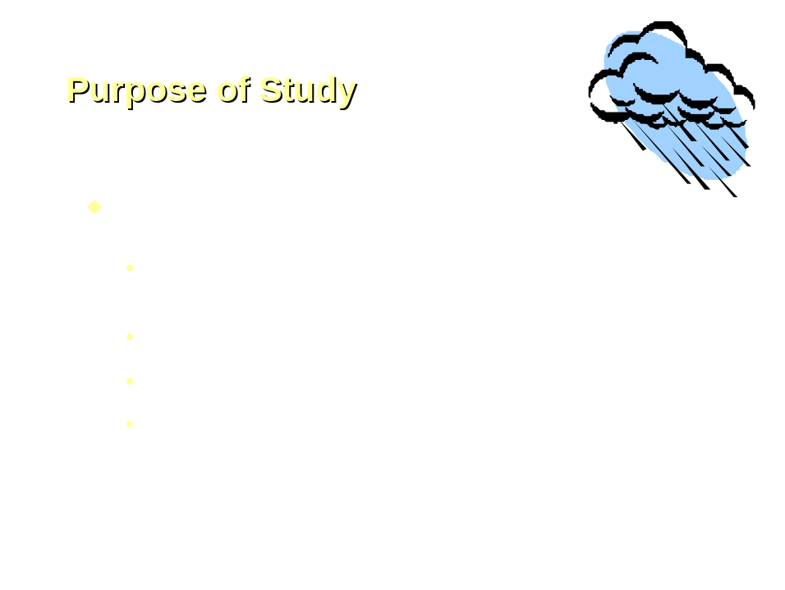

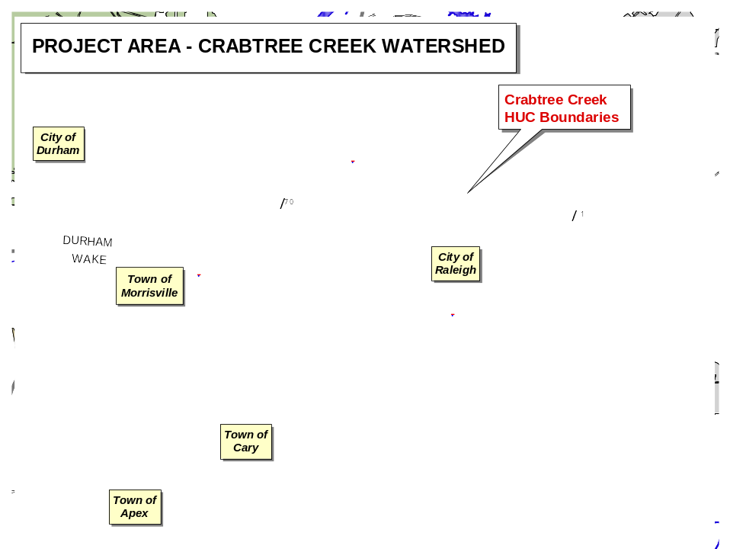

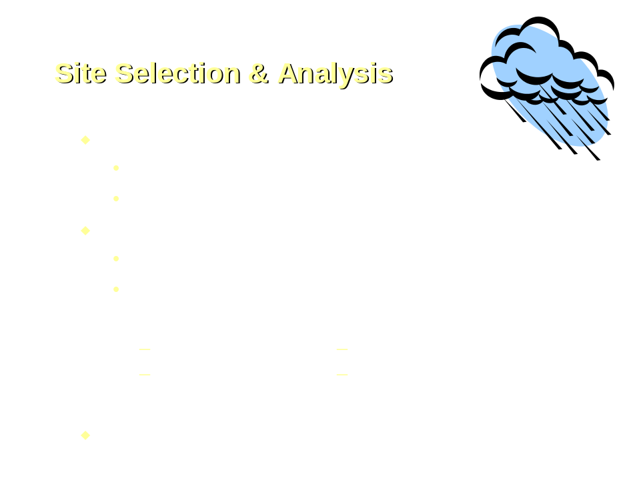

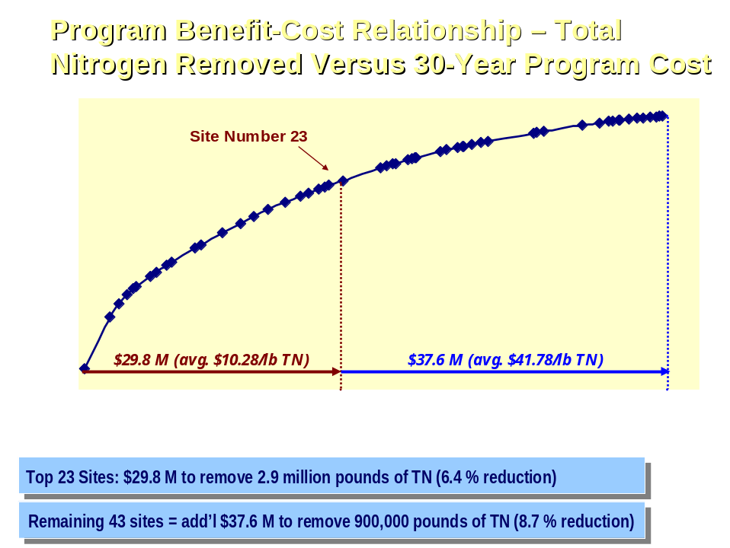

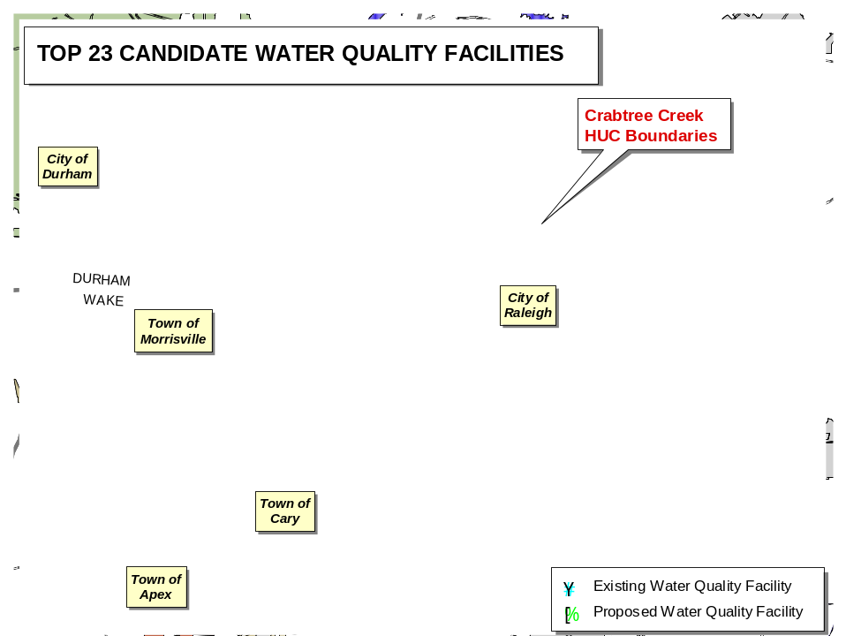

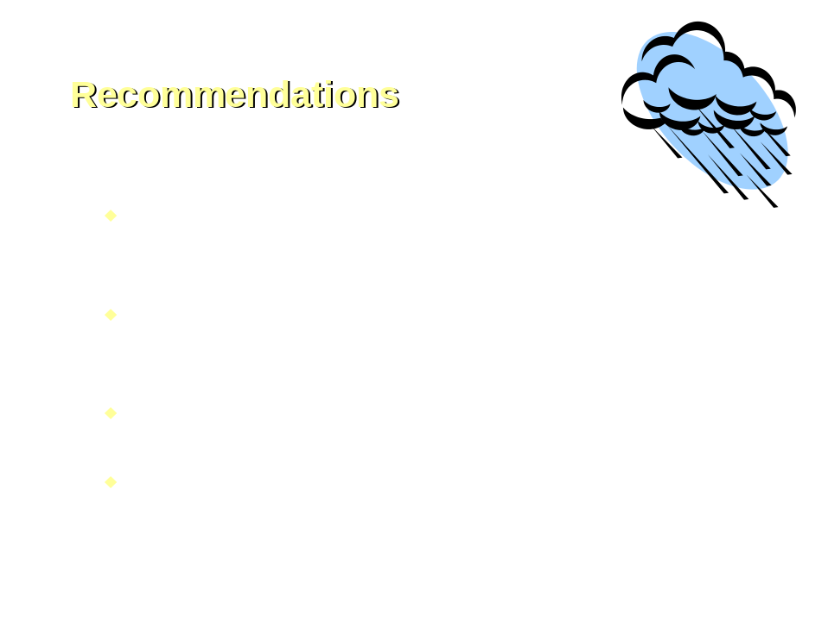

He briefly went over the material. Mayor Meeker questioned the funding and whether that would come from the Stormwater Utility Fee with the consultant indicating that is correct and spoke briefly about operation and maintenance over a 30-year period. Mayor Meeker moved the item be referred to the Stormwater Management Advisory Commission. His motion was seconded by Mr. Crowder and put to a vote which passed unanimously. The Mayor ruled the motion adopted.

CONVENTION CENTER BLOCK – UNDERGROUND PARKING STRUCTURE – INFORMATION RECEIVED TO BE PLACED ON NOVEMBER 2, 2004 AGENDA AS A SPECIAL ITEM; ADMINISTRATION AUTHORIZED TO NEGOTIATE CONTRACT WITH KIMLEY-HORN & ASSOCIATES TO BE BROUGHT BACK TO COUNCIL

City Council previously authorized the preparation of a feasibility analysis and schematic plan for the construction of an underground parking structure in the block currently occupied by the existing Convention Center. Kimley-Horn Associates has completed the feasibility analysis and schematic plan, which recommends pursuing the construction of a Phase 1 structure that would be built underneath the Headquarters Hotel and the Fayetteville Street corridor, contain approximately 980 parking spaces on four levels, and would also include elements of the hotel structural foundation and back-of-house space for the hotel on a cost-sharing arrangement with the hotel developer, at a cost of approximately $25,000 per space. This parking structure would be funded through the City’s Parking Fund. The Cultural/Convention District Plan has generated ideas for the Fayetteville Street corridor that need to be further refined and incorporated into the deck design. Approximately 640 additional spaces (total 1620 spaces) could be constructed in the second phase on the east side of the block in association with new development in this area. A Request of Qualifications was issued for a design consultant team to provide complete design and construction administration services for this underground parking structure, and other aspects of the demolition of the existing convention center and related streetscape improvements. Two firms attended a pre-submittal conference, held on September 29, 2004. One response was received from Kimley-Horn & Associates in partnership with Cooper-Carry and O’Brien Atkins Associates.

Recommendation: Authorize staff to negotiate a contract with Kimley-Horn Associates for the design of the parking structure, and other services as outlined in the RFQ, authorize staff to negotiate a parking agreement with Stormont-Noble Development that reflects this plan, and approve a preliminary financing plan for the parking structure.

The following memorandum was included in Council member’s agenda packet.

A feasibility study has been completed by Kimley-Horn Associates for an underground parking structure in the block occupied by the existing Convention Center. The study analyzes the possibility of constructing such a deck beneath the Fayetteville Street corridor, the new Headquarters Hotel and future development on the east side of the block. The conclusion of the study is that a parking deck is feasible to be constructed in two phases, the first to be beneath the proposed Marriott hotel and the Fayetteville Street corridor including approximately 980 spaces in 4 underground levels. The second phase, beneath a future building on the east side of the Fayetteville Street corridor between Fayetteville Street and Wilmington Street, can accommodate an additional 640 spaces for a total of approximately 1620 spaces.

Special design considerations included in the feasibility study.

- The structure of the deck can be designed to support the hotel. This was carefully considered and coordinated with the hotel developer’s design team in the preparation of the feasibility analysis. The additional cost necessary for the parking structure to accommodate the hotel building will be borne by the hotel developer, who had agreed in concept to this arrangement.
- Part of the hotel program can be designed into the deck. A large portion of the “back-of-house” space for the hotel has been planned to be located below grade. If the parking deck is constructed this space would be built into the parking structure, and its cost would be borne by the hotel developer. The hotel developer has agreed in concept to this arrangement.
- The deck has been conceived to support potential Fayetteville Street improvements above it. The feasibility study assumes that Fayetteville Street will be continued across the deck. Though this decision has not yet been made, the necessary structure to support the live loads anticipated from this have been built into the cost estimate.
- Vehicular entrances into and exits from this deck have been considered in respect to the Livable Streets principles. Efforts were made in the feasibility analysis to show how widths of vehicular entrances can be minimized at the sidewalk, and alternative locations were shown that will be considered in the design development phase relative to recommendations emerging from the Cultural / Convention District Strategic Development Plan, and the Fayetteville Street Urban Design Guidelines.
- The parking deck can be expanded to the east. The Phase 1 portion of the deck was designed to be expandable in Phase 2. Phase 2 can be constructed at any time when it appears a replacement development is feasible for the east side of the existing Convention Center. This schematic layout will allow the east side of the existing Convention Center to remain if a decision is made to retrofit and use it after the main portion of the existing Convention Center is demolished.
- The parking deck can be designed to be connected to the existing privately-owned parking deck to the north. The owner of the adjacent deck has responded positively to this idea in concept, which will allow for maximum flexibility for both the City and the property owner.

Why a parking deck in this location?

- The timing of construction of the Convention Center and Hotel provide an opportunity to maximize use of land. The new Convention Center and Headquarters Hotel will cause an extensive excavation project to take place on the new Convention Center site and will result in the demolition of the existing Convention Center. The incremental cost of excavation for an underground parking deck will be smaller if done at this point than at any point in the future, assuming such an excavation is even possible in the future.
- Existing parking in the immediate vicinity is being displaced by the Convention Center project. In excess of 400 existing surface parking spaces in the immediate vicinity of the Fayetteville Street corridor are being removed from service by the Convention Center construction and by the anticipated development proposals emerging from the Cultural / Convention District Strategic Development Plan.
- The City has an obligation to provide accessible parking for the hotel. The hotel development agreement creates an obligation for the City to provide 200 exclusive use spaces for the new hotel at ½ the market rental rate, and make available 200 others at market rate. This can be accommodated in existing City facilities on Lenoir Street and in the BTI Center parking deck and the Progress Energy parking deck, but if utilized in this way this reservation for hotel use will displace other users of these existing facilities at peak times.
- New Convention Center demand is unmet at this point. Demand for parking related to the operations of the new Convention Center, particularly at peak times and when in conflict with events at the BTI Center, will likely exceed the available supply.
- Development of City properties adjacent to this site is anticipated in the near future. New major developments that will be emerging from the Cultural / Convention District Strategic Development Plan are targeted to take place on the east side of Fayetteville Street in this block, on two sites between the BTI Center and this site, and on a site just east of the existing BTI Center deck, diagonally across Salisbury Street from this site. Convenient parking to support these developments will be critical to their economic success.
- Building a parking structure under the hotel reduces the cost of construction of the Convention Center. If built as originally designed, construction of the Convention Center would require a substantial underground retaining wall adjacent to the hotel site. If a parking deck is not constructed in this area under the hotel, the need for this retaining wall creates a significant additional cost (approx. $700,000) for the Convention Center.
- Direct connection of parking to Hotel and Convention Center is possible. This location will make possible the direct connection of parking to the Hotel and Convention Center. This need must be tempered with the desire to encourage pedestrians to use the Livable Streets above as their primary route around this end of downtown Raleigh, but is nevertheless an important marketing tool for both facilities. Attachment 1

Why build parking underground?

- Placing parking underground supports the Livable Streets concept. Above-ground parking structures reduce the buildable area of constricted downtown sites by absorbing part of the valuable above-ground square footage, and generally result in street level facades that are difficult to integrate into a pedestrian-friendly environment. Underground parking allows this resource to be convenient without creating “dead-zones” in the streetscape above.
- Underground parking maximizes the value of land. By placing parking underground, the air rights to develop above are retained, thus maximizing the potential value of public property.
- This location is uniquely situated, and cannot accommodate above-ground parking. Above-ground parking cannot be constructed on this site because of the hotel and Fayetteville Street corridor. This site is the only location that is immediately abutting 4 key publicly-owned development sites, the new Hotel and the Convention Center.

Trade-offs to be considered.

- Underground parking is expensive. The cost of this parking deck is substantially greater than an above-ground deck. Construction complexity, excavation and soil removal, groundwater management, etc. drive up the per-space cost of underground parking when compared with above-ground options.
- Ownership and operational issues become more complex. Because the proposed deck is underneath private developments as well as the Fayetteville Street corridor, complex condominium relationships and management practices may need to be worked through.
- The construction of a parking deck may result in the earlier closing of the existing Convention Center. The development of an underground deck in this location must be timed to ensure that it can be designed, permitted and constructed by the date upon which the hotel facility construction must begin above it. Potentially, this can result in a need to demolish the existing Convention Center at an earlier date than previously planned.

Financing.

- The proposed parking structure can be financed through the City’s Parking Fund, where a combination of cash, and debt which is supported by the revenues of the facility can be used to support the construction costs. A careful analysis will be done prior to issuance of the debt to ensure a proper proportion of taxable and non-taxable debt to allow a portion of the deck to be reserved to support private developments on the adjacent sites. This underground structure is more expensive per parking space than a typical above-ground parking structure, and as such the revenues necessary to support the debt are substantial and will require effective management of the facility after opening (see attached financing plan).

Timeline and actions necessary to move ahead.

- May 2006 - Transfer of “buildable pad” to hotel developer must take place in order for developer to meet requirement to complete hotel and open in conjunction with new Convention Center. The parking deck must be substantially complete - (18 months construction time for hotel)
- September 2005 - Construction of parking deck must begin in order to transfer to hotel developer in May 2006 - (9 months construction time for parking deck)
- July, 2005 - Demolition of existing convention center must begin in order to allow construction to begin on parking structure – (2 months demolition time for existing convention center)
- November 2004 - Design of the parking structure must begin in order to complete design development, construction documents and obtain approvals and permits prior to September 2005 – (10 months design and approval time for parking structure)

Design services.

- Two firms attended a pre-qualifications conference. One chose not to submit qualifications because of the availability of key staff to work within the proposed time frame.
- One firm submitted qualifications in response to the City’s Request for Qualifications. This firm is led by the local office of Kimley-Horn Associates, who prepared the feasibility analysis. They have partnered with Cooper-Carry from Atlanta, who are the architects for the Headquarters Hotel and a design partner in the Livable Streets and Fayetteville Street Renaissance projects, and O’Brien Atkins Associates, who are part of the architectural team for the new Convention Center.
- The partnership of these key players in the design process for the hotel, convention center, Fayetteville Street and parking structure will help ensure that the complex coordination issues inherent in this process are properly addressed. The team has substantial experience in the design and construction of parking decks in various cities, including our own. The City has extensive experience with these firms, who have performed admirably on other City projects.

Recommendation.

Because of the unique opportunity afforded by the demolition of the existing convention center and the excavation for the new convention center, the key location of this property, the need to maximize the value of these publicly-owned tracts, the economic development benefits of parking supply in this key location, the cost savings for the Convention Center project and the substantial build-up of parking demand in the vicinity, it is recommended that the Council:

- Authorize City staff to begin negotiations with the team of Kimley-Horn Associates, Cooper-Carry and O’Brien Atkins Associates for design services on the parking deck. The contract will be brought back to Council for approval. Funds to cover the initial phase of the design can be taken from the existing cash reserve in the Parking Fund;
- Authorize City staff to pursue a parking agreement with Stormont-Noble Development that will allow the City-provided parking for the hotel that was agreed to in the development agreement to be provided in this proposed parking structure, and will allow back-of-house space, service circulation and structural elements for the hotel to be built into the parking structure with the costs of the hotel-related improvements to be paid for by the hotel developer;
- Approve the preliminary financing plan for the parking structure. The financing plan for this project is attached. A more detailed financing plan will be brought back to the Council for approval after more defined cost estimates are available, and the proper proportion of public-use and private-use spaces is determined.

Related Actions.

Several other issues are being considered in the Cultural / Convention District Strategic Development Plan related to this parking structure concept. City Council will be receiving recommendations resulting from the plan in the upcoming weeks regarding:

- The development of a broader overall parking strategy update for downtown, including the Warehouse District and TTA station areas, the State Government Complex and Glenwood South area in addition to the downtown core;
- A specific mix of land uses to be targeted for development on the 6 city-owned tracts included in the scope of the plan;
- A recommendation on the future of the 1996 addition to the existing convention center, on the east side of the block;
- A schematic concept and a process for design of the Fayetteville Street corridor from the terminus of the Fayetteville Street Renaissance Phase 1 project southward.

Using a powerpoint presentation, City Manager Allen went over the information.

Mayor Meeker questioned the revenue picture and whether it would be similar to current parking deck revenue or if it would be higher or what. City Manager Allen pointed out they had run several different scenarios. He stated it would be a challenge financially and is not a homerun to pay for itself. He explained the City’s Parking Management Fund is designed to handle shortfalls in the early years. He stated there are a lot of techniques that could be used and talked about decisions which need to be made prior to being able to determine the exact revenue picture. Mayor Meeker questioned when a financing plan would be available with City Manager Allen pointing out we need to have more decisions made before a definitive projection could be given. He stated Parking Management and Administration is still working on different scenarios. He stated we do know there would be certain costs associated with the deck that we would net out to the hotel developer. The $25 million mentioned is a round number and would need to be refined.

Mr. Crowder pointed out as he read the information in the agenda packet he had questions about benefits and cost sharing with the hotel such as what is a prorata share of the hotel foundation that would be covered in the parking pad and the benefit to them if the City provided a finished parking pad for their hotel. He stated in addition in reading the information it looks as if assumptions that the South End Plans have been approved. He stated it is being studied but it has not been approved and talked about the correlation of the South End Plan, convention center, hotel and the parking deck. He questioned how an underground deck would impact the streetscape plan along Fayetteville Street. He stated he is wondering if the tail is wagging the dog rather than vice versa. He questioned how all this will be coordinated and when decisions would be made. City Manager Allen pointed out if we could get the contract negotiated and work underway for design of a structure and the other services we could get the big picture, the Council could be providing feedback and making the decisions such as whether the street will be extended, how we can preserve the streetscape, etc. He stated he felt it would be timely to go through this design effort and find out information that would help the Council make decisions.

Mr. Crowder questioned if the parking deck being discussed is being exposed to go under the Civic Center and asked about decisions on demolishing the existing Center. City Manager Allen talked about the phases and decisions which need to be made relative to the existing Civic Center. Mr. Crowder pointed out we received a very small response to the RFP and questioned if it was readvertised. City Manager Allen stated it was not re-advertised. The City is not required to readvertise. He stated he was not surprised at the small response pointing out it is a very complicated arrangement and proposal. In addition to designing a parking deck the consultant would be coordinating with hotel developers, convention center developers, Fayetteville Street work, etc. He stated this team has a vast knowledge and data of all of the on-going work and it is felt they could provide the service in an expedited way and it would be efficient to use this team. In response to questioning from Mr. Crowder, Assistant City Manager Howe pointed out the request for proposals was out for two weeks.

Mr. Regan stated as he understands a lot of what is driving the need for this new parking deck is the new hotel and the Convention Center. City Manager Allen pointed out that and what is happening in the south end or is proposed to happen in the south end. As it relates to financing, City Manager Allen pointed out we set up our parking management funds so that we could support parking deck operation and maintenance from the revenue. Mr. Regan questioned if we do not have the revenue generated as anticipated how the funds would be paid back with City Manager Allen pointing out if the parking revenue funds are not available to pay for the deck the general fund would subsidize the parking management fund.

Mr. Regan pointed out he is afraid of this whole project and asked permission to read two paragraphs from an article by Steven Malanga which appeared in the Spring 2004 issue of the City Journal. He read the information as follows:

Although Boston’s gleaming new $800 million convention center is set to open in a few months, so far it has booked only a handful of conventions. So dire is the facility’s outlook that it will need a $12–15 million annual public subsidy in its first few years of operation and may not reach its full booking potential for a decade, say Boston officials. Even that may be too optimistic, judging by what’s going on in Baltimore. There, a vastly expanded convention center that reopened in 1997 is finding it so hard to lure business that city officials are now searching for ways to make the facility more attractive, including spending millions in public money to build a subsidized hotel next door.

What is happening in Boston and Baltimore is not an anomaly but merely the latest chapter in what is turning out to be one of America’s biggest civic boondoggles. For more than a decade now, cities and counties have been rushing, at enormous public cost, to build new convention centers or add space to old ones, including a $191 million expansion of San Francisco’s Moscone Center, a $291 million new facility in Omaha, and a $354 million center in Pittsburgh. The increase in space has vastly outpaced the growth of the convention industry and often failed to generate the kind of economic activity predicted by boosters. Rather than energizing local economies, in fact, some convention centers are emerging as a drag on civic finances, requiring taxpayer operating subsidies on top of their huge, publicly financed construction costs. What’s more, the situation is only likely to get worse. Another eight to ten million square feet of exhibition space is scheduled to come on line within five years, an increase of about 15 percent in an industry where demand is barely growing.

Mr. Regan questioned if the Raleigh City Council feels it is smarter than those in Boston and Baltimore. He pointed out Boston and Baltimore both have harbors, water, etc., all sorts of attractions and their convention centers cannot make a go of it questioning what makes Raleigh think that ours will be different. He stated this whole project just bothers him and concerns him and he does not want to be a part of it and if this building ever gets built he would ask the Council to please leave this name off of the plaque as the City Council which authorized it.

Mr. West questioned if we have a proposed time line for making this decision. City Manager Allen pointed out at this point he is asking authorization to negotiate an agreement for the design firm and he would hope to bring that back to the Council by the second meeting in November.

Ms. Taliaferro talked about the cost and financing plan and how much the City paid per space for the Progress Energy Deck. She questioned if we have information on a proposed breakeven point on this proposed deck and the Progress Energy Deck. She pointed out she understands why an underground deck would be more expensive and she would be interested in hearing about projected breakeven dates and the financing plan. City Manager Allen pointed out staff would look at different assumptions and scenarios, cost, private use, etc. He stated we would have different scenarios on breakeven depending on how the financing is structured. He stated staff would continue looking at that question and would probably bring back a series or scenarios and/or recommendations. Ms. Taliaferro stated she would like to have that information. She stated here we are talking about another possible $25 million in public investment in the Convention Center and that concerns her. City Manager Allen pointed out we are talking about a $25 million investment in economic development for the downtown area. Ms. Taliaferro asked about the annual debt payment for another $25 million pointing out that is the number we would have to cover from general fund if there is a shortfall in revenue from the parking deck. City Manager Allen pointed out staff has that information and could show the Council how that would play out on year-by-year forecast and any possible general funds that may be needed if the revenues are not there. He pointed out we try to structure our parking management fund so that parking funds would cover the debt service and payment in the early years. He stated there are various models that they will be looking at and would bring information to the Council. Chief Financial Officer Perry James pointed out annual debt for $25 million would be just under $2 million per year based on current scenarios. The first source of revenue for that payback would be from the parking revenues, then the parking funds, then general fund if needed. He stated there maybe a difference of about ½ million in year one and that would decrease over time. He stated the debt could be covered by the current situation if that continues.

Ms. Taliaferro pointed out the City had an extremely tight budget year but were able to increase police but we had to increase taxes and fees for parking. She stated she thought those increases were to cover the current cost and she is concerned about another drain on the general fund. She stated the City receives approximately $1 million from the interlocal funds and she would suggest utilizing that money to offset this type project as those funds do not come from the taxpayers. She stated she had been told that demolition of the entire existing civic center at one time would be cheaper and she would like information on that. Ms. Taliaferro stated Administration has been talking about a parking plan for downtown and has an on-going study and questioned if we would need to continue with that effort if we go forth with this effort. She questioned if we are being premature in selecting another parking consultant when we have an on-going study. City Manager Allen stated he does not feel this is premature given what is going on in the southern end and what is proposed. Ms. Taliaferro again questioned if we would still need to have that parking plan pointing out it seems that a lot of stuff is coming towards the Council for decisions and there has not been a lot of forethought or in-depth planning. City Manager Allen defended the proposal and talked about decisions that need to be made for the Convention Center and hotel and on-going projects to move forward. He stated he feels this is the right way to go; however, he does realize there are some questions. He stated he feels all of these things will come together. We do have some good preliminary cost figures, good numbers on the Convention Center and hotel development and he feels the issues have been carefully thought through. He stated the Council did increase the parking management fee and that was to help keep the parking management fund healthy so we could make these decisions about decks, deck maintenance, etc. He stated the City’s rates need to be competitive so we are not dragging down the parking rates.

Mayor Meeker questioned if it is correct that there would be a cost savings to demolish the entire existing Convention Center at once rather than in phases. City Manager Allen pointed out that is correct. It is pretty clear that if we take the whole structure down at once it will be cheaper. Mr. Crowder stated that means that we would have someone interested in developing that property and that would have to be coordinated with all the other activities ongoing. He stated he understands the economics and the concept of going underground with the parking when you look at the big picture. He stated he is satisfied with that aspect. He stated he needs to see a strategy of how this all works together, how it pans out, what is proposed for the south end pointing out the plan is being addressed but it hasn’t been approved. He feels we need to see some coordinated efforts and how it will work. Mayor Meeker expressed appreciation to staff for looking at the underground parking proposal. He stated there is no question that underground parking is the way to go as that would provide an opportunity to use the real estate twice. He stated he understands underground parking costs more but he feels we should move forward, take a careful look at the design, how it coordinates with the hotel and convention center development, etc.

Mr. Crowder stated he knows there is some comfort level in dealing with partners that are already on board and working on various aspects in this area; however, it concerns him that we had such a narrow response for design of the underground parking structure and he feels it would be advisable to readvertise. He stated Kimley-Horn is a good firm. We have an excellent working relationship with them but as a policy, as the State does, he feels we should readvertise and he would make the recommendation that we do go to re-advertisement while we debate this issue further.

City Manager Allen pointed out the hotel developer is very concerned about what team we put together as it relates to the underground parking. He stated they do have a working relationship with Kimley-Horn and would feel comfortable with the recommendation he is making. He pointed out the City standard procedure doesn’t call for readvertising and again pointing out timing is very important. He stated it is also very important to the hotel developer that we have a very qualified team and he feels the team that is being put together knows more about all aspects of the various projects than any other team available. He would strongly urge the Council to move forward with allowing the recommendation as outlined.

Mr. Hunt pointed out he would like to see some information on the cost of building the parking above the ground maybe a block away. The information should be cost per space and we should include land acquisition, etc. He feels it is incumbent upon the Council to explore all bases. He stated he knows it would be more convenient to have the parking underground as proposed but he feels we should look at all options. He stated he would also need information on the hotel developer participation in the cost if we went underground, what credit the City would get for providing the foundation or pad, would there be credits to the City and how. He questioned what the savings would be to the hotel to not have to build the foundation. City Manager Allen pointed out the hotel developers would have to pay for the foundation and if we give them a building pad that would have to be taken into consideration. We would have to look at what it would cost to build the hotel without being furnished the foundation or pad versus the hotel having to do that. Mr. Crowder stated he needs a little more information on how that works. He stated we must have someone on the City’s side fighting for the City’s interests. He stated he feels we are talking about a fine line and he feels in the negotiations we have to have someone who is advocating or fighting for the City. City Manager Allen pointed out that would be Administration’s role that is to fight to make sure the City gets treated fairly and holds its position.

Ms. Taliaferro pointed out there seems to be a lot of questions and Council members have asked for a lot of information; therefore, she would suggest that this be held until the next meeting. Mayor Meeker stated he had no problem with holding the item until the next meeting but he wants to make sure all of the questions are on the table. He stated there are probably 15 to 20 more important decisions the Council would have to make relative to the on-going efforts in the downtown area and if we wait two weeks on each that would add a year to the projects. He stated he is not saying it is wrong to wait but just wanted to throw out that caution.

Ms. Taliaferro asked that staff provide the Council with a list of items or decisions that the Council will need to address in the future as it relates to the hotel/convention center/Fayetteville Street/south end and that the list include a timeline for making those decisions. She stated it concerns her as the first time she had heard about the underground parking was last Thursday and here the Council is being asked to make another $25 million decision. City Manager Allen pointed out the City Council had approved the feasibility study for underground parking with Ms. Taliaferro pointing out she understood that but what is being proposed today goes way beyond a feasibility study. Mayor Meeker stated it would be nice to know everything in advance but there is no way to predict all of the decisions and timelines. It is an evolving process. The size of this proposed deck has increased and is evolving over time. He stated the item would be held until the next meeting and if Council members have questions to get them to the City Manager by Friday of this week.

City Manager Allen questioned if the Council would authorize him to negotiate a contract with Kimley-Horn & Associates as outlined that is negotiate a scope of service. Ms. Taliaferro questioned how much that would cost with City Manager Allen pointing out it would not cost anything for the negotiations. Mr. Hunt stated he feels it would be fine for Administration to be authorized to negotiate a scope of services and for the design as was outlined but that Administration should not be authorized to sign any agreements. Mr. Crowder moved that the Council authorize readvertising for the design services. His motion did not receive a second. Mr. Hunt moved that Administration be authorized to negotiate the contract with Kimley-Horn as outlined in the recommendation but not to sign any contracts and bring the negotiated contract back to Council for consideration. His motion was seconded by Mr. Crowder and put to a vote which resulted in Mr. Regan and Mr. Crowder voting in the negative. The Mayor ruled the motion adopted.

REQUESTS AND PETITIONS OF CITIZENS

REZONING APPLICATION – DUKE REALITY/SMITH ESTATE MASTER PLAN – WAIVER OF DEADLINE – APPROVED

Attorney R. James Cox, Jr., representing Duke Realty/Smith Estate Master Plan, was at the meeting to request Council to grant a waiver in the filing deadline in order for him to submit a rezoning application for approximately 15 acres located on Sugarbush Road in the vicinity of Crabtree Valley Mall in order for the case to be heard at the November 16 public hearing. He briefly explained the history on this issue which relates to a City Council determination that the previous petition was invalid based on the finding that the property owner lacked authority to petition the City for a change in the property’s zoning. He told of the work with the City through the courts, etc., to get this issue resolved. In response to questioning, Planning Director Chapman pointed out there is time to get the legal requirements met if the Council wants to grant the waiver of the filing deadline. Mayor Meeker moved granting a waiver of the deadline for filing a rezoning case on this property in order for it to be heard November 16. His motion was seconded by Ms. Taliaferro and a roll call vote resulted in all members voting in the affirmative. The Mayor ruled the motion adopted.

GREENWAY EASEMENT – HOPE COMMUNITY CHURCH AND GRACE CHRISTIAN SCHOOL – NO ACTION TAKEN

David Martin, Pastor Mike Lee and Pastor Ellis, Hope Community Church had requested permission to discuss greenway easement across properties of Hope Community Church and Grace Christian School on Buck Jones Road. Bob Dascombe pointed out they have had second thoughts on this issue and would like an opportunity to interface with the Parks Department more. He stated they may come back to the Council after further discussion but at this time would like to withdraw their request from the agenda. Mr. Dascombe indicated David Martin who could not be at the meeting wanted to publicly commend the City Clerk and talked about who her being a “Great City Official.”

ENCROACHMENT – BANNER OVER PERSON STREET DURING 33RD ANNUAL CANDLELIGHT TOUR OF HOMES – APPROVED

Darla Brown, Society for Preservation for Historic Oakwood, has requested permission to hang a banner over Person Street between Oakwood and Boundary Streets to advertise the 33rd Annual Candlelight Tour of Homes. They wish to have the banner displayed between mid November and December 12. City Manager Allen pointed out this is an annual request and staff has no problem. Mr. West moved approval. His motion was seconded by Ms. Taliaferro and a roll call vote resulted in all members voting in the affirmative. The Mayor ruled the motion adopted.

STORM DRAINAGE PROJECT – 5417 SEAFARER COURT – APPROVED FOR REIMBURSEMENT

James Ploscyca, 5417 Seafarer Court, spoke about a 24-inch storm drainage pipe in his back yard which is causing sink holes and erosion problems. He pointed out he has five sink holes on his property. It is a very dangerous situation. He has put guard rails around the sink holes and plywood over the sink holes. He told of his meeting with John Hollis and the fact that it has been determined that this problem could be addressed through the City’s storm drainage policy with cost sharing funding. City staff has estimated that the repairs to the storm drain line would cost approximately $5,000 with 80 percent of the cost being paid by the City and 20 percent by the private property owner. This is a cost estimate for replacement of one junction box and repair of the other. He stated he understands the approval process takes place only twice a year. Mr. Ploscyca stated he would be glad to go ahead and pay for the repairs with the understanding he could be reimbursed through the next approval process. City Manager Allen pointed out this project could be expedited as a reimbursement project whereby the owner would be responsible for retaining a contractor to perform the repairs with Stormwater Management staff observing the work to ensure that the repairs are made satisfactory and in accordance with City requirements and this could be handled as a reimbursement project rather then waiting until February 2005 to go through the City’s drainage petition process. Mayor Meeker moved approval of the reimbursement as outlined. His motion was seconded by Ms. Cowell and a roll call vote resulted in all members voting in the affirmative. The Mayor ruled the motion adopted.

CLAIMS – FIREWOOD AND WATER BILL AS IT RELATES TO TRASH – NO ACTION TAKEN

Warren Muhammad, 1103 Garner Road, pointed out he has been to the Council with these situations before but nothing has been resolved. He alleged that firewood was stolen from his property by City workers and he is being charged for trash pickup he does not use. He stated he was told to meet with the City Attorney which he did and the City Attorney investigated but no action was taken. He stated the firewood was on his property and is what he uses to heat which lowers his energy cost. He talked about water and sewer bills that have not been resolved. He stated he is getting billed for trash pickup that he does not use. The trash people do not pickup his trash. He takes it away himself but he still gets billed on his water and sewer bill. He stated he does not understand why he has to pay for services he does not use. He stated in addition there has been no resolution to the fact that a police officer arrested him improperly but the City stands behind the police officer. Citizen’s rights and privileges are being abused.

City Attorney McCormick pointed out he did meet with Mr. Muhammad and he talked with our Housing and Environmental Inspections Division. He stated as he understands there was a tremendous amount of wood on the property but it was not all chopped into firewood. It was just a lot of wood and they removed what was not cut into firewood. He stated as far as the trash pickup is concerned, everyone has to pay for trash pickup whether they use it or not and he told Mr. Muhammad the only way that could be changed is for the City Council to change the ordinance. He stated Mr. Muhammad is concerned about being billed for a service that he doesn’t need or want.

Mr. Muhammad pointed out he is being charged for trash pickup and he doesn’t feel that is right. He stated it is like stealing as far as he is concerned. He stated he was using the firewood he just had not had time to cut it all up. He talked about complaints about his property.

Mr. Regan stated as he understands our current laws require that people pay for garbage pickup whether they use the garbage pickup service or not with City Attorney McCormick pointing out that is correct. Mr. Regan stated he would support looking at a volunteer trash pickup program. He trusts people to take care of their own garbage. He feels that we could look at an ordinance that would allow people to have private pickup and not be charged and asked that the matter be considered in Public Works Committee. There was no second and no action was taken on Mr. Muhammad’s concerns.

UNFIT BUILDING – 822 EAST MARTIN STREET – NO ACTION TAKEN

Wanda Shade had requested permission to address the Council relative to reconsidering action relative to the ordinance requiring demolition of the building at 822 East Martin Street. Ms. Shade was not at the meeting; therefore, no action was taken.

NUISANCES – 10 ENTERPRISE STREET – NO ACTION TAKEN

Amanda Donnelly was at the meeting to discuss problems with apartments at 10 Enterprise Street. She stated her current mailing address is Box 944, Fuquay. She stated in January of 2003 she rented Apartment E at 10 Enterprise Street. She talked about this apartment was for her son who is manager of the football team at NCSU and rides his scooter. She stated the landlord promised to fix the ceiling and other problems in the apartment. He put a sump pump in the living room. She stated she was there seven months and had nothing but problems. She had some personal problems also. She talked about water coming into the apartment and black mold growing on all of her possessions, the walls, etc. She pointed out two City inspectors came by and expressed amazement and found over 100 violations in the apartment. Everything she owns has been destroyed and is still in the apartment but she and her son had to move out with nothing but the clothes on their back. She read letters from the Inspections Department pointing out the apartment she was in was not a habitable space. She talked about the condition of the foundation and the mold in the apartment and how it could impact the rest of the building making it a sick building. She stated the landlord was supposed to make the repairs over a year ago and fix the foundation but nothing has occurred. She stated it will cost her $15,000 to $20,000 to get her stuff out of the apartment and get it cleaned, renovated, etc. She talked about the foundation in the boiler room and the fact that her stuff is still there. She stated she has a lawyer and a lawsuit has been filed. She understands the property owner cannot rent out the apartment. She stated, however, one of her concerns is that it is a sick building and talked about other people in the apartment who have become sick.

Inspections Director Ellis pointed out they have looked at the situation and had determined there were eight apartments in the building and there was supposed to be seven; therefore, they terminated the ability to rent the eighth apartment. It is not a habitable space.

Lengthy dialogue followed with Inspections Director Ellis explaining the situation and that basically the basement is not to be occupied and Ms. Donnelly talking about the apartment being rented out for years. She explained in detail the concerns, water problems, the feeling the Inspections Department is not understanding the concern, what the Inspections Department had ordered, location of sump pumps, what the basement is being used for, the actions of the Inspections Department and the problems Ms. Donnelly had gone through. A friend of Ms. Donnelly spoke at length about the condition of the apartment, how Ms. Donnelly had to be evacuated, the condition of the apartment, the fact that they did not know the apartment had ever flooded previously and the feeling that it is a sick building and the other people could be adversely impacted if the City doesn’t require repairs and/or improvements. No action was taken.

TOWING – COMMENTS RECEIVED

Pam Hopkins, 1120 Longstone, Raleigh, North Carolina 27614, stated predatory towing should not be condoned and she feels it is the Council’s responsibility to make changes. She stated if the Council wants people to come downtown they have to make some changes. Predatory towing will keep people in the suburbs. She explained a situation which occurred to her on Hillsborough Street several weeks ago at 10:30 a.m. when she stopped to purchase bagels. She presented a photo of the sign at the parking lot where she parked. She stated she was in the bagel store for only four minutes and when she came out her car had been towed. Someone had been watching and when she parked they came in and towed her car. She stated this type predatory towing should not be condoned. She stated it is basically like having her car stolen. She explained problems in getting her car pointing out the tow company demanded cash only. She questioned the cash only basis of the business and questioned if that money is being properly reported. She stated her tax dollars are going to help revitalize downtown but if the predatory towing continues people will not be coming to downtown. She stated maybe she misread the sign but anytime your car is towed away within four minutes she feels it is predatory towing. She talked about the practice, misleading sign, the fact that the towers have unmarked cars and trucks and just her total anguish during the situation. She stated someone was just waiting for her to park and then took her car. She was abandoned. She expressed concern about what could happen and what could happen to other people. Mr. Regan questioned if Ms. Hopkins knew she was parking in a space reserved for the pizza business when she visited the lot. Various Council members expressed appreciation to Ms. Hopkins for coming down and explaining her story with Ms. Hopkins pointing out the absence of action on the part of the City Council is not good. She talked about the negative impact this predatory towing will have on people coming to the downtown area.

ENCROACHMENT – BANNER RELATING TO GLENWOOD/BROOKLYN NEIGHBORHOOD ASSOCIATION HISTORIC TOUR OF HOMES – APPROVED

Attorney Benjamin R. Kuhn, 1223 Pierce Street, was at the meeting requesting permission for temporary banner sign for the annual historic Glenwood/Brooklyn Neighborhood Association’s Historic Tour of Homes. Council members had received in their agenda packet information which indicates they want to hang a temporary banner sign on the Peace Street façade of the building located at 700 Glenwood Avenue for the purpose of promoting the event. They would like the banner to remain in place during the week of November 28 through December 4. The information indicated the banner is approximately 20 feet long and 5 feet in height. Council members had received information showing the location, design, etc. Attorney Kuhn pointed out their association doesn’t have the 33-year history Oakwood has but they hope for this event to become similar to the Oakwood Tour. He stated their request is a little bit different from the Oakwood in that their sign is on a building. City Manager Allen pointed out Administration has no objection. Mr. Crowder moved approval of the request as presented. His motion was seconded by Mr. West and put to a vote which passed unanimously. The Mayor ruled the motion adopted.

CHURCHES – RELATIONSHIP WITH THE COMMUNITIES – REFERRED TO ADMINISTRATION

Philip Poe, Co-chair of the Five Points CAC, talked about a recent plan in which church property was carved out of an overlay request. He stated he does not feel that is a big issue but churches in neighborhoods have produced issues for some time. He stated we used to have neighborhood churches and neighborhood schools; however, many have become destination churches and destination schools. The areas have changed. Populations have changed. People move from one area of the City to another area but want to keep their membership or attend churches in areas from which they moved. He talked about some of the problems such as huge demand for parking spaces and activities carried on by churches such as schools, feeding the homeless and various programs. He stated in some respects churches are becoming somewhat competitive in trying to get and keep membership. He stated there also seems to be a renewed interest in churches. He stated he feels it would be good to look at some of the issues and hopefully avoid problems. It may be time for us to step back and revisit where churches can locate, etc. He stated maybe we could try to anticipate some of the issues and avoid problems in the future. He stated the representative of the church whose property was carved out of the small area plan has indicated they would be happy to work with the neighborhood to make sure concerns are addressed.

Mayor Meeker questioned who should look at this issue with Mr. Poe pointing out maybe the City Council could setup a committee. We might utilize the CAC but we need to get a good cross representation. Ms. Taliaferro stated it would be good to ask the Planning Commission to review all of the issues. She talked about the issues of churches in watersheds. She stated it is not simply an urban issue, it is a suburban issue, issue of churches in watersheds, etc. She stated the Planning Commission would be a good place to start the discussion as it relates to issues of churches, mega churches, new services offered by churches, etc., and how all of that fits into the fabric of the neighborhood. How we can integrate churches into the neighborhood. Mr. Crowder suggested the issue should be referred to staff and get some communication or direction as to how to go. He stated we should get a broad based representation including clergy, etc. He stated whatever procedure is used we should make sure to include Mr. Poe to help look at the various issues. After brief discussion it was agreed to refer the issue to staff and rather than giving them a time limit as to when to come back with the report that staff work with Mr. Poe or whoever to come back with a well thought out plan or recommendation. Mr. Crowder stated he would like to see something before Christmas. Without further discussion the item was referred to Administration to work with Mr. Poe and come back with some recommended course of action as to how to address the issues.

MATERS SCHEDULED FOR PUBLIC HEARING

TOWING – PROPOSED ORDINANCE – SPECIAL WORK SESSION – TO BE SCHEDULED

This was a hearing to receive public input on a proposed ordinance relative to nonconsensual towing. The Mayor opened the hearing.

Dave Permar, 327 Hillsborough Street, stated he was representing himself and one towing company. Mr. Permar stated there are more then 40,000 parking spaces in the downtown area, there are 27,000 plus people who work in the downtown 5 days a week and some 2,000 people who live in downtown Raleigh. Virtually all of these have automobiles and they own, lease or have access or control of a parking space. He called on the Council to think about the impact this ordinance is likely to have on all of those people. He stated everyone at some time will need a towing company whether it be to tow their own vehicle or a need to tow someone else’s vehicle out of their space that is to have someone’s car removed. He pointed out the City needs towing companies. The City has a rotation contract with approximately 10 companies. He pointed out those companies pick up abandoned, wrecked, etc., cars. The City sets a fee that the towing company can charge on those contract tows. He stated in most of the cases relating to abandoned or nuisance vehicles the towing company picks up the car, takes it to their facility and it sits there for months. They’ve got to store the vehicle a certain length of time knowing they will not get any pay for their tow or storage; therefore, we have transferred this public expense to the towing company. Towing companies however are willing to bear that expense in order to be on the rotation towing contract.

Mr. Permar stated as a property owner he needs a towing company. Everyone who controls parking spaces has a use for a towing company. He stated if this ordinance is not drafted carefully, fair and reasonable, everyone will probably have a problem with the ordinance. He stated at least twice in the past he has suggested that the City adopt this type ordinance and he is still in support of that; however, the ordinance before the Council needs a lot of work. It has a lot of problems. He called on the Council to think of what could happen under this ordinance. He stated he had suggested to the Council that the Downtown Raleigh Alliance do some research and they provided the Council with some information and after 15 to minutes of discussion the Mayor directed the City Attorney to draft an ordinance similar to the one in Atlanta. He stated there was no input from the Police Department or towing companies. Mr. Permar stated Raleigh is not Atlanta and Atlanta’s ordinance will not work for Raleigh. The ordinance has some good and some bad features. He pointed out all towing companies have fixed costs including office, storage facility, trucks, etc., but their revenues vary based on the number of tows they make. He stated there are a number of issues in the proposed ordinance he doesn’t understand such as there is no definition of nonconsensual towing. We don’t know what nonconsensual towing includes. Does it include towing from the right-of-way? Does it include the towing of abandoned vehicles, vehicles in private parking lots, etc. He stated we somehow need to mil this into the current use. He stated he believes towing under the City contract could be considered nonconsensual towing. Will this ordinance apply to the towing companies under contract with the City and the tows they make under that contract. He stated the ordinance has no requirement for the towing companies to accept checks or credit cards and he feels that should be in the ordinance. There is no enforcement mechanism in the ordinance. He stated if the ordinance is going to work we’ve got to have the consent of those it governs and they need to participate in the process of developing the ordinance. He talked about the possibility of a licensing or permit system for towing companies. He stated the Mayor had asked how many tows take place in the City in any one timeframe. He stated we do not know that and do not know how to gather that information. We do not know how many companies even operate in the City of Raleigh. He stated the ordinance needs a mechanism to adjust the rates. He stated that is in the Atlanta ordinance but not in the proposed City of Raleigh ordinance.

Mr. Permar stated probably his biggest concern is when he has someone parked illegally in one of his spots he has to call someone and they are there in about 15 minutes. He stated if we don’t set a rate at the right level no one will come. He stated the City has more clout than the individual who needs a tow company. He called on the City not to adopt an ordinance that is so stringent that no one will want to tow the cars for the citizens. He asked the Council to get the police involved, get the police attorney involved as she is the one who worked on the towing contract. The Council needs to invite towing companies to participate in this discussion pointing out he doesn’t think that many of them even knew this item was on the agenda. We should get interested citizens, Downtown Raleigh Alliance and property owners involved. He called on the Council not to be in such a hurry but to make sure what they adopt is correct. He stated we have been throwing around the phrase predatory towing, nonconsensual towing for quite some time and he hasn’t heard any substantial discussion with the parties involved asking them to come up with a solution.

Mr. Permar pointed out his wife’s car has been towed twice from the area in which Pam Hopkins described her towing nightmare. He stated that area needs to have some hourly parking and the City is the one to make that happen. He called on the Council to give the task to the Real Estate Department and get them working on some parking for that area.

Greg Hatem stated he agreed with a lot of what Mr. Permar had said. He stated his company owns lots that house about 200 parking spaces and talked about their involvement with towing companies pointing out they have a good idea of how a towing company works. He stated everyone must understand we are trying to create something in downtown and revitalize downtown and everyone must work together. He stated it doesn’t help anyone when you tow someone’s car as you have lost that person as a customer for good. He stated for instance Ms. Hopkins explained her situation and he fears we have lost her as a downtown customer. We have to set guidelines that allow people an opportunity to come downtown without a fear of being towed. He stated $125 paid to a towing company is a lot of money. He stated his company has never had a car towed as they have never felt it was necessary. He stated he agrees that anytime anyone gets towed in a 5 minute period you are talking about predatory towing. He talked about ticket rates and stated we must work together.

Charles Bullock, B&B Towing, Knightdale, pointed out towing companies and wrecker services provide a lot of service for the public including helping with abandoned vehicles, emergency response, cleaning the roadway, etc. He stated the City of Raleigh has an opportunity to do something with this problem by regulating it through the sign ordinance. The City could require parking spaces to be signed properly. He talked about fire lanes in shopping centers not being enforced by the police. The property owner has to enforce those fire lanes or the City will fine the property owner. He stated the City of Raleigh has a chance to set in motion an effective way to deal with this and that is through proper signage. Get people to work together. He called on the Council to not take away property owner’s rights and called on the Council to look at this proposal real hard. He talked about how much it costs a wrecker company to get on the contract for rotation towing and called on the Council to sit down with the towing companies and get their input. He stated the City could setup a grievance committee to look at unfair tows. He pointed out he was on the Council in Knightdale and he understands the concerns.

Lawanda Wray, 330-B Walnut Creek Parkway, pointed out she had her car towed recently. She pointed out as a recent college graduate just starting out in an entry level position with her first apartment and car and having her new car towed was a nightmare. She stated paying a $125 fee to get her car back is ridiculous. She talked about the cost of getting a cab to find her car and the problem she had in finding an ATM machine to get cash as they would not accept a check or credit card. She again stated $125 is a little much. She pointed out Raleigh is a city which has five colleges and a lot of young people who do not have the $30,000 a year job so $125 has a great impact on them. She questioned why towing companies are allowed to take your car so far away pointing out in her situation there was a towing company location right near where her car was parked but it was carried some 9 miles away. She stated there are over 100 towing companies in the City and she wonders just how much money they are making if each charge $125. She stated having her car towed was a traumatic experience for her. She thought her car was stolen and she is trying to balance her budget after having to pay out the $125 plus.

Pam Hopkins talked about her car being towed and her concern that the towing companies would only accept cash. She stated she feels they should be required to accept a credit card or a check. She stated a towing company should have their wreckers and/or cars properly and clearly marked. She too talked about the possibility of having a radius requirement as to where cars are towed.

Diane Griffin, Holiday Towing, talked about the problems of apartment complexes that are populated by students. She pointed out they park everywhere. The complex stickers for their occupants and guests but many times the students do not get the stickers. They won’t take the time to go in the office and they end up getting their cars towed. She stated her company is the one that towed Ms. Wray. She stated her company does not have an ATM machine. She stated a towing radius could cause problems as would being open 24 hours per day as many times the drivers get up at 3:00 or 4:00 in the morning and they want to get their pay before they leave. She stated they try to be reasonable and understand the concerns. She stated, however, in the apartment complexes if the people would get their stickers and park in the proper places there would be no problems. She stated it would be good if everyone could come to the table, talk about the issues and get the problems resolved.

N one else asked to be heard, thus the hearing was closed.

Mayor Meeker pointed out if all the landlords were as thoughtful and sensitive as Mr. Hatem we would not have this problem. He stated the public does appreciate the work of towing companies but we do have an issue where people park in the wrong place or make a mistake and their cars are towed off immediately. He stated in the public hearing he heard three or four points which need to be addressed as it relates to this proposed ordinance. One is the need for a definition of nonconsensual towing. The question also came up as to whether towing companies have to be open all night, whether we need to license towing companies, the $85 versus $125 charge, the need for companies to report towing activities, and problems with recovery of the cars. He stated these issues are valid and in his opinion it is matter of public safety. People are out late at night or at other times and come and their car has been towed and they do not know where, how to get to the towing company and it does create a problem. Mayor Meeker suggested having a Special City Council meeting for anyone who wants to attend and that includes members of the public, towing companies, etc., have the group set down and work to come up with a solution that’s fair to the public and fair to the towing company so we could have as few problems as possible. He suggested that the Council meet in a Committee as a Whole some day next week at 5:00 p.m. and set down together and work through these issues. He suggested the Council meet at 5:00 p.m. on Tuesday of next week. Mr. Crowder pointed out there is a conflict as the Law and Public Safety Committee meets at that time.

Mr. Regan questioned why this couldn’t be handled during the normal course of business as most of the Council members have set their schedules and can attend regular scheduled meetings but it does cause a problem when special meetings are set. He stated he does not see why this is being treated differently and he does not see the need for a special meeting as it would be difficult for him to attend. Mayor Meeker stated he was suggesting a special meeting because this item stayed in the Law and Public Safety Committee for four months and they took no action. Mr. Isley objected pointing out this is not the ordinance that was in Committee. The Committee was studying an ordinance proposed by the Mayor and the Mayor should apologize for his comments now. Mr. Isley stated he could not set at the table and have the Mayor treat the Council this way for political purposes. He called on the Mayor to slow down and let the Council work through this issue. He stated the same thing with the Tree Preservation Ordinance, Neighborhood Task Force, stormwater, etc. and expressed concern that the Mayor keeps coming up with ordinances and wants the Council to vote on them immediately. He pointed out Mr. Permar made some excellent points and he feels the Council does need to have an opportunity to digest what was said at the public hearing. He expressed concern that this issue was moving to quickly for what he feels is the wrong purpose. He called on the Council to let everybody get the information, let the police comment on the proposal and some action could be taken. He expressed concerns about other issues that some want to push through and he feels that the City Council should have an opportunity to study the matters and make informed decision and expressed concern about items being pushed through. Mayor Meeker apologized if he was pushing the City Council too fast. He stated this issue has been before the Council six or eight months and he understands it is an emotional issue.

Mr. West pointed out the Council has discussed some issues previously in Committee as a Whole and he would agree to that process if the Council decides that is the best way to go.

Ms. Cowell talked about the procedure and pointed out she understands the Mayor sense of urgency. She stated very possibly the City Council will have two new members following the November election and she would love to see this issue resolved before that occurs. She pointed out she does not want the new City Council members who have not had an opportunity to track the issue to have to work on the issue. She stated if there is someway we could get this resolved and get something in place in the next couple of months she would love for that to occur.

She stated she does not want the new City Council who haven’t tracked all of this to have to go back through all of the information, get educated and possibly start all over. If there is any way to resolve this and get an ordinance in place in the next couple of months she would love to do so.

Ms. Taliaferro pointed out when Mr. Hunt and Ms. Cowell made the decision to run for another office they knew that if they were elected they would probably leave some City Council business undone and that was their decision. She stated what we have before us is a fairly good proposal and talked about the timeline not being driven by personal reasons but being driven by the right ordinance. She stated the ordinance while it is much improved does leave out a couple of important points such as method of payment. She stated she is perfectly willing to have a committee of the whole meeting but the time suggested by the Mayor would not work for her as she has another commitment. She stated if the meeting is held at that time she couldn’t be here but one of the things she would like to see discussed is whether by going to a lower towing fee we are pushing the towing companies to do more tows.

Mr. Regan made a motion to refer this item back to Law and Public Safety Committee where they can have a hearing or bring all of the people to the table. He stated there are some changes or some tweaking that needs to be made such as looking at the requirements for an attendant to be available at all times when cars are towed. Another concern he has relates to the towing companies not taking credit cards. He again asked that the issue be referred to Law and Public Safety Committee so that they can deal with it as expeditiously as possible.

Mr. Crowder pointed out his urgency has nothing to do with Mr. Hunt and Ms. Cowell possibly moving to another position. He stated he thinks we do have an urgency about businesses not only in downtown but along Hillsborough Street. This issue affects life safety. He talked about the situation of his daughter and Ms. Hopkins and the possible safety issues there. He pointed out this is a growing problem and something needs to be addressed now and not later. He pointed out many times we talk and talk about problems until sometimes there is a backlash. He stated he feels we should go ahead and address this head on and he would second the Mayor’s motion to have a special committee of the whole meeting.

Mr. West stated he thinks it would be beneficial to get all of the input and he thinks Mr. Isley’s comments about getting proper input from the experts is a good idea. He stated sometimes when we rush through things we do not come out with the best decision. It was pointed out there is a motion on the floor to refer the issue to Law and Public Safety Committee. Mr. Crowder made a substitute motion that the issue be referred to a special committee of the whole meeting. His substitute motion was seconded by Ms. Taliaferro.

Mr. Regan pointed out maybe there are certain circumstances that require faster action or action outside the normal channels but he would ask again what is it about this particular item that makes it go outside the normal channels. What is the argument that says that issue is more important than other issues. He stated he wants to participate in the meeting but would have a hard time participating if it is outside the normal meeting time. He stated he tries to set a schedule so that he can attend meetings based on a regular schedule but attending a special meeting does cause him problems. Mr. Crowder pointed out we have made a tremendous amount of investment downtown and to see it being towed out it bothers him. He stated we are trying to turn a corner on downtown and if do not address this issue he feels a lot of the investment will be for nothing. He stated he is getting a lot of calls concerning this issue and it is an issue as it is affecting a lot of people. The substitute motion to refer the issue to a special committee of the whole meeting was put to a vote which resulted in all members voting in the affirmative except Mr. Isley, Mr. Hunt and Mr. Regan who voted in the negative. The Mayor ruled the motion adopted.

Mayor Meeker questioned when the Council wants to hold the special meeting. Different suggestions were put forth after which it was agreed to let the Council staff work with the Council members and their schedules and try to set a meeting in the next week or ten days. Brief comments took place as to whether the Police Department and others would have enough time to bring the information or answer the questions.

Mayor Meeker apologized if the Council felt he was rushing them.

ANNEXATION PETITIONS – VARIOUS AREAS – HEARING – ORDINANCES AND RESOLUTIONS ADOPTED

This was a hearing to consider the following petitioned annexations. If following the hearing, the Council wishes to proceed with the annexations it would be appropriate to adopt ordinances annexing the properties effective December 31, 2004, and adoption of a resolution placing the properties in the appropriate electoral districts.

LOCATION ELECTORAL DISTRICTS

Coastal Building and Intervening Right of Way,
Sunnybrook Road C
Durston Subdivision Pinecrest Road E
Harrington Pointe/11301 Leesville Road E
Wyndcroft Subdivision/Leesville Township A
Landings at Neuse Crossing B

Mayor Meeker pointed out the petition for annexation for Wyndcroft Subdivision/Leesville Township, if approved, should be made effective October 31, 2004 with the others to be effective December 31, 2004. The Mayor opened the hearings. No one asked to be heard, thus the hearings were closed. Mr. West moved adoption of ordinances annexing the properties effective December 31, 2004 with the exception of Wyndcroft Subdivision/Leesville Township which would be effective October 31, 2004 and adoption of resolutions placing the properties in the appropriate electoral districts. His motion was seconded by Mayor Meeker and put to a vote which resulted in all members voting in the affirmative. The Mayor ruled the motion adopted. See Ordinances 726, 727, 728, 729, 730 and Resolutions 257 and 258.

SEWER EASEMENT EXCHANGE – KIDD’S HILL/THE GALLERIA – HEARING – RESOLUTION ADOPTED

This was a hearing to consider exchanging City of Raleigh sanitary sewer easements relating to Kidd’s Hill/The Galleria according to information in Resolution 2004-236. The Mayor opened the hearing. Kirk Rightmyer pointed out this is a routine exchange relating to redevelopment of the property and spoke in support of the exchange. No one else asked to be heard, thus the hearing was closed. Mr. Crowder moved adoption of a resolution authorizing the exchange. His motion was seconded by Mayor Meeker and put to a vote which passed unanimously. The Mayor ruled the motion adopted. See Resolution 259.

SEWER EASEMENT EXCHANGE – EAGLE PLAZA CONVENIENT STORE – HEARING – RESOLUTION AUTHORIZING EXCHANGE ADOPTED

This was a hearing to consider exchanging sanitary sewer easements relating to Eagle Plaza Convenience Store according to terms outlined in Resolution 2004-235. The Mayor opened the hearing. Kirk Rightmyer spoke in support of the exchange pointing out he would be glad to answer questions. No one else asked to be heard. Mr. Crowder moved adoption of a resolution authorizing the exchange. His motion was seconded by Mayor Meeker and put to roll call vote which resulted in all members voting in the affirmative. The Mayor ruled motion adopted. See Resolution 260.

SEWER EASEMENT EXCHANGE – BEDFORD AT FALLS RIVER – HEARING – RESOLUTION ADOPTED

This was a hearing to consider sanitary sewer exchange relating to Bedford at Falls River Phase 31 according to Resolution 2004-234. The Mayor opened the hearing. No one asked to be heard, thus the hearing was closed. Mr. Crowder moved adoption of the resolution authorizing the exchange as outlined. His motion was seconded by Mayor Meeker and a roll call vote resulted in all members voting in the affirmative. The Mayor ruled the motion adopted. See Resolution 261.

REPORT AND RECOMMENDATION OF BUDGET AND ECONOMIC DEVELOPMENT COMMITTEE

DOWNTOWN FAÇADE GRANTS – TO BE PLACED ON NOVEMBER 2, 2004 AGENDA AS A SPECIAL ITEM

Mayor Meeker reported the Budget and Economic Development Committee recommends appropriating $241,000 for the Downtown Façade Grants Program. The source of funds would be various streetscape line items. On behalf of the Committee, Mayor Meeker moved the recommendation be upheld. His motion was seconded by Mr. West.

Mr. Regan pointed out this is way outside what City government should be doing with taxpayer money. He stated we are in need of more police, inspectors and attorneys to enforce the law; therefore, he will vote against this proposal.

Ms. Taliaferro stated she had a number of questions such as how staff determined this recommendation, how staff determined who will get the funds, is there a total amount of funds available, is there limit on how many grants could go to one company or property owner and the source of these funds. City Manager Allen pointed out the applications are funded on a first come first serve basis. He pointed out we try to target the small businesses but is basically first come first serve. Ms. Taliaferro stated she thought this was an effort to help the mom and pop business improve their facades but the bulk of the money is not going to those people and that concerns her. She stated she is concerned that when Council develops a budget for something and the program goes over the budget will we just expanding the budget as more applications come in. She stated she also had questions about the source of funds. She pulled out the CIP and searched at length but could not find the source of funds maybe it involves funds that were left over from a previous year. She expressed concern about taking money out of the Oberlin, Cabarrus and other streetscapes and she has concern about all of the resources being spent in a specific area of downtown. She stated façade grants are not available to other parts of town. She just has a lot of questions and wonders if we have really thought through the application process and the granting process. She is not really sure that has occurred.

Mr. Crowder suggested deferring the item for two weeks. Mayor Meeker questioned if Ms. Taliaferro is questioning the fact that one business is being recommended to receive five or six grants. Ms. Taliaferro pointed out that is one of her concerns. She stated in addition in the anticipated application one is for $50,000 and that would take up almost half the money. She pointed out when you have well thought out process and criteria for grants she does not feel that would occur. We need to have a well thought out process. She stated it concerns her that we put a program in place and a few months later come back and say we need more money and again stated the process concerns her.

City Manager Allen explained the program was setup in midyear at the recommendation of the Downtown Raleigh Alliance. He stated he thought the main thrust would be to address small business improvements but the Council wanted revitalization efforts in the whole area. The staff responded to the Council in trying to put a program in place that would provide some incentives to get facade improvements made. He stated certainly staff is ready and able to refine the program and he thought the staff was pretty careful in saying the initial funding wouldn’t be enough and that at some point the Council would cutoff the funding but this is the application process we are following.

Ms. Taliaferro stated as she understands this was put in place mid budget year last year and it would have been helpful for her to have had these being discussed at budget time. She stated we did have a limited amount of money and it would have been good if the Council had been told that the streetscape projects could wait. She has concerns about how this came about. She pointed out in the CIP she sees a line item entitled, “Façade Improvements” but that is not funded until the O6-07 year in the amount of $25,000. She is not sure about the source of funds.

Mr. West stated he thought we were trying to target certain blocks and make sure everyone on the block participated. Discussion followed as to how the program came about, the intent of the program, the fact that the property owner has to provide matching grants so that may make it hard for some small businesses to participate and what is trying to be achieved. It was pointed out the Council was trying to simulate improvements in the area. Staff had recommended the façade program for Fayetteville Street but the City Council expanded it to side streets. City Manager Allen pointed out it was his understanding that the Council wanted to get the resources in place and then would refine the program as we go along.

Mayor Meeker stated this is a good problem to have. The City expected 8 to 10 applications but we received 27. He stated this is not urgent so it could be held for two weeks and get the answers to the questions. He stated just because one business owner owns a lot of property in the area and is doing a lot of work in the area he is not sure that should disqualify them from the grants. Ms. Taliaferro stated she does not disagree and talked about the amount of money in this fiscal year for the program. She stated we only have a certain amount and maybe a lot of people would apply but are not aware of the program. She stated some people are more attuned to what is going on in City government and downtown and may have come in an applied for the grants and be first in line while other people do not even know about it and by the time they learned of the program the moneys could be gone. She stated it is her understanding that the first seven of the eight applications have been committed with City Manager Allen pointing out those are within budget.

Mr. Crowder questioned how this program was communicated to the public. Margaret Mullin, DRA, pointed out they sent a letter to every property owner in the area. They put it in the newsletter. She stated the report may be misleading. You may have one property owner applying for façade grants for various tenants. The property owner has to apply as the property owner is the one who has to provide the match. She stated some of the tenants are the small business or mom or pop businesses. Mr. Crowder pointed out obviously this is a very successful program. He stated maybe the Council needs to look at expanding this program and help rejuvenate economic development in other areas and he hopes that will be considered at a later time. Without further discussion it was agreed to place the item on the next agenda as a special item.

REPORT AND RECOMMENDATION
OF THE COMPREHENSIVE PLANNING COMMITTEE

TEXT CHANGE – MULTI-FAMILY DEFINITION – TOWNHOUSES – PUBLIC HEARING AUTHORIZED

Chairperson Hunt reported the Comprehensive Planning Committee recommends that the proposed text change as included in the agenda packet be authorized for public hearing at an upcoming zoning hearing. On behalf of the Committee, Mr. Hunt moved the recommendation be upheld. His motion was seconded by Mr. Crowder and put to a vote which passed unanimously. The Mayor ruled the motion adopted.

SP-10-04 – CROSSLINK CARWASH – EVIDENTIARY HEARING SCHEDULED FOR DECEMBER 7, 2004

Chairperson Hunt reported the Committee recommends that this item be scheduled as an Evidentiary Hearing before the City Council on Tuesday, December 7, 2004. On behalf of the Committee, Mr. Hunt moved the recommendation be upheld. His motion was seconded by Mayor Meeker. In response to questions from Mr. West, Associate City Attorney Botvinick explained the quasi-judicial or evidentiary process pointing out the City Council acts as the jurors and there are eight standards that can be considered. He pointed out only the information the Council receives during the evidentiary hearing maybe used to make their decision. Mr. West expressed concern about the process pointing out as he understands the process the City Council is not to be exposed to any evidence outside the hearing. He stated in this particular case the item went to Comprehensive Planning Committee and there has been extensive discussion before the Committee and the neighborhood. He stated this is an interesting technique and process. Council members have all this information and have to pretend they don’t know anything about it. The motion as stated was put to a vote which passed unanimously. The Mayor ruled the motion adopted.

REPORT AND RECOMMENDATION
OF THE PUBLIC WORKS COMMITTEE

STORMWATER – 4009 ROCK QUARRY ROAD – REMOVED FROM THE AGENDA

Ms. Cowell reported the Public Works Committee recommends that the item relating to stormwater problems at 4009 Rock Quarry Road be removed from the agenda with no action taken. Mayor Meeker stated without objection the report and recommendation would be followed.

REPORT OF MAYOR AND COUNCIL MEMBERS

HOMELESS – FEEDING ON JUDD PROPERTY – REFERRED TO LAW AND PUBLIC SAFETY COMMITTEE

Mr. Regan pointed out he had been talking with Ms. Judd who has a program for feeding the homeless. He stated he would like a report on exactly what occurred and asked the City Manager to get a review of the situation. He stated apparently Ms. Judd had been classified as a charitable organization. She was feeding the homeless out of her home. He stated he had been attempting to get the information from the City Attorney but has not heard anything; therefore, he would question how this become a problem and a status of the question. City Manager Allen pointed out he is somewhat familiar with the situation and he understands it relates to a violation of the zoning code. Mr. Regan stated he did not understand how Ms. Judd got classified a charitable organization. He stated the work she is doing is outstanding and if there is something that the City could do to help he would like to pursue that avenue. City Manager Allen pointed out the only thing he could think of is for staff to help Ms. Judd find a new location. Mr. Crowder suggested she work with the Planning Department and the Ending Homelessness Task Force as there could be some suggestions there. Mr. Regan suggested taking the matter to Law and Public Safety Committee to hear her story and see if there is anything the City could do to help her pointing out he believes she is making a significant impact. His motion was seconded by Mr. Crowder and put to a vote which passed unanimously. The Mayor ruled the motion adopted.

STORMWATER PROBLEM – HENION PROPERTY ON MILLBROOK ROAD – REFERRED TO THE PUBLIC WORKS COMMITTEE

Mr. Regan pointed out he had been talking with a gentleman who has a stormwater problem pointing out the property is located on Millbrook Road. He stated the gentleman, Steve Henion, was told by Mr. Ellis that the ordinance would allow the City to help him but as a rule the City has not been helping in his particular situation. City Manager Allen pointed out he thought it was a stormwater problem on private property that doesn’t meet the thresholds. Mr. Regan stated Mr. Henion was told it did meet the threshold but the City was not assisting with those situations. After brief discussion at the suggestion of Mr. Regan the item was referred to Public Works Committee.

CEDARWOOD LANE – REQUEST FOR STREETLIGHTS – COMMENTS RECEIVED

Mayor Meeker pointed out at the last meeting he thought Mr. Regan was asked to work with Ms. Albert relative to streetlights on a cul-de-sac. He questioned if Mr. Regan had a report. Mr. Regan stated he had asked staff to work on that issue and other issues in the area. Mayor Meeker stated he thought Mr. Regan was to work on it. City Manager Allen pointed out staff has contacted the one resident who had objected to the streetlight and said they would be willing to sit down and talk to all involved. Mayor Meeker stated he would be glad to meet with the neighbor with Mr. Regan pointing out he feels that staff should continue doing the job. Mayor Meeker pointed out the City Council could rule that the streetlight be installed if staff cannot get the issue resolved. Ms. Taliaferro pointed out she thought there were some broader issues and Captain Deck Brown has been involved. She stated she is okay letting staff continue with the work. City Manager Allen stated he does not know if staff is close or not but would try to get some consensus.

WATER BILLS – REQUEST FOR INFORMATION – REFERRED TO ADMINISTRATION

Ms. Cowell pointed out she had been receiving questions as to why the City of Raleigh water bills are returned to Charlotte. She stated something like that always hits her wrong and she would like information as to why the City outsourced this to Charlotte. The item was referred to Administration.

RECYCLING – STATE FAIR – REFERRED TO ADMINISTRATION

Ms. Taliaferro stated she understands the State Fair is a real success. She stated she knows the City has no control over the State Fair but she has been told that people cannot find recycling containers. She pointed out it is too late for this year but perhaps Administration could interface with the State to make sure recycling opportunities are available for fair goers.

BIG BRANCH – COMMENTS RECEIVED

Ms. Taliaferro pointed out she knew the Public Works Department has been working on the Big Branch situation for a year or so and FEMA is involved. She stated she had heard that there are some problems in easements and obtaining easements that are necessary to get the work done particularly as it relates to Cherry Crest Court, Maple Ridge and a few other streets. She asked that Council be provided a report on the status of the project and if there is anything the City Council needs to do to expedite the program.

BUS MERGER – ROAR SURVEY – REFERRED TO ADMINISTRATION

Ms. Taliaferro indicated on Sunday she attended a ROAR meeting. She stated they have been doing some grassroots work looking at the bus merger proposal and have surveyed 150 people. She stated she does not know if the information has been submitted to staff but she would provide a copy of the information. She talked about their interest in CAT extending the evening hours and she just wants to make sure that ROAR is involved in the merger discussions. She stated she would pass the information to the City Manager to make sure the Public Works Department had the information available.

KENTWOOD COMMUNITIES IN SCHOOLS – REFERRED TO BUDGET AND ECONOMIC DEVELOPMENT COMMITTEE

Mayor Meeker spoke briefly about the Kentwood Community in Schools and their desire to expand their after school program. He asked that the issue be referred to Budget and Economic Development Committee. Without objection the item was so referred.

CONSTRUCTION AND DEMOLITION MATERIAL RECYCLING – MODEL ORDINANCE – REFERRED TO PUBLIC WORKS COMMITTEE

Mayor Meeker spoke briefly about the Construction and Demolition Materials Recycling Ordinance that come out from Wake County. He suggested that the item be placed in Public Works Committee to see if the City should become involved.

TRYON ROAD WIDENING – APPEAL OF STATE’S DENIAL OF ENCROACHMENT – TO BE PLACED ON NOVEMBER 2 AGENDA

Mayor Meeker pointed out recently the Council discussed the Tryon Road widening and the State’s denial of the encroachment permit. He stated he had met with Secretary Tippett and others and there will be a meeting in the next day or so. He suggested that the issue be placed on the November 2, 2004 agenda as a special item to receive a report and determine how the City should proceed.

OBERLIN BAPTIST CHURCH – REQUEST – COMMENTS RECEIVED

Mr. West indicated he recently attended a ground breaking ceremony at Oberlin Baptist Church. He stated some of the church members had asked about help getting the church listed on the Historic Registry. He stated Reverend Williams is the pastor. It was pointed out they need to contact Dan Becker.

Mr. West pointed out some of members at Oberlin Baptist Church have expressed concern about being able to get safely across the street from their parking lot to the church. He stated he understands there is a crosswalk but it is not working well. Ms. Cowell pointed out that issue is in Public Works Committee. Ms. Taliaferro stated that is another reason she wanted to look at source of funding for the façade program as part of it was the Oberlin Road Streetscape money.

STORMWATER UTILITY FEE – TRACKING OF IMPERVIOUS SURFACES – ADMINISTRATION TO PROVIDE A REPORT

Mr. Crowder questioned how the City is addressing increases in impervious surfaces on various properties that is how is the City tracking those increases. He stated for example there is a situation in his neighborhood where a lot of paving has been done and the people did not have to get a permit; therefore, he was wondering how the City would know about the increase in impervious surface and change the fee or adjust the fee that is charged. Administration was asked to provide a report.

TREE PRESERVATION ORDINANCE – PUBLIC HEARING AUTHORIZED TO CONSIDER EXTENDING INTERIM ORDINANCE – APPROVED

Mr. Meeker: Mr. Hunt?

Mr. Hunt: Yes, relative to our tree ordinance, it is scheduled to expire in about sixty days. Right now it is in the Planning Commission Text Change Committee, and I think it would be, with Thanksgiving vacation and Christmas coming up I think it ought to go ahead and be pro-active and extend the existing ordinance to March 1 to make sure we have time to do all the work we need to get this in a form that we can all approve. The Text Change Committee is doing a great job in evaluating, and Ira has done a great job in trying to put the legalese in and the Text Change Committee is trying to make it more simple, and the Task Force has done a great job in coming up with these ideas. But I believe we need another…I’d like to ask that we extend it to March 1.

Mr. Meeker: So your thought is that will not be to us by November 2 as we requested to have it, but it is not going to happen. Okay, why don’t we put that under special items before we take it…?

Mr. Botvinick: Well, technically speaking, we can’t, because we already had a public hearing and the extension date is, I believe, the first week of January, so we have until the fist week of January. If that period is presumed to be too short, we would have to do a renewed (inaudible) public hearing (inaudible) deadline extension. And we can certainly advertise that for public hearing (inaudible).

Mr. Meeker: Why don’t we do this; how about if the City Attorney reports back to us in two weeks as to whether we need to extend it? Does that (inaudible)?

Mr. Hunt: That would be fine.

Mr. Crowder: I’ve heard a pretty good report that the Text Change Committee is going to be meeting at 7:00 in the coming morning and they are out working very hard to get it to us.

Ms. Taliaferro: Mr. Mayor, I too have heard directly from the Planning Commission Committee about this additional 7:30 meeting. The problem is they are trying to meet the deadline the Mayor imposed. Again as we discussed earlier sometimes we impose these deadlines before the ordinance is ready to come out. The concern that I have heard is that the people involved feel there is still more work to be done and if they are allowed to do that work in their…at their pace…at the Planning Commission pace that an ordinance that meets everyone’s needs and that we all feel good about and they will feel good about and the public will buy into and development community will buy into. Then need to try to formulate that rather than to rush to something that they are coming out and deny or come to a forum and say we don’t agree with this. And then set it onto our lap and we say, “Oh my gosh this is a mess.” The whole point about this is to get the stakeholders at the table to work this out and I think we need to give direction to the Planning Commission that they need to take the time that they need. There is no effort I don’t think to try and kill this. It’s to come up with the right solution for tree preservation in this City. So, I would support Mr. Hunt’s idea of giving the Planning Commission time that they move to get the appropriate ordinance out.

Mr. Hunt: In fact we may as well. I’ll go ahead and suggest we put it on the agenda for next time for a public hearing.

Mr. Meeker: As we…advertise a hearing on the extension of the time.

Ms. Taliaferro: But in the meantime, the Planning Commission is meeting at 7:30 next Tuesday morning because they feel this huge obligation to meet the timeline the Mayor put down. And I think we need to tell the Planning Commission no, you take the time that you need to get this right the first time.

Mayor Meeker: Let me just respond to that Ms. Taliaferro. I certainly agree that we want an ordinance that is practical and it works. Part of what has happened is the process has gone on so long now it’s almost a year that people…

Ms. Taliaferro: When did it come to public hearing?

Mayor Meeker: Well, the fact that is soon as the Council…the ordinance went to hearing is fairly new. The Tree Preservation Task Force I think got going shortly after additional authority was given to us back in June or July of 2003. What has happened is the people who, the stakeholders were initially involved came to relative agreement and some of those people left and new people have come in recent weeks. I think it’s fine to have everyone involved; but what is happening is some of that consensus was reached prior to public hearing, and now the new folks are raising questions and part is what is going on.

Ms. Taliaferro: And I understand that. And I’ve been around City Hall as long as you have and the fact of the matter is that many people do not get involved until it is an actual public hearing item and we are never going to change that part of human nature. What we need to do is embrace the people that come forward and let them work these things out at the grassroots and the Committee level and get an ordinance that everyone comes to us, with consensus as you are always saying, the developers and the neighborhood come to us with something that you are buying into so that we can then make sure that it meets the test. And I think by rushing through these processes and by demanding a certain time line because we are worried about, you know, people leaving Council or new people coming onto Council or whatever, that is not in the public’s best interest. I think we are going to come up, or the Text Change Committee and development community and the Task Force are going to come up with an ordinance that meets the intended requirements and the author has the right kind of credits put in place and its going to be an ordinance that we are all very proud to support. But if you rush that we are not going to get there.

Mr. Crowder: I too, like you and Ms. Taliaferro, have been around here for a few years. And as we all know even when consensus was brought once it gets to the Council we like to put our, dabble our fingers into it as well. Again, I think it is productive to go ahead and move forward on this. This has been…not just a year process but a two year process with a stakeholder group that has had designers, developers, and environmentalists. From what I understand it was trying to be gutted, what was brought to a consensus, and that in fact there was some despair that there was some efforts to do that and derail it. I think we need to go ahead and let it run its course and not try to delay this and just move on forward and bring it in. It will probably go into a Committee here and that is where we can have continuing dialogue.

Mr. West: I do want to make a comment. I’ve had an opportunity to interface with some people from the development community and I’ve heard some of their concerns by maybe a couple of months ago. I think that they were very legitimate concerns. And I appreciate the fact that some have had the opportunity to participate. But we should learn from our experiences and I think the property is a very, very good example. We went through a year and a half but we didn’t get some of the other people truly engaged until the last minute because of the hearing. And I met with a gentleman today and I couldn’t help him a whole lot; but I certainly did empathize with him and somehow we’ve got to figure out that people sometimes just don’t get involved until after that hearing. So we need to devise a way to make sure we get some meaningful input. I am truly of the opinion that the we are moving in the right direction and certainly would not like to a part of shutting some people out of the process. If we are talking another month or so, to me if we can get a good product that will be beneficial to everybody involved I think we ought to allow that.

Mr. Regan: We have been talking for a while. Was there a motion on the table?

Mayor Meeker: There is a motion that we have a public hearing on the 2nd to extend the time of the interim ordinance from early January 2005 to early March 2005 is that correct? Okay, any more questions?

Ms. Taliaferro: Do we have a friendly amendment to that, that we direct the Planning Commission to take the time that they need to draft this ordinance properly?

Mr. Hunt: That’s fine.

Mr. Allen: I’m sure we can get the public hearing set to meet the time frame.

Mr. Chapman: The public hearing you’re asking for will be a joint public hearing with the Planning Commission and Council so your asking the Planning Commission to come in for a special public hearing on this?

Mayor Meeker: So we can do it November 19th that is when we normally do it.

Mr. Chapman: Somewhere in the 19th, I’m sorry, November 19th would be the first possible time. The public hearing has already been set.

Mr. Crowder: Mr. Mayor, I’d like to make a substitute motion that we hear back in two weeks from, Mr. Thompson or I believe Mr. Cutler is the Chair of the text change along with the Task Force chairs to come back and report back to us so that we aren’t making this decision in a vacuum and we can hear firsthand; so that would be my motion.

Mayor Meeker: I second that motion. Any discussion? All in favor say aye.

Council Members: Aye.

Mr. Meeker: Any opposed?

Council Members: No.

Mr. Meeker: That would be 2 to 6.

Mr. Regan: I would like to follow up. The motion then is to have a public hearing to decide whether to delay the…?

Mayor Meeker: No, it’s to extend the Interim Tree Ordinance from January until March; so in case the permanent Tree Ordinance is not adopted by early January the interim will stay in effect. And I think there has been a friendly addition to that the Planning Commission was directed to take such time as they need to come back with their recommendation.

Mr. Regan: So we need to have a public hearing in order to decide whether to extend the current ordinance?

Mayor Meeker: We would have to decide…the temporary ordinance…and that would be for November 19 if that is okay with you, Mr. Hunt, wouldn’t it?

Mr. Hunt: Yes.

Mr. Regan: (Inaudible) help me understand.

Mr. Botvinick: The current ordinance has a sunset clause. Beyond that it dies. So that is the change that Council needs to talk about.

Mr. Regan: Understood.

Mayor Meeker: Okay, all in favor of Mr. Hunt’s motion with November 19th being the hearing say aye?

Council: Aye.

Mayor Meeker: Any opposed? Then that will be unanimous. Anything else, Mr. Hunt?

SOLID WASTE COLLECTION – QUESTIONS – REFERRED TO ADMINISTRATION

Mr. Isley pointed out he received a fax from a person who lives in the Pilot Solid Waste Collection Program. He stated they had no problem during the pilot program; however, they have now received a paper with an “Oops” sticker saying that this was the third and final notice relative to garbage pickup. He stated the people stated they have not received anything before. They made several phone calls and finally got an individual in the solid waste service who told them that they had to place their solid waste at the curb between 12:00 midnight and 7:00 a.m. He pointed out the household is in complete disarray as they do not know what to do and confusion is spreading to the neighborhood. City Manager Allen suggested Mr. Isley provide him with the name and address and someone would contact the individuals. Mayor Meeker pointed out he has received a handful of calls concerning the solid waste collection and he has been directing those to staff.

APPOINTMENTS

APPOINTMENTS – VARIOUS ACTION TAKEN

The City Clerk read the following results of the ballot vote:

Appearance Commission - One Vacancy. Nominations include Lisa Kimbrough and Andrea Marcos. Mr. West and Ms. Taliaferro nominated Kimberly Siran. Mayor Meeker nominated Thomas J. Skolnicki.

Greater Raleigh Convention and Visitors Bureau - At Large Vacancy - Paul R. Pope – 5 (Crowder, West, Meeker, Taliaferro, Cowell); Laura Raynor – 2 (Hunt, Isley).

Housing Appeals Board -Three Vacancies. Mr. West and Ms. Taliaferro nominated Mary Lou Smith.

Parks, Recreation and Greenway Advisory Board - One Vacancy - Chris Smith – 5 (Hunt, Isley, Meeker, Taliaferro, Cowell).

Planning Commission - One Vacancy- Ted Shear – 3 (Crowder, Meeker, Cowell); Ron Fowler – 1 (Hunt); Brad Mullins – 4 (Regan, Isley, West, Taliaferro).

Wake County Keep America Beautiful - Two Vacancies - No nominees.

The Mayor announced the appointment of Paul R. Pope to the Greater Raleigh and Convention and Visitors Bureau and Christopher Smith to Parks, Recreation and Greenway Advisory Board.

Mayor Meeker suggested the Council take another vote on the Planning Commission between Mr. Shear and Mr. Mullins the top two vote getters. That resulted as follows. Shear – 4 (Hunt, Crowder, Meeker, Cowell); Mullins – 4 (Isley, Regan, Taliaferro, West). A second show of hands resulted as follows: Shear – 3 (Crowder, Meeker, Cowell); Mullins – 5 (West, Hunt, Isley, Regan, Taliaferro). The Mayor announced the appointment of Brad Mullins to the Planning Commission. The other items will be carried over.

REPORT AND RECOMMENDATION OF THE CITY ATTORNEY

No report.

REPORT AND RECOMMENDATION OF THE CITY CLERK

MINUTES – VARIOUS – APPROVED AS PRESENTED

The City Clerk reported Council members received in their agenda packet copies of minutes of the joint meeting with the Wake County Board of Commissioners of September 14, 2004 and October 12, 2004 as well as copies of the minutes of the October 5, 2004 City Council meeting. Mayor Meeker moved approval of the minutes as presented. His motion was seconded by Mr. Crowder and put to a vote which passed unanimously. The Mayor ruled the motion adopted.

STREET CLOSING – HALLOWEEN CELEBRATION ON OCTOBER 31, 2004 – TIME CHANGE APPROVED

The City Clerk reported during the September 21, 2004, Council meeting, the City Council authorized the closing of the 1000 block of Harvey Street between Jarvis Street and Carr Street on Sunday, October 31, 2004 from 6:00 p.m. to 6:30 p.m. for a Halloween Celebration. Because of a conflict with another neighborhood event, the applicant has asked that the time be changed to 4:30 to 5:00 p.m. on the same date. The Clerk reported she had checked with the Police Department and they had no objection. Mr. Isley moved approval of the change in time as requested. His motion was seconded by Ms. Taliaferro and a roll call vote resulted in all members voting in the affirmative. The Mayor ruled the motion adopted.

ADJOURNMENT:

There being no further business, Mayor Meeker announced the meeting adjourned at 4:30 p.m.

Gail G. Smith
City Clerk

