SPECIAL CITY COUNCIL MINUTES

The City Council of the City of Raleigh met jointly with Wake County Board of Commissioners on Tuesday, April 5, 2005, at 8:00 a.m. in Convention Center Conference Room, Raleigh Convention Center, Raleigh, North Carolina, with the following present:

City Council County Commissioners

Mayor Meeker, Presiding Chairman Bryan
Mr. Craven Mr. Council
Mr. Crowder Ms. Gardner
Ms. Kekas Mr. Gurley
Mr. Isley Mr. Jeffries
Ms. Taliaferro Ms. Ward
Mr. West Mr. Webb

Also Present

City Manager Allen
County Manager Cooke
Various City & County Department Heads

Mayor Meeker called the meeting to order and the following item were discussed.

CONVENTION CENTER DESIGN DEVELOPMENT – UPDATED BUDGET – APPROVED – ORDINANCE ADOPTED

City Manager Allen welcomed the group pointing out the purpose of discussion today will be the design development and updated budgets and cost estimates. County Manager Cooke gave a brief update on the financing plan. He pointed out when the project was stared the group had estimated a 3 percent growth in the occupancy tax and a 5 percent growth in the prepared food tax. At this point we have achieved a 6 percent growth in the occupancy tax and over 10 percent in the food and beverage. He stated he feels we are in good shape budget wise.

Dudley Lacy, O’Brien Atkins and Scott, utilizing a PowerPoint presentation presented the design development phase. Mr. Dudley pointed out tomorrow is the official ground breaking for the new convention center. He explained the process that has been utilized to get to this point including number of presentations to the joint group, receiving of comments, utilization of a peer review of Dean Marvin Malecha, Dean of College of Design NCSU and Dean Bennett from Auburn University. Mr. Dudley made a presentation beginning with the site plan of the building site, exhibit hall, service location, the design of each floor including prefunction, service areas, circulation, street level presentations from the various streets, conceptual drawings from various views, typical circulation areas, aerial views, day and night lighting treatment, elevation studies, lobby treatment, shimmer wall, ceiling treatment in the grand ballroom, roof shape, refining of the Salisbury façade, series of computer images, various opportunities relating to art including the shimmer wall, tower, the ability to enter the building from different levels, etc. They presented an animation of the building from different views.

Dean Marvin Malecha, NCSU College of Design, talked about the peer review that he and Dean Bennett of Auburn University conducted. He pointed out when a City has an opportunity to build a building such as this you have a couple of approaches. One is signature building. He pointed out Raleigh has signature buildings in the form of Memorial Auditorium, the State Capitol, etc. He pointed here the approach of a citizen building, he talked about the opportunity that has been developed to take advantage of the topo and responds to surrounding scale and type. The importance of having markers in place for way finding was pointed out. The connection of the building to North Carolina in general, the ability to expand skyline and articulation of the building during the day and at night was considered. He urged the Council to find a way to fund the shimmer wall pointing out the architectural features of the art work are very important as it sends messages about the building. He talked about the function, details and stated the design of the building works, etc. He stated he does not know of any design teams that have gone through as many public meetings as has been held on this and pointed out what is being presented does represent a good citizens building. The relationship between the exterior design of the convention center and the hotel was talked about with Dean Malecha pointing out there should be mature conversations between the buildings but the exterior of one shouldn’t dictate the other.

John Muter, Vice-President of Barnhill Contracting, went over the following information.

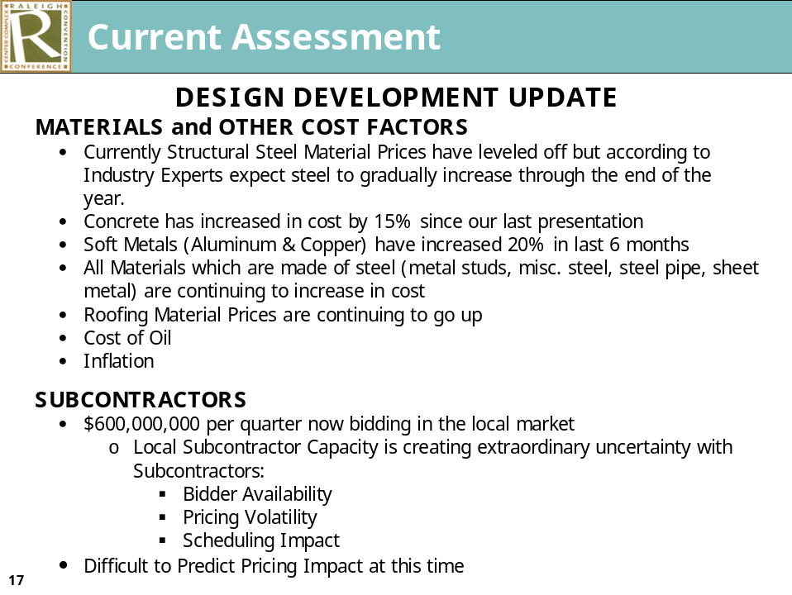

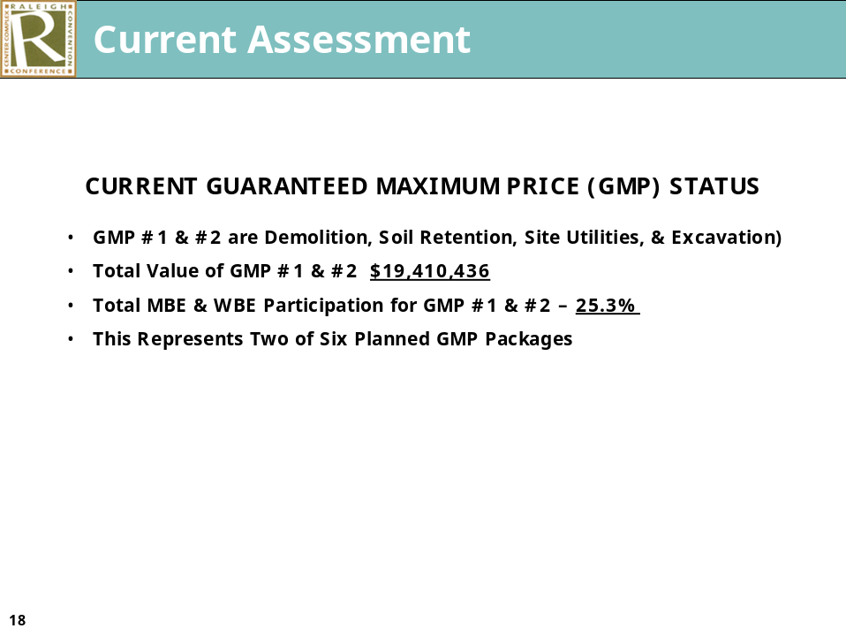

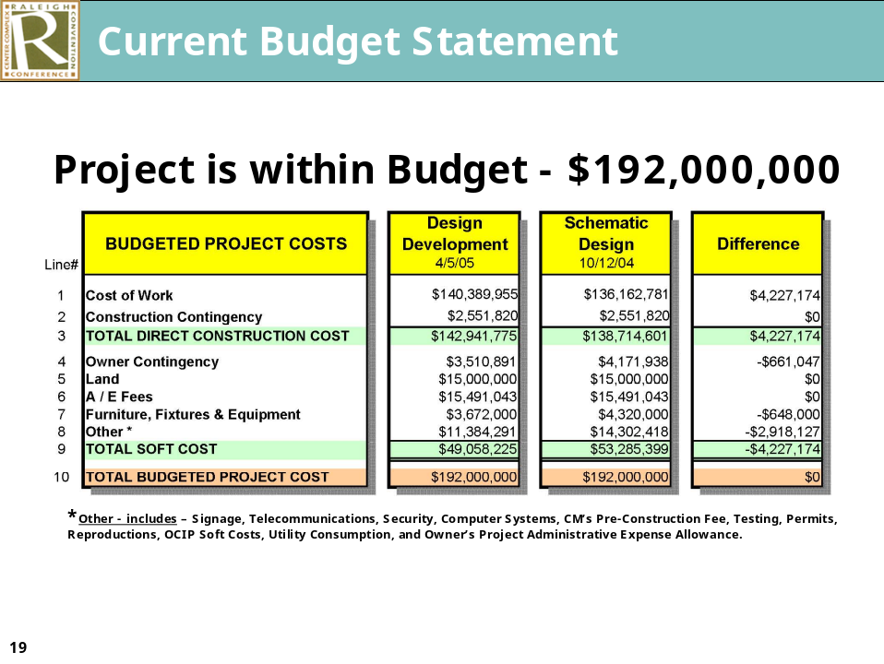

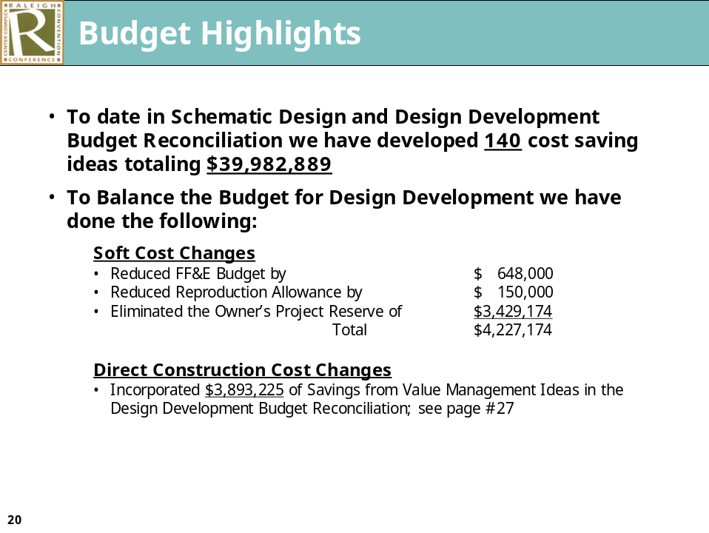

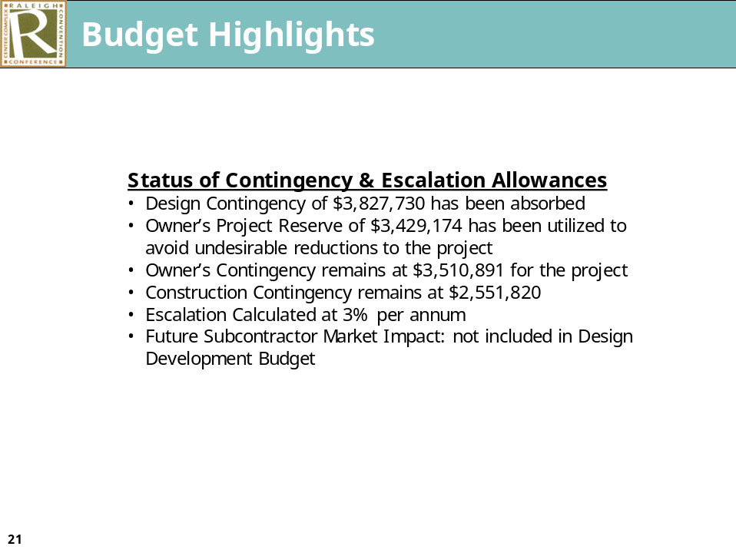

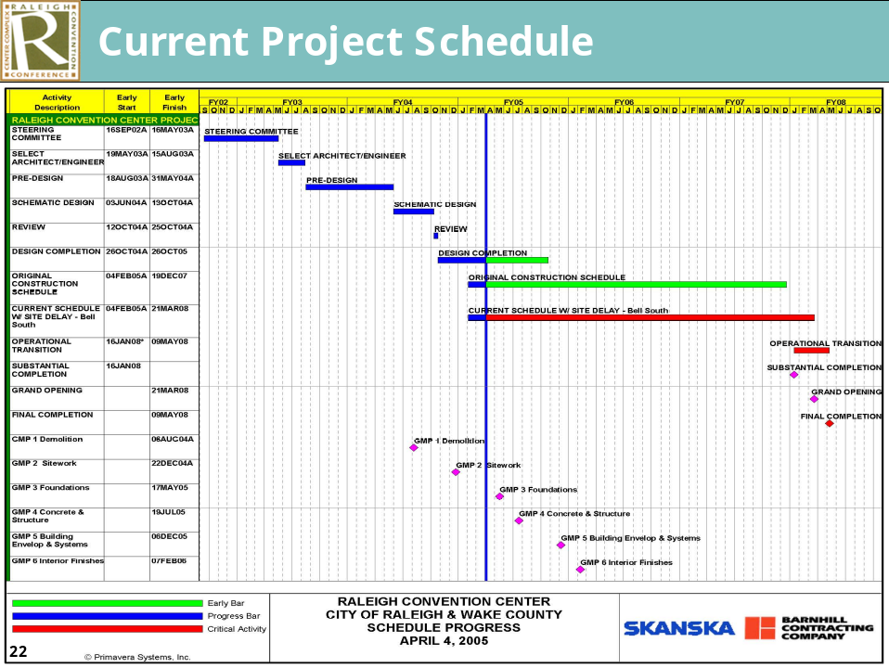

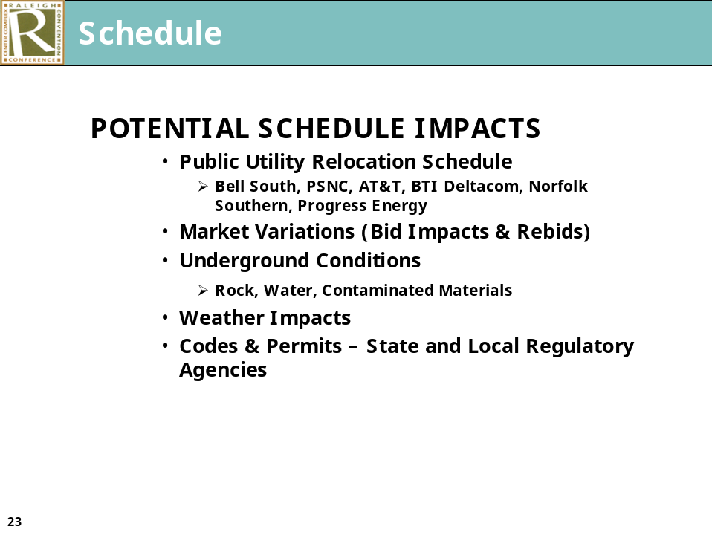

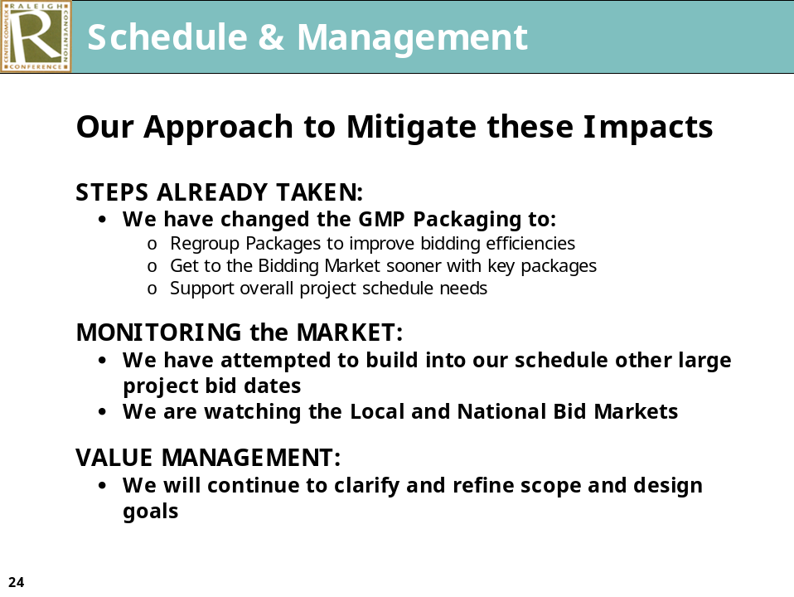

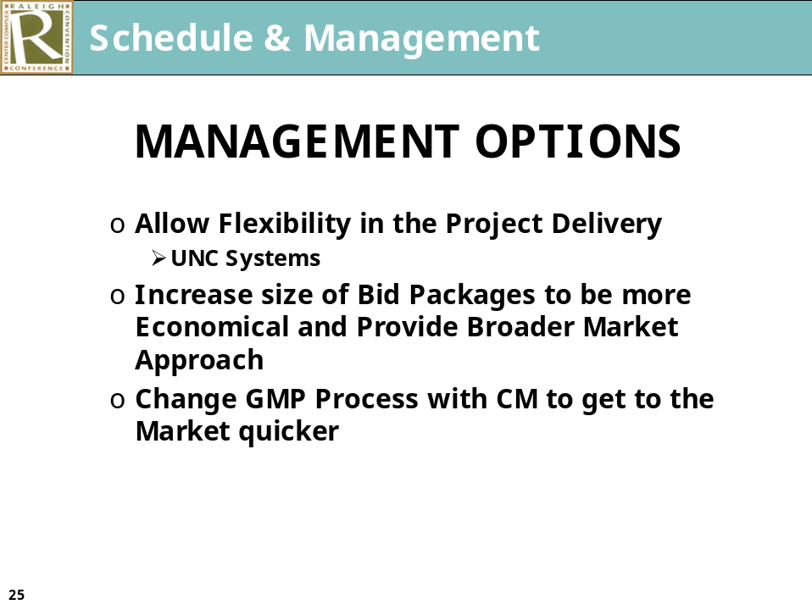

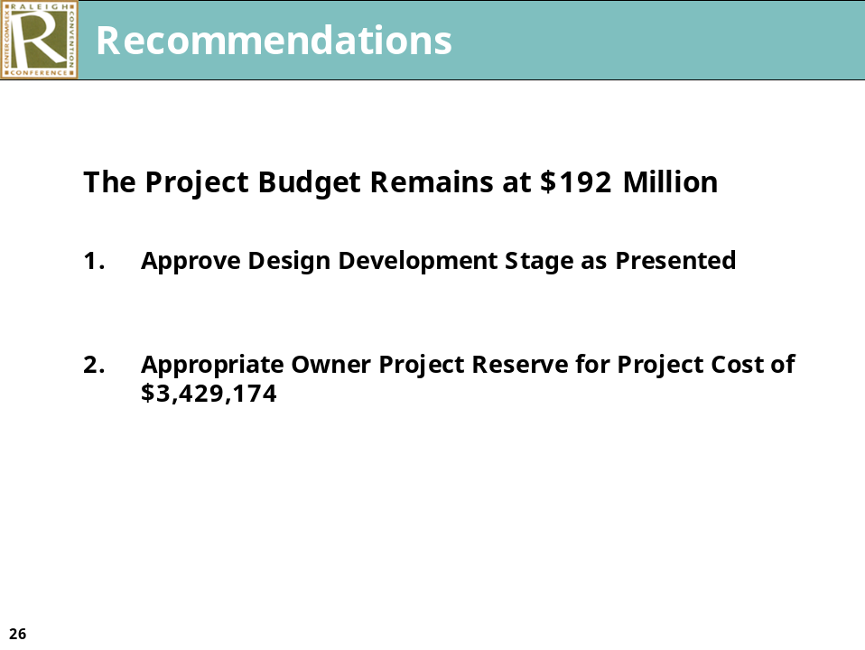

The list of the current unfunded items was presented as follow:

Additional Considerations for Items Yet Unfunded

- LEED Enhancement to Silver level $1,750,000
  - Date Decision Required – May 2005**

- Water Feature Enhancements $950,000
  - Date Decision Required – May 2005**

- Vertical Element at Southeast Corner $470,000
  - Date Decision Required – May 2005**

- Shimmer Wall at Western Face $155,000
  - Date Decision Required – May 2005**

- Convention Center/Hotel/Parking Deck Connector $3,500,000
  - Date Decision Required – September 2005**

- Public Art $1,250,000
  - Date Decision Required – January 2007**

**Decisions after date listed will result in additional costs

Discussion followed on the budget, status of contingencies and the GMP process. Ms. Taliaferro expressed concern about not having enough contingencies to cover the cost with Mr. Council questioning the date that we will know the exact cost with no potential for variation. The GMP approach and how we got from 5 GMP’s to 6 GMP’s and the fact that the fourth GMP was split in order to get to the market faster was talked about and what the original contract called for as it relates to GMP’s. The approach to mitigate price escalations, construction costs and the variations and changes in the market were talked about. City Manager Allen pointed out there is a 4 ½ percent contingency in the budget and it is felt it is reasonable. He talked about other sources of revenue if required and pointed out how interest income was originally budgeted and the increase in interest earnings which is more than what was anticipated. He stated if there are cost overruns the only other source is within the interlocal model. He stated we have tried to hold everyone to the $192 million budget but pointed out there are risks and briefly spoke to what is being done to minimize those risks.

Mr. Council pointed out later in the meeting the group is to discuss the allocation of interlocal money questioning whether it is wise to allocate money to other projects until such time as we know the exact cost of the convention center project. When we will know the results of the last GMP was talked about as was the methodology of splitting the GMP’s. Mr. Muter pointed out February 6, 2006 is the date to tie down the total GMP packages and the date of knowing the total cost with the City Manager pointing out that is correct unless the owner changes the scope.

The unfunded items listing as presented earlier was discussed.

It was pointed out the building is LEED certified. What is listed in the unfund items is to take the building beyond certification to the silver level. Mr. Crowder questioned if we went to the silver level of certification if there would be a payback. In response to questioning from Mr. Isley, Mr. Dudley pointed out there is value in going to the silver certification as it relates to air quality, marketability, etc, It does add value but they are not necessarily recommending going to the silver certification but it is an opportunity and it is up to the owner. Mr. Dudley pointed out he believes there are 6 silver certified buildings in the Federal program.

Ms. Ward talked about some of the things such as the water feature, shimmer wall, public art, etc. are important and are things that may have opportunities for public participation through naming rights, etc. The fact that the basic item relating to the water features, the building of a base for a tower are included in the numbers, private donations being needed to complete that aspect of the building. Designs that are presented remains within the $192 million budget, however, the unfunded list is as presented.

Points of discussion related to the connection between the parking deck, convention center and hotel and the fact no funds were budgeted for connecting the three, and the feeling that it is critical for the connection and why that was not included in the budget. Mr. Schuster pointed out the project was designed to be as seamless as possible between the hotel and convention center. When it was decided the parking deck would be below the hotel it was felt it would provide an opportunity to have the 3 projects connected as seamlessly as possible. The connection being a part of the cost of the hotel and parking deck and not a part of the convention center budget was spoken to. What was built into the basic design as it relates to public art which includes a foundation for the tower component but not the actual component. What is needed to proceed from this point, the changes in the line item budget but not the total budget and when final figures will be available was talked about.

Mayor Meeker moved approval of the design as presented. His motion was seconded by Ms. Taliaferro and a roll call vote resulted in all members voting in the affirmative. (Regan absent) The Mayor ruled the motion adopted.

Mayor Meeker moved approval of the budget as presented. His motion was seconded by Mr. West. Ms. Taliaferro indicated as she understands the action taken by Council would be approving 6 GMP’s rather than 5. She talked about the change from 5 GMP’s to 6 GMP’s, assumptions that had been made, promises of when things would happen and allocation of the owners and design contingencies. The fact that the additional interest income is not allocated and the amount of contingencies and the amount of reserves at this point was talked about. The fact that approval of the motion would be eliminating the design contingency but putting no money for parking deck connection was pointed out. The motion as stated was put to a roll call vote which resulted in all members voting in the affirmative. The Mayor ruled the motion adopted.

Ms. Ward moved approval of the budget as was presented and as approved by the City. Her motion was seconded by Mr. Council and a roll call vote resulted in all members voting in the affirmative. Commissioner Bryan ruled the motion adopted.

Discussion followed on the unfunded items that had been previously presented. Desire to have the art amenity package funded by private donations was talked about and what would occur if that does not come to pasts. The LEED enhancement to silver level and the convention center/hotel/parking deck connector items was talked about. It was pointed out the connector would be in another budget that is the hotel or parking deck or some other funding but would not come from the convention center funding was touched on. What the basic design includes as it relates to the water features and vertical element was touched on. The fact that we do not know the design or what is being considered as it relates to the water features, vertical tower and shimmer wall, public art was talked about with Mr. Dudley pointing out what is included in the basic design such as the underground structure or the base for the vertical element, the basic electrical etc. for water features which would include bubbling water. What to allow the design team to proceed with was discussed with various Council or Commissioners asking about the LEED enhancement and whether it should be on the table or not was touched on. What the LEED enhancement would provide, and additional cost was discussed. Mr. Isley moved that we remove the LEED enhancement to silver level from the table. His motion was seconded by Mayor Meeker. The Mayor pointed out again that the building would be LEED certified but enhancement to the silver level would not improve the efficiencies or provide any actual payback and the understanding enhancements have been included to make the building LEED certified in as environmentally friendly as possible without adding another close to $2 million to obtain another level. Ms. Taliaferro pointed out everyone wants the building to be as environmentally sensitive as possible and we have taken steps as it relates to heating, cooling, etc, but to go beyond that does not seem to be practical at this point. The motion as stated was put to a vote which resulted in all members voting in the affirmative. (Regan absent). The Mayor ruled the motion adopted.

Ms. Ward moved the County concur in removing the LEED enhancement to silver level from the table. Her motion was seconded by Mr. Council and put to a vote which passed unanimously. Chairman Bryan ruled the motion adopted.

Mayor Meeker moved the City Council ask staff to work with the architects and come back with prices on the water feature enhancement, vertical element at the south east corner, shimmer wall at the western face and the public art issues. His motion was seconded by Ms. Kekas, and a roll call voted resulted in all members voting in the affirmative. (Regan absent) The Mayor ruled the motion adopted.

Discussion then took place relative to the convention center/hotel/parking deck connector, Ms. Taliaferro pointed out if it is not worked out that funding come from the hotel or parking deck budget she would like for staff to come back with options for funding. No one is asking that it be taken off the table at this point.

Mr. Gurley expressed concern pointing out what we have been talking about are extra items that are not in the budget now and it is his understanding that they will be done with private money. He questioned if it is being said the County would have no vote on those items. What the interlocal agreement says and who approves what was discussed with it being pointed out we are talking about design elements and we are trying to determine the exact numbers.

INTERLOCAL FUNDING FOR OTHER PROJECTS – VARIOUS ACTIONS TAKEN BY THE COUNTY; CITY TO TAKE ACTION AT A LATER DATE

The following proposal to fund projects from occupancy and prepared food and beverage taxes was presented.

PROPOSAL TO FUND PROJECTS FROM OCCUPANCY AND PREPARED
FOOD & BEVERAGE TAXES

PROJECT | PROPOSED FUNDING
NC Museum of Art | $15,000,000
Cary Aquatics Facility | $10,000,000
Green Square Project – Natural Research Center | $ 2,000,000¹
Track Project at St. Augustine’s College | $ 1,000,000
North Carolina Ballet | $ 250,000
Falls Whitewater Park | $ 150,000
Total | $28,400,000

¹The City and County will commit work with the NC Museum of Natural Sciences to find $8 million from other revenue sources for the Nature Research Center. This will specifically include exploring the option of Amendment of One self-financing bonds within six months.

Commentary/Highlights

- Funding these projects will require a commitment of anticipated revenues through fiscal year 2017. The money will be disbursed as described in attachment 1.

- If occupancy and prepared food and beverage tax revenues do not meet projections, disbursements for projects will be reduced to match available revenues.

- Before releasing any funds, agreements will be required between the receiving entities and Wake County, or the City of Raleigh. Each agreement will detail, at least, the project scope and schedule, funding commitments from other parties, and the entity responsible for on-going operating expenses. No project will receive any funds unless they are matched, at a minimum, 1:1 (one-to-one) from another source. The occupancy and prepared food tax revenue is, in essence, the “last dollar in.” If the receiving entities do not meet the elements of the agreement, funding for the project will terminate.

- No distributions will be made until award of fifth Guaranteed Maximum Price contract is awarded for the Convention Center – estimated to occur by January 2006.

- The Council acknowledges that if Raleigh exercises paragraph 11.6 section E (IV)(d) in the Eighth Amendment of the Interlocal Agreement (this is the language that allows Raleigh to use additional funds up to $1 million for convention center expenses, and, in return Wake County receives two dollars from the revenue stream not dedicated to the convention center for each one dollar used by Raleigh), then Wake County’s receipt of revenues as provided by that section will be deferred until sufficient revenues are received (either during the period 2006-2017, and/or after.)

- The convention center financing plan, as defined in the Eight Amendment of the Interlocal Agreement, anticipated an expansion of the center in approximately 2020 by establishing Column “O” which provides additional revenues for debt service. With concurrence with the City and County, column “0” may also be used for major capital upgrades/renovations of the existing convention center in excess of $1 million and not covered by capital reserve/maintenance expenditures covered in Column “N”.

Attachment 1
Year (June) | Art Museum (Up to 15m) | Cary Aquatics  (Up to $10m) | NC Museum of Natural Science  (Up to $2m) | St. Augustine’s College Track  (Up to $1m) | NC Ballet  ($250,000) | Whitewater Park  ($150,000)
2006 | $3,500,00 | $500,000 | $0 | $0 | $50,000 | $150,000
2007 | $1,000,000 | $500,000 | $200,000 | $0 | $100,000 | $0
2008 | $1,000,000 | $500,000 | $200,000 | $100,000 | $100,000 | $0
2009 | $1,000,000 | $500,000 | $200,000 | $100,000 | $0 | $0
2010 | $1,000,000 | $700,000 | $200,000 | $100,000 | $0 | $0
2011 | $1,000,000 | $700,000 | $200,000 | $100,000 | $0 | $0
2012 | $1,000,000 | $1,000,000 | $200,000 | $100,000 | $0 | $0
2013 | $1,000,000 | $1,000,000 | $200,000 | $100,000 | $0 | $0
2014 | $1,000,000 | $1,000,000 | $200,000 | $100,000 | $0 | $0
2015 | $1,500,000 | $1,000,000 | $200,000 | $100,000 | $0 | $0
2016 | $1,500,000 | $1,000,000 | $200,000 | $100,000 | $0 | $0
2017 | $500,000 | $1,600,000 | $0 | $100,000 | $0 | $0
Total | $15,000,000 | $10,000,000 | $2,000,000 | $1,000,000 | $250,000 | $150,000

Mayor Meeker moved approval of the proposal dated April 5 with the amendment to bullet #4 which would change “fifth guaranteed maximum price” to “sixth guaranteed maximum price”. Commissioner Bryan moved approval of the proposal as presented and amended by the Mayor. His motion was seconded by Ms. Ward.

Lengthy discussion followed what approval of the motion would mean, the fact that no distributions would be made until award of the sixth guaranteed maximum price contract is awarded which is estimated to occur by January of 2006, what would occur if the funds were needed, the fact that this is a priority listing not a commitment to funding, projects that are on the table and the wording in the proposal which talks about committing an effort to help fund the Green Square project. The importance of the Green Square project and the commitment of the City and County to help with the funding mechanism was discussed. Mr. Crowder read excerpts from an article in the New York Times relative to America loosing its competitive edge. In reading the excerpts he talked about the need for the expansion of the museum and the Green Square project. Ms. Taliaferro pointed out she doesn’t need to be sold on the museum downtown. Her main concern relates to voting on the package prematurely.

Larry Wheeler presented the Council members a letter signed by the NC Museum of Arts, NC Museum of Natural Sciences, Carolina Ballet, Town of Cary, St. Augustine’s College and Elizabeth Gardner representing the Falls Whitewater Park. The letter indicated those groups are unanimous in their support of the proposal as presented and have so signified on behalf of their respective boards of directors or town councils. He urged the Council to pass the proposal today.

Mr. Webb suggested changing in the attachment to indicate that St. Augustine’s track would receive a $100,000 in 2006 and 2007 respectively by reducing the proposed appropriation to the Art Museum by $100,000 in 2006 and a $100,000 in 2007 but increasing the appropriation to the Art Museum by $100,000 in 2016 and 2017.

Mr. Council stated he would support Mr. Webb’s motion to modify the proposal but he wanted everyone to understand what bullet #4 says. He also stated he understood the Centennial Authority will be coming to the group asking for additional money. Perry Saffran, Britt Barringer and City Attorney McCormick, all members of the Centennial Authority, pointed out there is no intent of the Centennial Authority to ask for additional money. City Attorney McCormick pointed out the Centennial Authority is considering two capital improvements to the building and explained the proposals. He stated both of those capital improvements would be funded from reserve funds that they have set aside pursuant to the interlocal agreement. He talked about the direction of the interlocal agreement as it relates to set asides debt service etc.

Mr. Council asked about the operating budget of the convention center and, asked for clarification on how that was structured. City Manager Allen talked about the work of the task force and the study done by HVS. He talked about the $1.8 million lost and how the interlocal agreement addresses that. He also talked about the operating loss of the existing civic center and how that is funded. Mr. Council pointed out as he understands the City has covered the operating loss of the existing Civic Center from general fund and the City and County agree that all of that is mutually exclusive of the 15 percent we are talking about allocating today. Mr. Council again talked about bullet #4 of the proposal, pointing out as he understands the reason action would be taken this morning is to give the people who had requested funds some planning ability. However, he wants everyone to understand the money may be needed for the convention center and may never be distributed as prioritized.

Mr. Isley spoke about an analogy of a mother bird making a nest for eggs which become little birds. The little birds begin making noise and want to be fed. We have projects that need to be funded and everyone is hearing a lot of noise. He stated he supports all of the projects on the table. His problem is he wants to make sure that we have enough money to fund the projects that have been approved. He stated he is very concerned that we may have cost overruns and pointed out you need to plan for worst case scenarios and he does not think it is prudent to fund any of the proposals until we know we can pay for what is already on line and he would prefer not to have any of the dollars go out until the projects on line have been finished. He stated at this point he simply cannot support the current proposal as he feels we should make sure we have enough funds available. Mr. West agreed but pointed out he feels bullet #4 does indicate that if the City and County needs the money for the ongoing projects no funds would be appropriated or distributed for additional projects.

Mayor Meeker stated he appreciated the concerns as outlined by Mr. Isley. Everyone wants to be prudent. He spoke in support of the proposals and pointed out he understands the need to plan for worst case scenarios but prudent also means taking advantage of opportunities. Mr. Isley’s analogy was discussed. What had been done with the money in the past, the conservative estimates, the amount of money that has been taken in and how the estimates were figured or projected was talked about by County Manager Cooke. Various Council members and Commission members offered their opinion as to how to proceed, their concerns about the proposal that have been presented and whether they are still the same proposals, what would happen if some of the projects did not proceed as proposed, did not raise matching funds and how that would impact today’s decision. Mayor Meeker stated this action is not allocating any money it is just setting priorities and before any money is disbursed an agreement would have to be negotiated by the City and County and the receiving party and if the proposal is not the same then the project could be scraped. If the project is not as proposed there would be no agreement, any agreement to allocate money would be null and void. What each group had requested was talked about.

Discussion took place concerning the Cary Aquatics Center proposal and whether it has changed since the original presentation was made. Whether what is proposed to be built at the aquatic center is the national venue that was first spoke about or whether the project has changed in scope was discussed. Ms. Taliaferro pointed out she feels it would be good if we saw percentages and agreements based on a certain percentage of the total project.

Lengthy dialogue followed with various Council or Commission members expressing their feelings as to how to proceed whether they could support the motions on the floor and the possible change in some of the proposals. Mr. Gurley expressed concern that some of the proposals before the group today are not the same proposals that were presented at the original meeting.

Mayor McAlister of Cary pointed out the proposal presented by the Town of Cary in August was for a $30 million project. At some point prior to that it was a $45 million project and that included additional amenities. He explained the aquatic proposal before the group today is for a $30 million project, $15 to be funded by the Town of Cary and $15 from interlocal funds. At this point we are talking about less than was originally requested. He talked about Cary’s commitment to finish the project. Who and what area the project would serve was talked about with it being pointed out the Town of Cary is still committed to bringing an aquatic center for the local and regional area. Mr. Jeffries talked about the change in the project and his concern about the change and whether the other amenities will ever be built. Mr. Bryan restated the motion which had been seconded by Ms. Ward to approve the draft with the changes outlined relating to the Museum of Art and the St. Augustine’s track. The amended motion was put to a vote which resulted in all Commissioner members voting in the affirmative except Mr. Jeffries and Mr. Gardner who voted in the negative. Chairman Bryan ruled the motion adopted.

Ms. Taliaferro talked about her concerns pointing out she can support the Museum of Art program and she is willing to move ahead and vote for approval for funding the Museum of Art request but there are some outstanding questions she has on other projects. She stated she if very reluctant to leave the Green Square project out. She stated she would be happy to add the Ballet and the Whitewater park and although she supports St. Augustine’s track she does need to know how that may be affected by joint venture with Shaw University. Ms. Taliaferro made a substitute motion to approve the funds for the Museum of Art, Ballet, and the Whitewater Park. Her motion was seconded by Mr. Isley. Mayor Meeker stated he could not support the substitute motion. He feels we should continue to work with the County and he feels we should have a joint recommendation. Mr. West expressed concern leaving out the St. Augustine’s track and pointed out there is nothing official about a joint effort. Ms. Taliaferro stated she would accept funding of the St. Augustine’s track as a friendly amendment. The substitute motion as amended was put to a vote with Ms. Taliaferro and Mr. Isley voting in the affirmative and the remainder of the Council voting in the negative. The Mayor ruled the motion defeated.

Mayor Meeker pointed out he would hold the vote on the main motion and the City Council would take it up at the appropriate time.

Mr. Jeffries expressed concern pointing out in March 2003 the Wake County Commissioners voted that they would not take a vote on anything involving a municipality until that municipality had voted on it first and what just occurred is exactly opposite from the action taken by the County Commissioners. Mr. Bryan pointed out we have many joint meetings and sometimes the municipality votes first and sometimes the County votes first.

ADJOURNMENT

No further action was taken and the meeting adjourned 10:30 a.m.

Gail G. Smith
City Clerk

Gh/scc4/5/05

