SPECIAL CITY COUNCIL

The City Council of the City of Raleigh and Wake County Commissioners met in a special joint session on Thursday, October 27, 2005 at 8:00 a.m. in the Progress Energy Center for the Performing Arts. Members present included:

City Council County Commissioners

Mayor Meeker Chairman Bryan
Mr. West Mr. Gardner
Mr. Craven Mr. Gurley
Mr. Crowder Mr. Jeffreys
Ms. Kekas Mr. Webb
Mr. Isley
Ms. Taliaferro

Also in Attendance

County Manager Allen
County Manager Cooke
Deputy City Attorney Rasberry
County Attorney Ferrell
Various other City and County staff members

Mayor Meeker called the meeting to order and the following item was discussed with action taken as shown.

Convention Center Project – Status Report Received; City Council Authorized to Post Bid GMP Process for Packages 5 and 6

City Manager Allen pointed out this project is at a very exciting stage. You can see actual construction going on. He talked about the investment and energy in the whole downtown area which is growing monthly. He stated the Convention Center project is a very complex project, there have been a lot of risks but a lot of the risks are behind us. He stated we did get into the financial market at a good time. He stated about 50 percent of the project is under construction or under bid; however, we do have some challenges remaining and today we will talk about those challenges and will identify ways to meet those challenges. He stated at the end of the meeting the City Council will be asked to authorize post bid GMP on Packages No. 5 and 6 so that we can get the pricing, come back in January at which time the group we will see about 98 percent of the total project bid.

County Manager David Cooke congratulated City Council both returning and new members on their election and very successful bond referendums. He also talked about the Hurricane Katrina evacuation effort and expressed appreciation to the City of Raleigh both elected and staff members who worked with the Katrina evacuation shelter. He stated it was a strong team and expressed appreciation to all involved.

County Manager Cooke talked about the changing market conditions pointing out the County Commissioners have seen it as it relates to schools and libraries. He pointed out on the Convention Center projects the conservative revenue projection and the timing of getting in the market has produced a strong team effort and position.

Steve Schuster pointed out what everyone is seeing in the room are examples of the final design and finishes, signage program including opportunities for sponsorship, samples of carpet, fabric, stone, etc. He stated the final selection will not be made until later but what is being shown are examples of the quality of products that we will be looking at when those bids are made.

Mr. Baker presented the following slides, explaining each item.

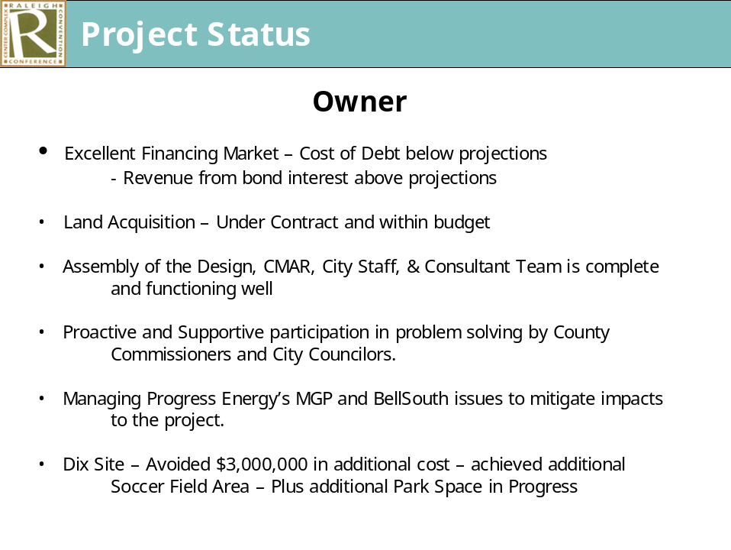

Mr. Baker talked about the excellent cooperation we have had from Progress Energy but pointed out the remediation efforts have taken a little longer and have been more complicated than expected therefore the progress has been slower than anticipated. He talked about the critical systems which had to be coordinated between BellSouth and Progress Energy and how that worked.

Dudley Lacy, O’Brien Atkins, presented the following status report. He explained we have been in the ground for 10 months with a lot of complex work going on. There are a few sets of documents yet to be released. He explained what is included in GMP 5 and 6.

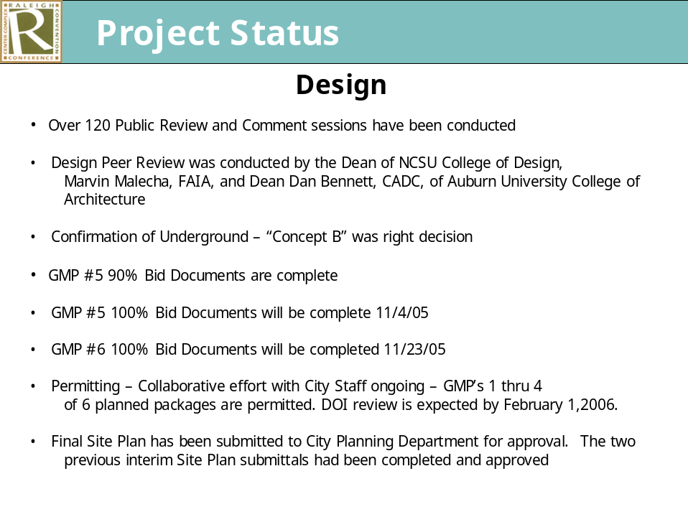

John Muter, Barnhill Contracting presented the following information.

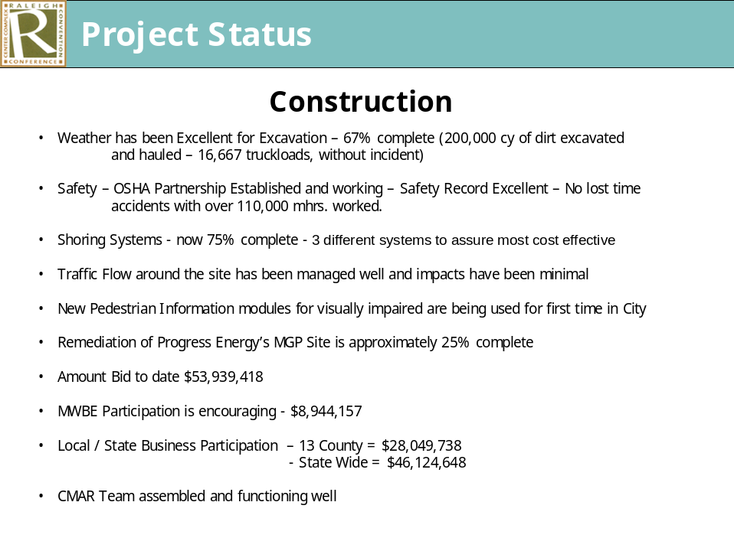

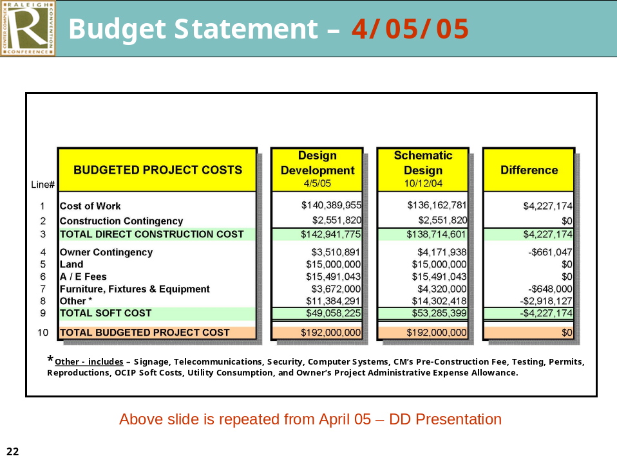

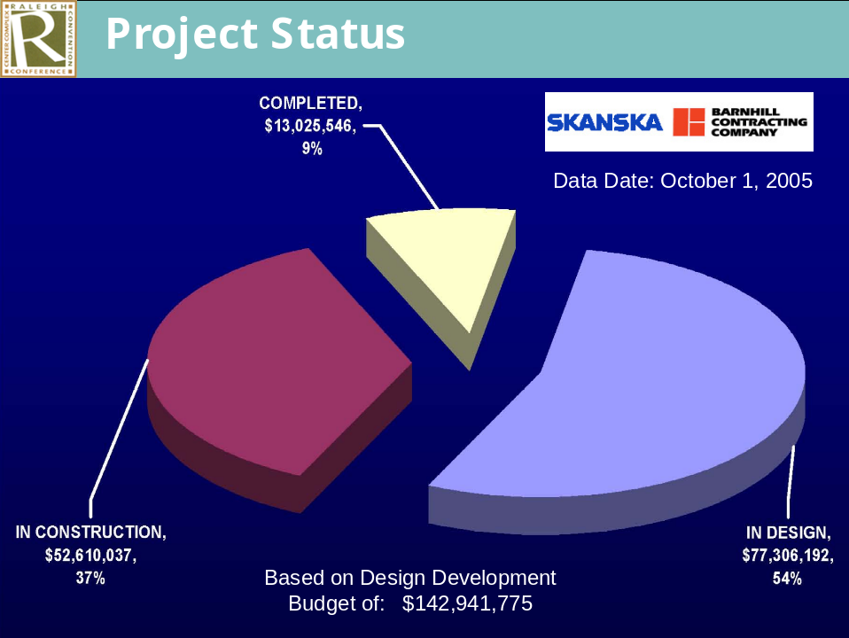

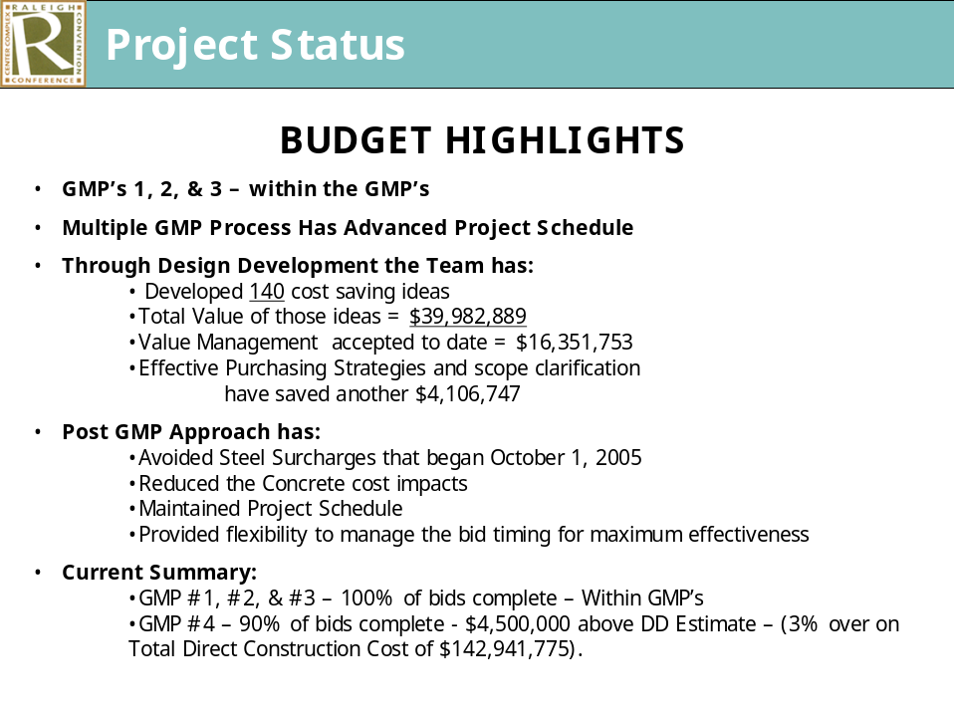

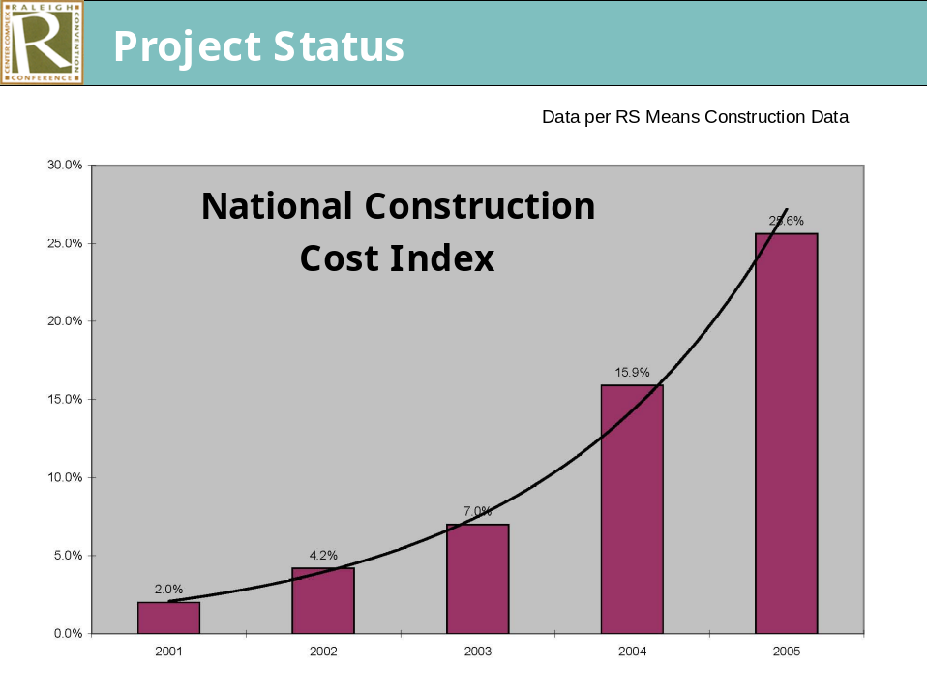

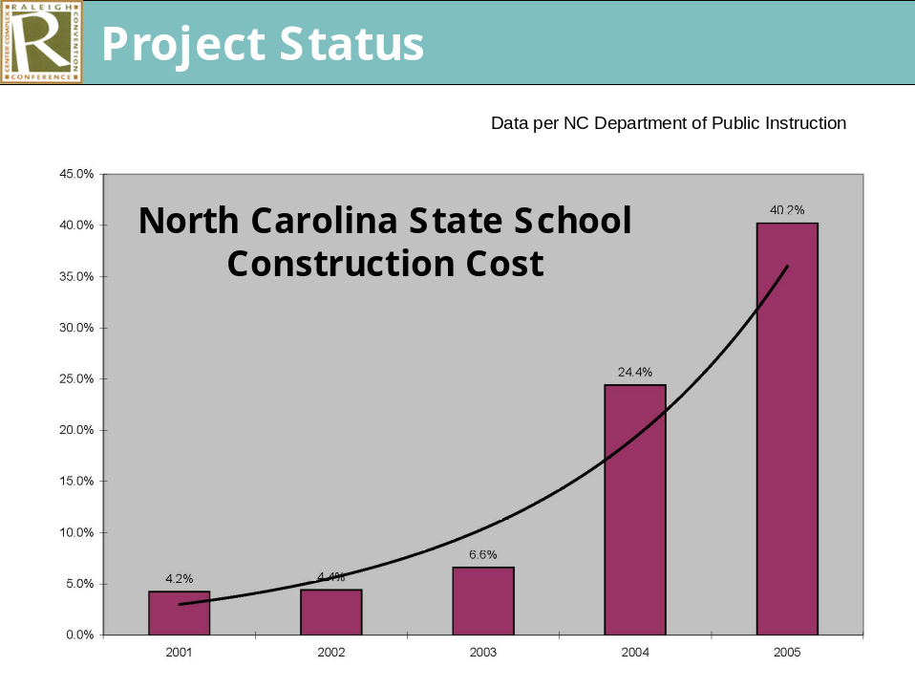

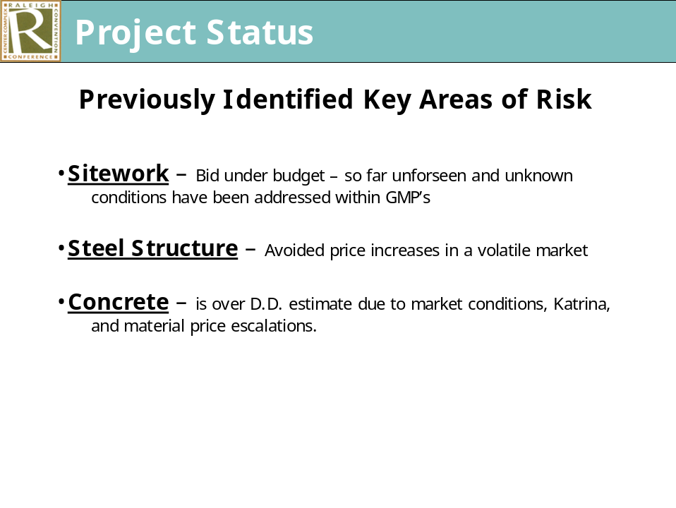

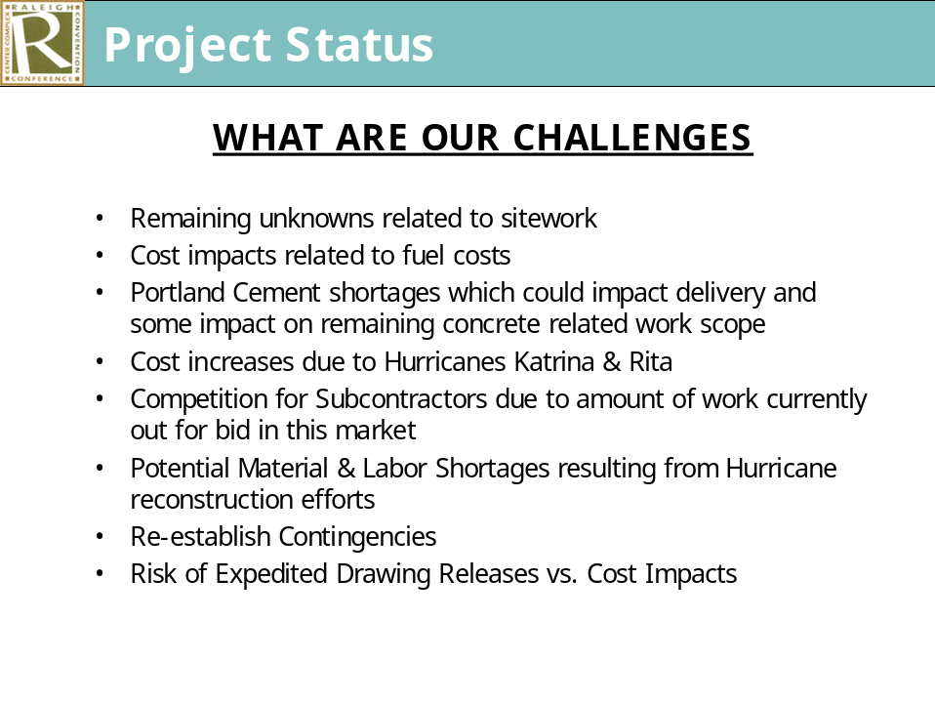

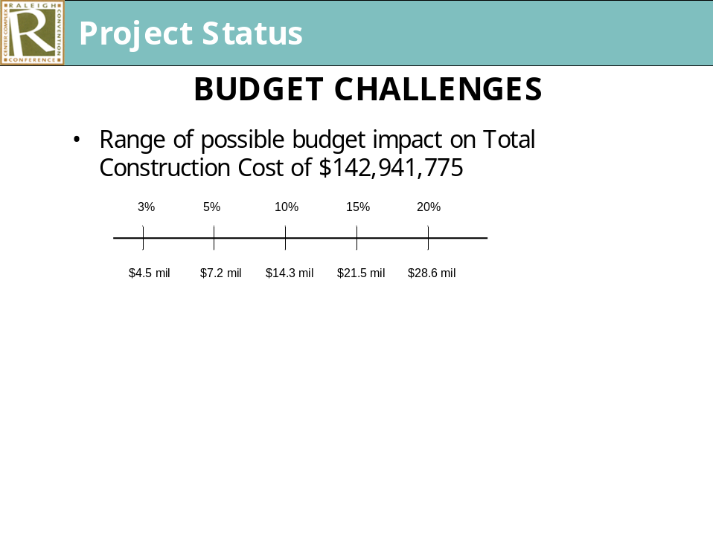

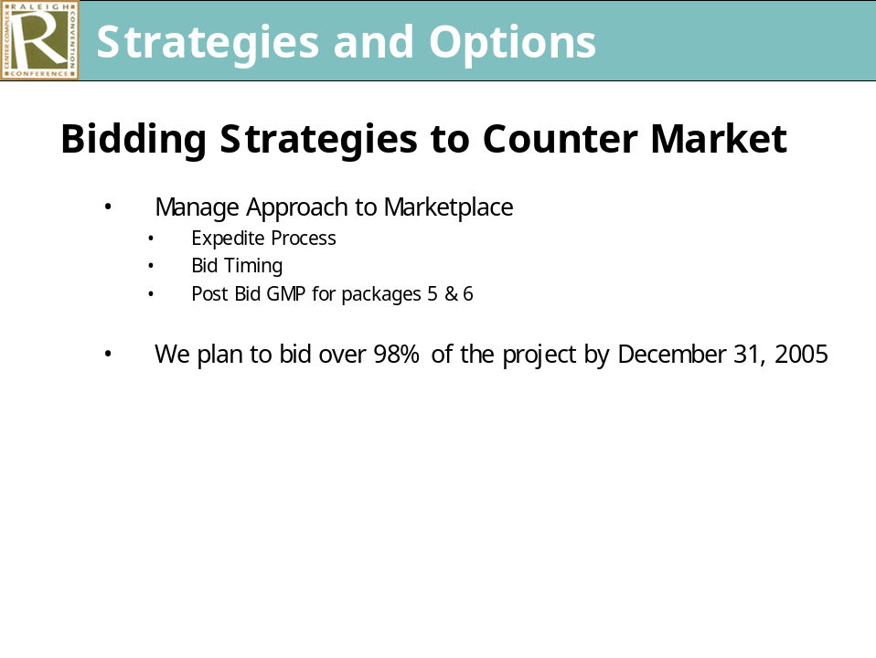

Ms. Taliaferro questioned how we would reinstate contingencies and the GMP#4 is over budget and the original estimate. Mr. West asked about the local participation of MWBE and the breakdown among groups.

City Manager Allen talked about additional funding options and range of reductions available as it relates to equipment leasing and quality reductions.

County Manager Cooke and Chief Financial Officer James went over the following updated spreadsheets.

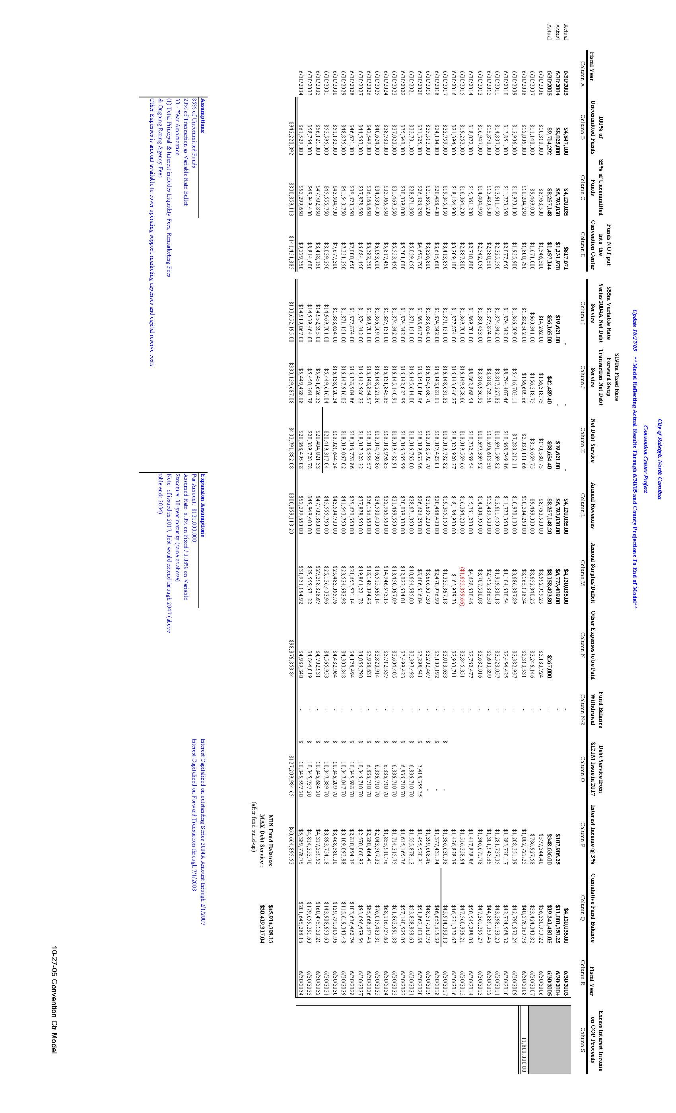
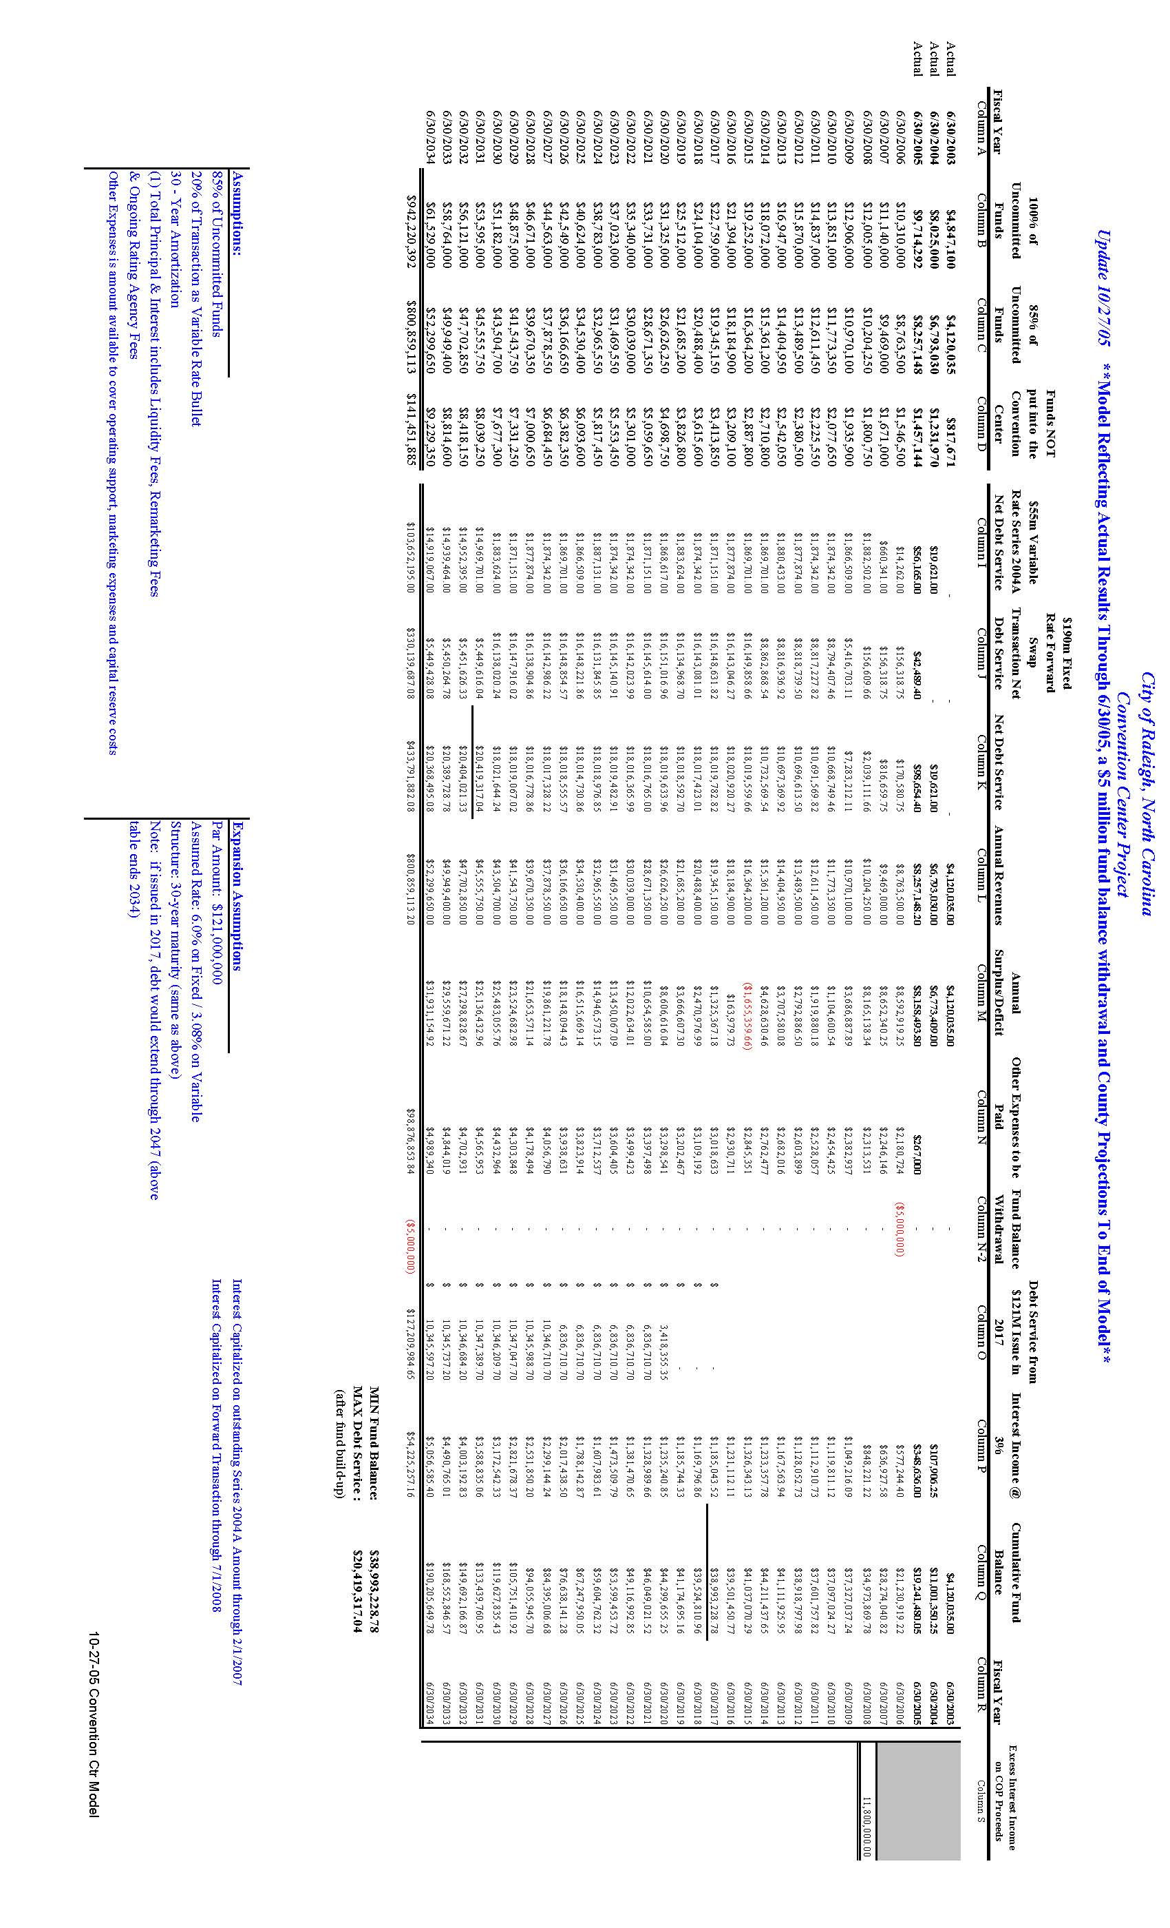
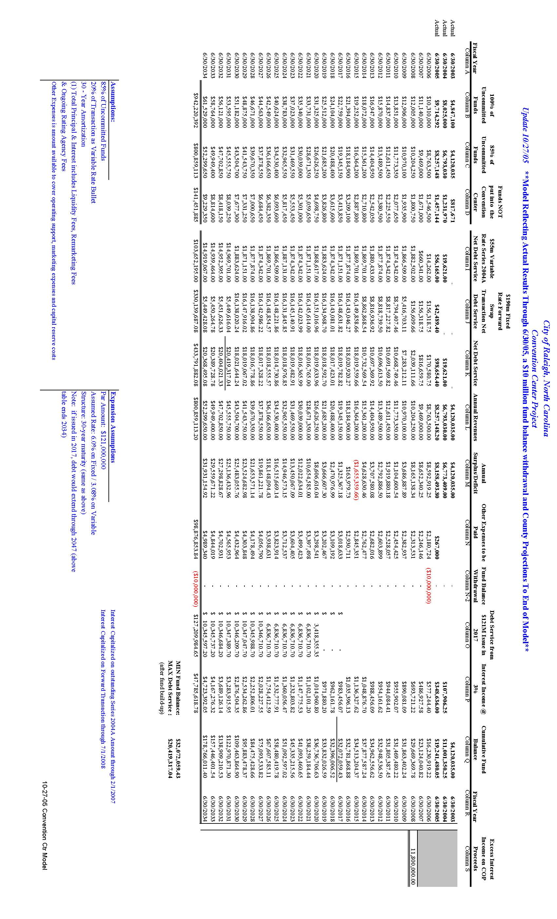

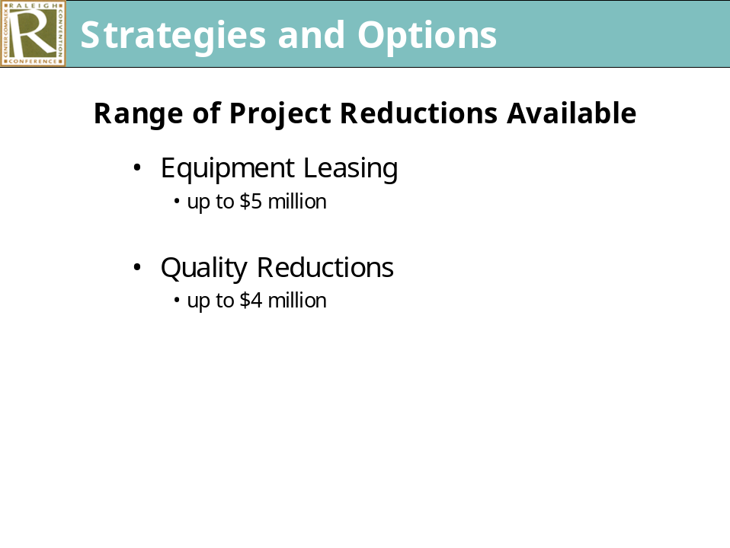

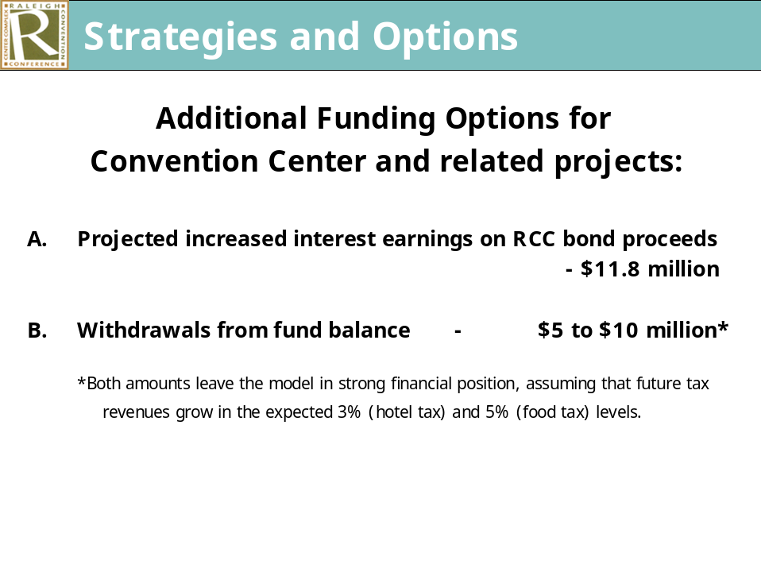

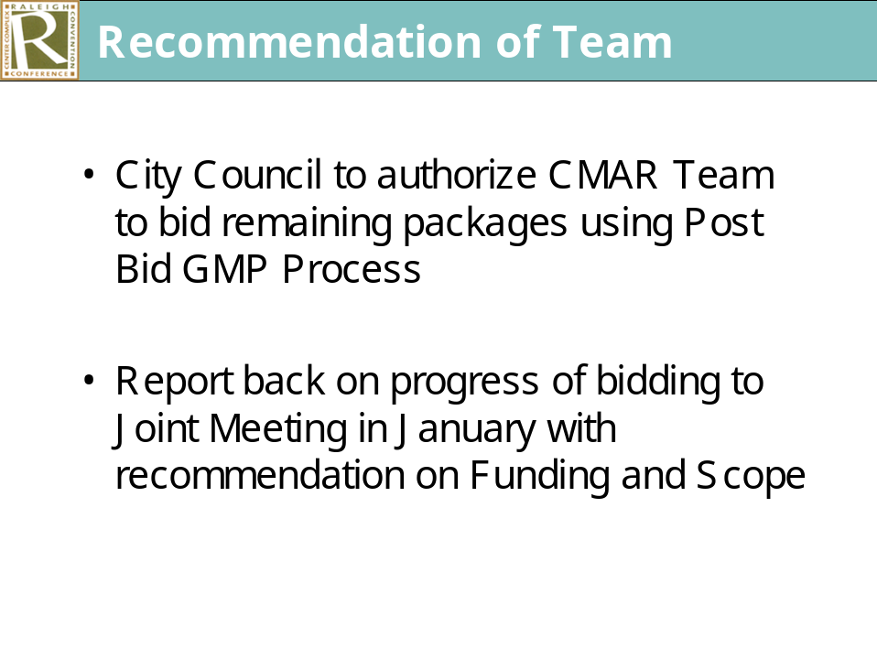

It was pointed out only the City Council needs to take action. Mr. Craven stated he would have to vote against the recommended action citing problems with the process, amounts over budget, etc.

Mayor Meeker moved authorizing the team to move forward with post bid GMP process for packages 5 and 6. His motion was seconded by Mr. West and put to a roll call vote which resulted in all members voting in the affirmative except Mr. Craven who voted in the negative. (Regan absent) The Mayor ruled the motion adopted on a 6-1 vote.

Adjournment:

There being no other business, Mayor Meeker announced the meeting adjourned at 9:20 am.

Gail G. Smith
City Clerk

dm

