CITY OF RALEIGH, N.C.  |  | Fire Marshal’s Office  2010 City of Raleigh Ordinance
SUBJECT  Use of Pine Straw Mulch |  | SECTION  Ord. 13-3019 | PAGE  1 of 6 | EFFECTIVE DATE  01 December 2010
 | PREPARED BY  Raleigh Fire Marshal’s Office |  |  |  | APPROVED BY  Asst. Chief W.R. Styons
TECHNICAL BULLETIN

1.0 Purpose

To establish regulations to prevent conflagration (the spread of fire between multiple structures) with combustible exterior surfaces through the use of pine straw mulch. This document is established with the intent to first educate the property owner and / or public of the fire hazards posed by a combination of combustible construction in close proximity to pine straw mulch with follow-up enforcement.

- Scope

Any structure currently regulated by the International Fire Code with North Carolina Amendments, exclusive of private residential 1 and 2 family dwellings.

Organization(s) Effected

City of Raleigh Fire Marshal’s Office

3.0 References

City of Raleigh Municipal Code Ordinance 13-3019

- Definitions

Combustible Exterior Surface Outer surfaces of structures including but not limited to siding, soffit and exposed structural members made of materials that will burn when ignited or melt when exposed to open flame exposing other combustible framing, sheathing or insulating materials which can burn.

- Requirements

General Requirements

No pine straw mulch shall be placed, kept, or stored within ten feet of buildings with combustible exterior construction. This provision shall not apply to one and two family dwellings as defined in Section R101.2 of the North Carolina Residential Building Code, as the same may be amended, nor shall it apply to pine straw falling from trees located on the same parcel as the dwelling.

- Enforcement

  - Effective Date

This ordinance was legally adopted by The City of Raleigh City Council in Chambers in regular session 04 May 2010. Effective date of enforcement shall begin no later than 01 December 2010.

  - Penalties

Penalties assessed for non – compliance after the effective enforcement date shall be at minimum per violation no less than $50.00 and shall be no more than $500.00 total.

  - Record Keeping

At the time of each site visit, whether scheduled or unscheduled, the inspecting officer shall indicate in the database if a particular structure or complex falls under the applicability of City of Raleigh Ordinance13-3019.

7.0 Appendix

Examples: Figure A
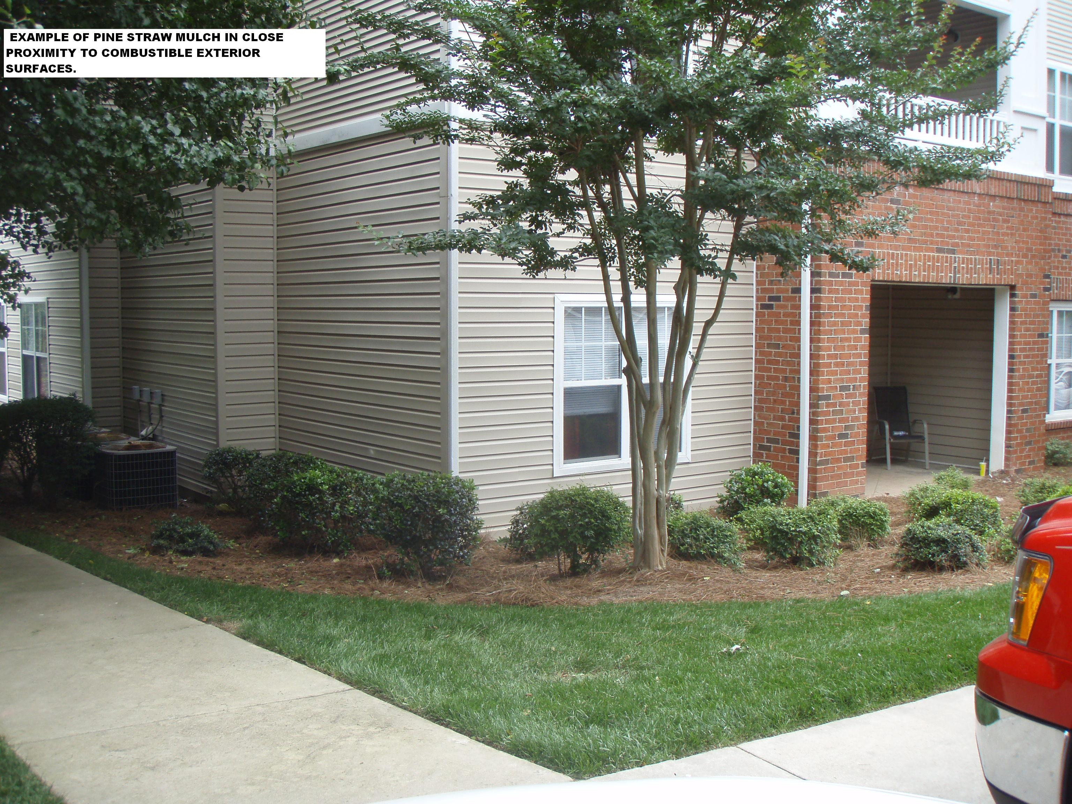

Figure B

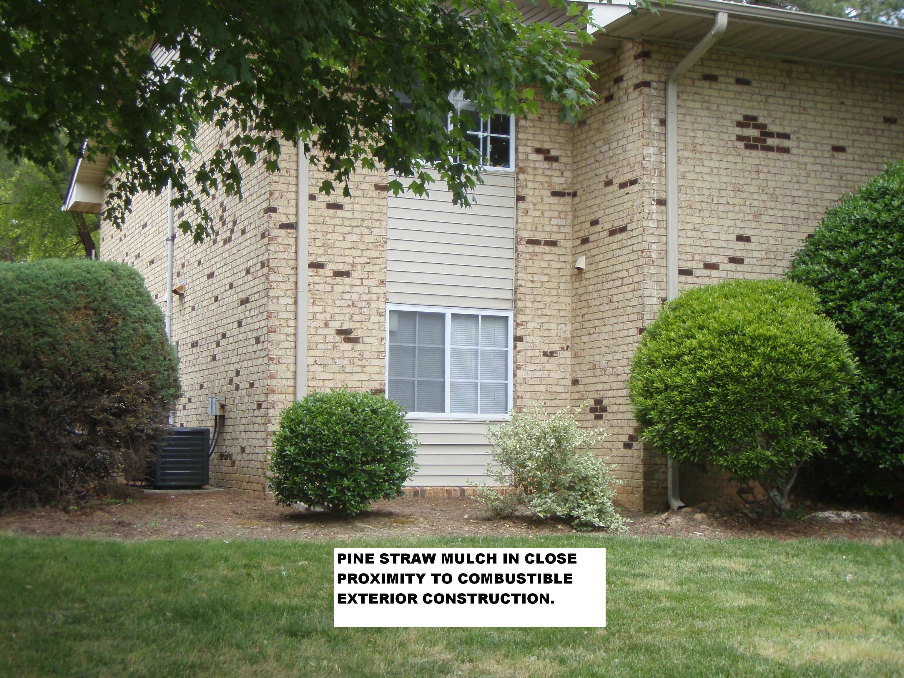

Figure C

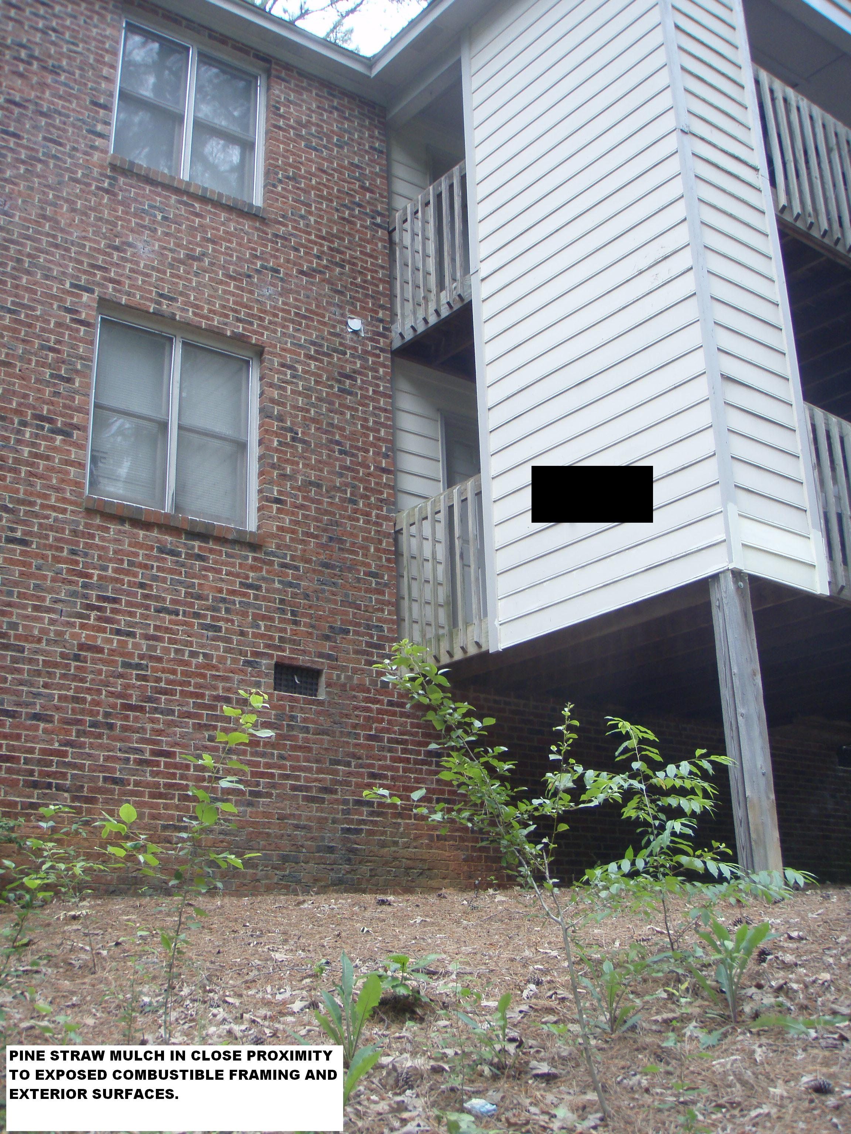

Figure D

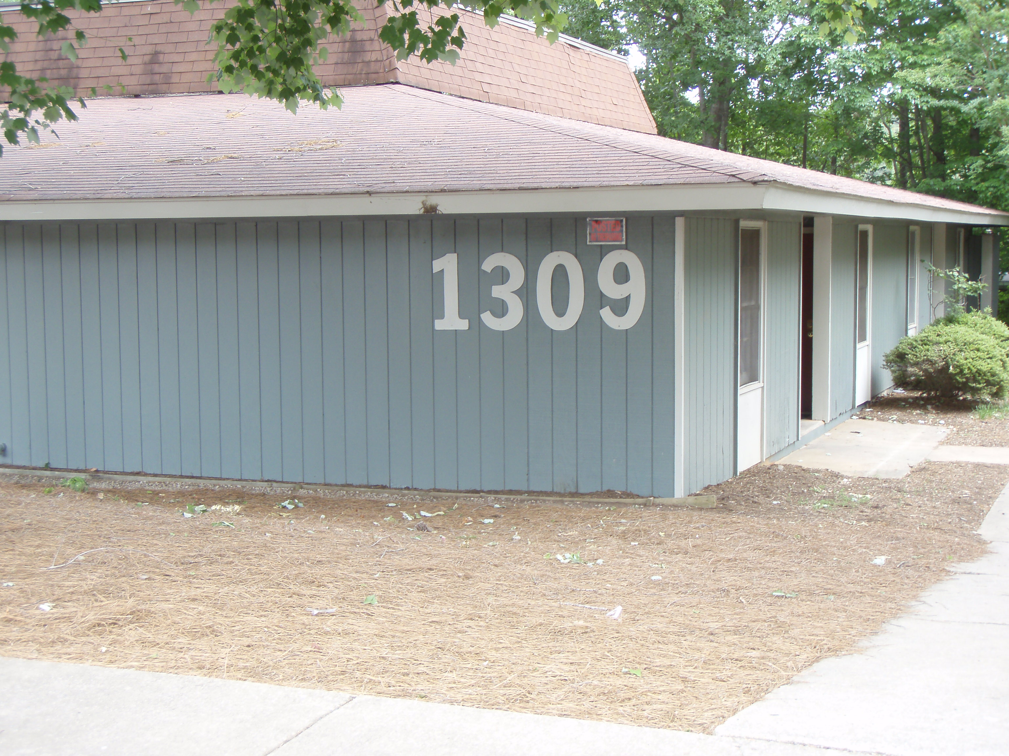

8.0 Frequently Asked Questions

- Q. May I place approved landscape materials over existing pine straw landscaping?

A. No. To meet the intent of the ordinance, all prohibited landscape material shall be removed before installing any new material.

- Q. What if the bottom floor of the building in question is made of non-combustible
Materials, but the floor(s) above are of combustible construction materials?

  - The ordinance still applies. Combustible pine straw landscaping will be kept at
minimum, 10 feet from any building containing exterior combustible construction materials.

- Q. Do decks count as combustible construction materials even if attached to a
building which is made of non-combustible exterior construction?

  - Yes. If the deck is made of a combustible material, by definition it is exposed
combustible framing.

- Q. Are townhomes and condominiums included in the ordinance?

  - Townhomes are not subject to the provisions of the ordinance since they are
considered private, one and two family dwellings, having no public common areas and are not subject to fire inspections. Condominiums do have common public areas and are subject to the regulations of this ordinance.

