2019 - 2020
Arts Learning Community for Universal Access
Scrapbook
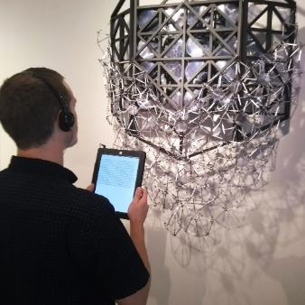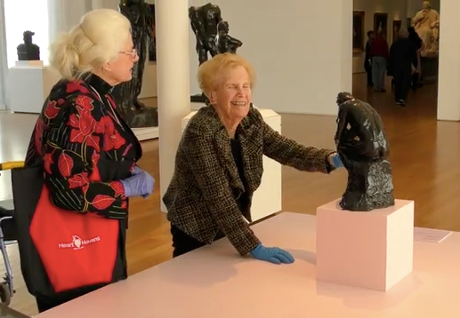
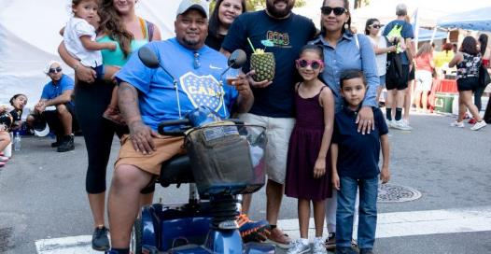

Table of Contents

Table of Contents 1
Introduction 2
Participant Organizations 4
Impact of COVID-19 5
Individual Organizational Projects 7
Artspace 7
CAM Raleigh 9
El Pueblo, Inc. 11
Gregg Museum of Art & Design 13
Marbles Kids Museum 15
Project Goal 15
North Carolina Arts Council 17
North Carolina Museum of Art 19
North Carolina Symphony 21
Women’s Theatre Festival 23
Learning Community Achievements: A Year of Highlights 25
Learning Community Members 28
Document Accessibility Information 33
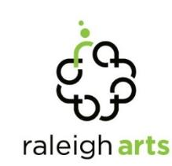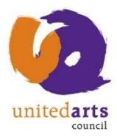

Introduction

The Arts Learning Community for Universal Access is a peer cohort of arts and cultural administrators who collaborate to advocate for and improve access to the arts for people with disabilities. Based in Raleigh, North Carolina and a joint initiative of the City of Raleigh’s Arts Commission and the United Arts Council of Raleigh and Wake County, the program was founded in 2015 and is now in its fifth year.
This yearlong program brings together a group of 10-12 nonprofit staffers to improve their knowledge and skills in the areas of ADA accommodations, disability arts and disability culture through 12 months of collaborative study, expertise exchange and dialogue. Each learning community member sets an individual goal for improving accessibility at their own organization and commits to carrying out a group project that impacts the broader arts community. The learning community format brings structure to the process of developing and sustaining a community of practice, while sharing the responsibilities for success and the workload across all participants.
The 2019-2020 learning community consisted of accessibility coordinators from a variety of arts and cultural organizations, representing different artistic disciplines, levels of accessibility expertise, budget sizes and programming. They were and are an amazing group of individuals whose commitment to accessibility and tenacity for the work was put to the test by the COVID-19 pandemic, which first shut down all of their organizations this past March then required they completely re-envision and transition what programming they could online. This scrapbook represents their group project for the year. While it documents the good, the frustrating and the happily surprising regarding learning community members’ progress towards their individual goals, the book was created to be an idea book or jumping off point for other arts and cultural administrators embarking on their own accessibility journeys. We hope you find it so.

Sarah Corrin
Learning Community Facilitator & Arts Grant Director
City of Raleigh – Office of Raleigh Arts

Margaret Toomey
Learning Community Facilitator & Arts & Accessibility Assistant
City of Raleigh – Office of Raleigh Arts

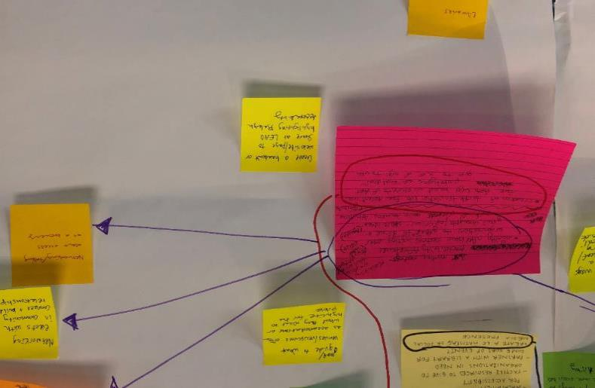
A close-up of a brainstorming activity.

Participant Organizations

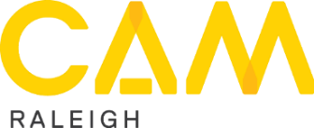
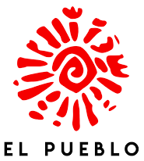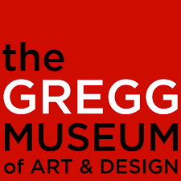

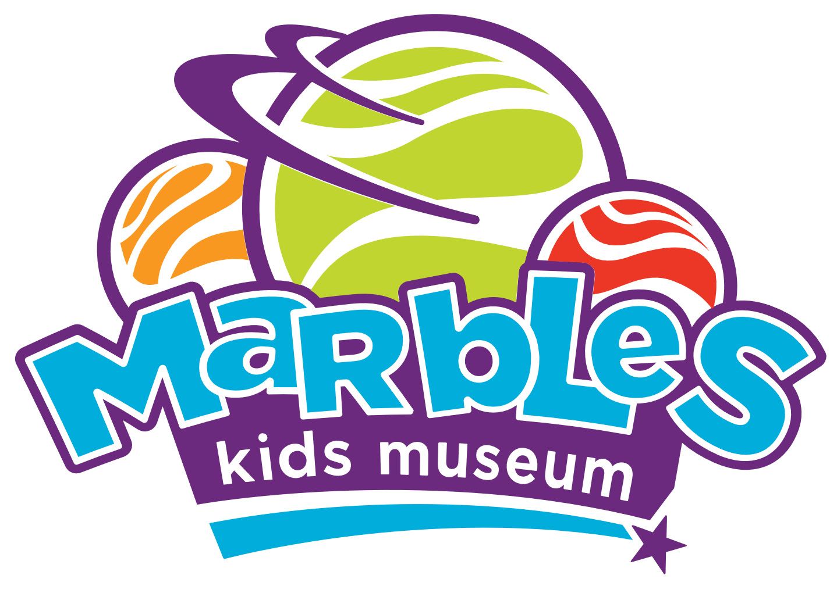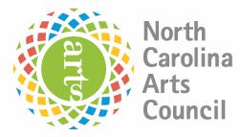

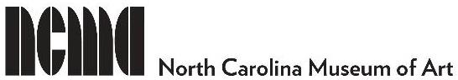
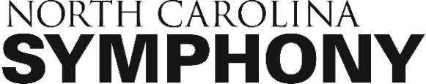

Impact of COVID-19

The Corona Virus started rippling through the Raleigh arts community in early March with the cancellation of the City’s annual International Festival, a three-day event that typically drew over 20,000 people downtown. By the end of the month, the entire city was shuttered due to a state-wide stay at home order that lasted for almost two months. At the time of this scrapbook’s publication, over three months into the pandemic, the State of North Carolina remains in only Phase 2 of its re-opening plan, due to the continuing increase in the rate of COVID-19 cases and hospitalizations.
As a result, Raleigh’s arts and cultural organizations remain effectively shuttered with staff members continuing to work from home. Every organization has moved at least some of its traditional programming online. Among this year’s learning community members, virtual programming offerings ranged from virtual tours and artists talks of visual art exhibitions, to home-based arts activities for children, to an entire theatre production staged and performed online, and classical music education concerts and “at-home” video performances by symphony musicians.
Both despite and because of the pandemic, learning community members accessibility work continued. Several members took charge of captioning their organizations’ online video content, creating accessible PDF documents and writing alt text for digital images. Another member shifted her individual goal entirely to create a virtual accessibility toolkit for her own organization, as well as the other organizations it serves. A music educator in the group worked to develop and implement a summer webinar for local teachers on the connection between social emotional learning and sensory friendly programs.
However, despite the silver-linings of virtual programming, the pandemic has deeply damaged the local arts community, in the same way it has cut through every arts community around the country. Many arts organizations lost significant amounts of revenue as seasons, arts education programs and fundraisers were cancelled. The learning community itself lost two members due to staff lay-offs and furloughs.

This scrapbook is dedicated to the two access friends we miss – Janine Eash and William Henry (pictured below).

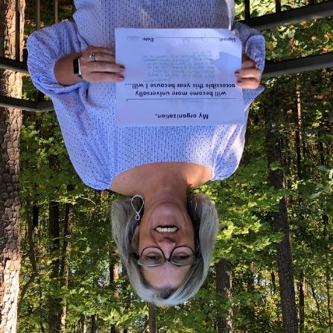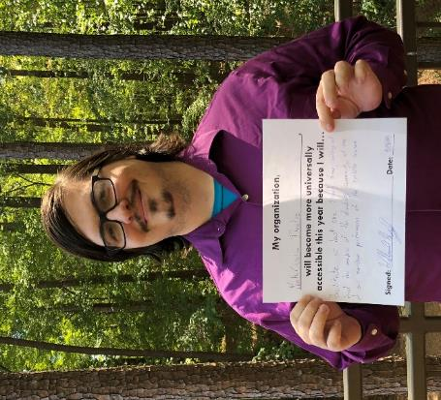

Individual Organizational Projects

Artspace

Brett Morris, Program Coordinator
Organization Mission: Artspace inspires positive community impact through art

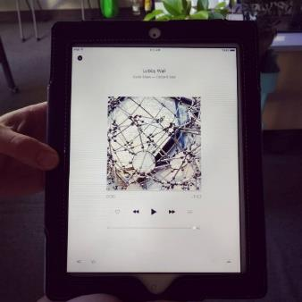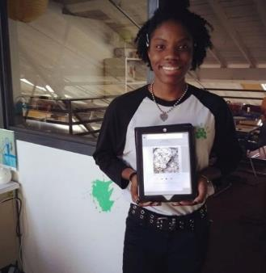

Project Goal
Provide audio descriptions for two exhibitions in our main gallery spaces.

Lemons
No budget: I worked around this by using a donated iPad and Music app to display and play audio descriptions.
Short turnaround: I made sure to receive images from artists in advance of exhibition openings to create artwork descriptions.
Interface: I initially used the Notes app and Voiceover function, but it was not intuitive for users. After experimenting, I settled on making audio recordings to be played using the Music app.

Lemonade
Organizational buy-in: Increased visibility of accessible accommodations led to interest in providing more accommodations.
Interns: This provided a great project for our spring intern to work on during their internship.
Fluency: I became much more fluent in describing artwork, making it easier to provide better descriptions and alt text for digital images.

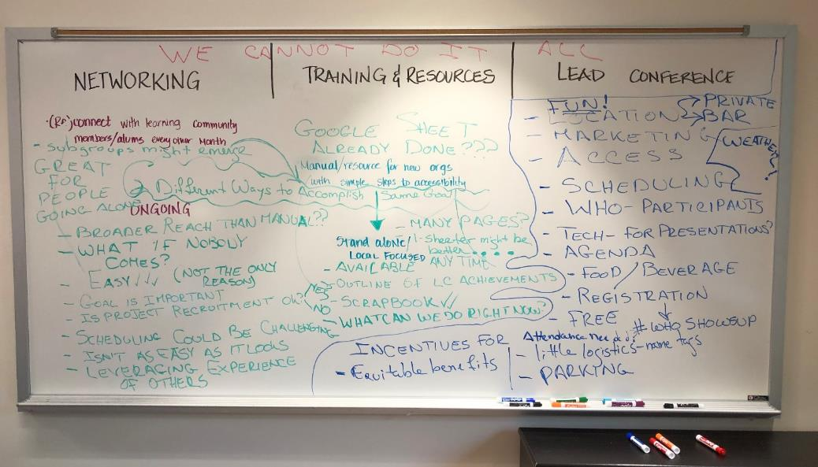
The white board after the February meeting during which a final group project was being discussed.

CAM Raleigh

Krista Nance, Registrar and Accessibility Manager
Organization Mission: CAM Raleigh is the non-collecting contemporary art museum that provides an environment for transformation through educational programs, cultural experiences, and bold, non-traditional exhibitions by living artists.

Project Goal
Design and implement a drop-in touch tour and train gallery educators and all staff during the Viva Viclas: The Art of the Lowrider Motorcycle exhibition.

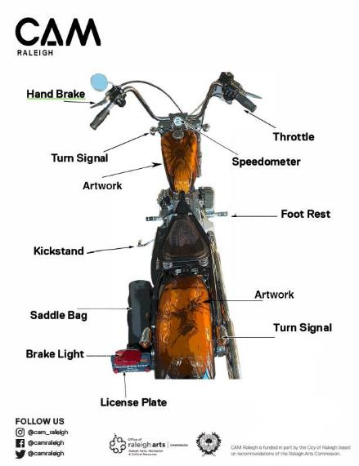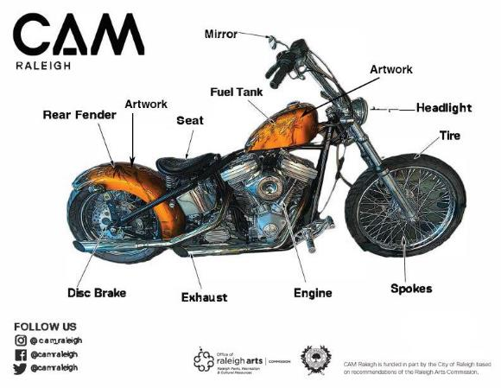

Framework
The touch tour was created using a stationary motorcycle in the museum lobby and available resources. I designed an easily printable motorcycle map with labeled motorcycle parts and artwork for visitors to use while in the museum and take home. Visitors were encouraged to touch and sit on the bike while learning the parts and artwork labeled on the map. Gloves were available for visitors with touch sensitivity. The opportunity to take the maps home engaged visitors in further reflection (and repeat visits).

Training the Team
I met with each of the gallery educators and discussed ways to engage visitors with the tour. I emphasized that the tour could be led by them, or self-guided. Key to the training concept was the importance of highlighting and touching parts of the motorcycle themselves in order to create a comfortable space for visitors.
Gallery educators were excited to share a dynamic and universally accessible activity to introduce all visitors to the exhibition. The maps were also helpful in broadening their own knowledge.

Sensory Outreach
The opportunity to experience the exhibition at entry to the museum through touch and by sitting on a motorcycle was an excellent tool to welcome new visitors, especially for monthly Sensory Saturdays, where we saw an increase in attendance.

Additional Outcomes
The maps were also used as a learning tool in all of our education and community programs. The motorcycle and maps in the lobby welcomed visitors, provided context for the exhibition, and created a comfort level with visitors as soon as they arrived, removing barriers, and created a fun and meaningful memory. Additionally, many visitors commented that sitting on a motorcycle created a sense of empowerment, freedom, and confidence.

El Pueblo, Inc.

Cecilia Saloni, Operations Manager
Organization Mission: To build collective power through leadership development, organizing, and direct action so that the Latin American community and other marginalized communities control our own stories and destinies.

Project Goal
I will improve this year’s La Fiesta del Pueblo’s accessibility information on the event web page, and I will proactively invite groups, associations, and agencies that work with/advocate for people with disabilities.
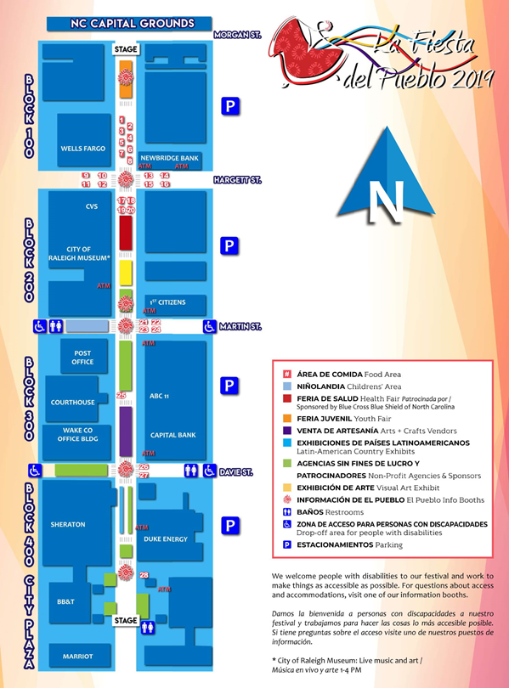

Challenges
- Limited technical skills and limited access of resources to make our event web page accessible
- Lack of information of agencies that work with or advocate for people with disabilities, and lack of experience on how to reach that population to invite them to attend La Fiesta del Pueblo 2019.

Outcomes
Using the resources collected from the learning community Google Docs, the communications coordinator was able to learn and add descriptions to all our pictures, and we used high contrast and large print font.
Also, using the same documents, we identified and invited several groups and agencies that work with or advocate for people with disabilities, resulting in an increase of people self-identified as having a disability on the event survey, from 9% of the attendees in 2018, to 11% of the attendees in 2019.

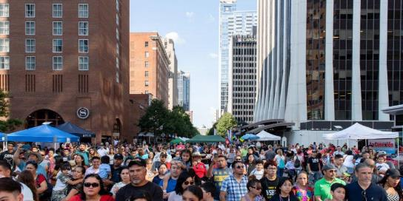

Even though it seems like a small increase on the percentage of attendees, it shows that an intentional and direct invitation to specific communities works and we hope to improve in future years.
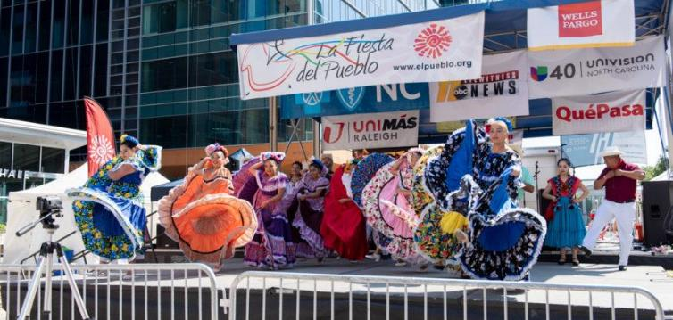

Gregg Museum of Art & Design

Daniel Ellison, Board Member
Organization Mission: As part of a research-extensive land-grant university, the Gregg Museum of Art & Design inspires creativity, innovation, and the expression of ideas. The Gregg Museum makes its collections and activities accessible to the university, community, and to the public.

Project Goal
To coordinate an exhibit at the Gregg of antique and vintage braillewriters from the collection of the Governor Morehead School for the Blind (GMS). The date of the exhibit to coordinate/overlap with the Learning Exchange for Arts and Disability (LEAD) Conference in Raleigh.

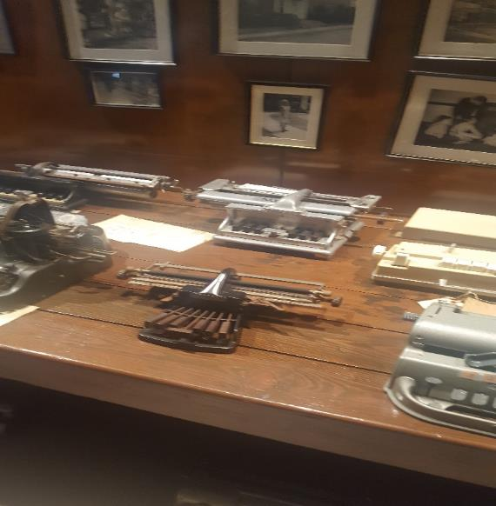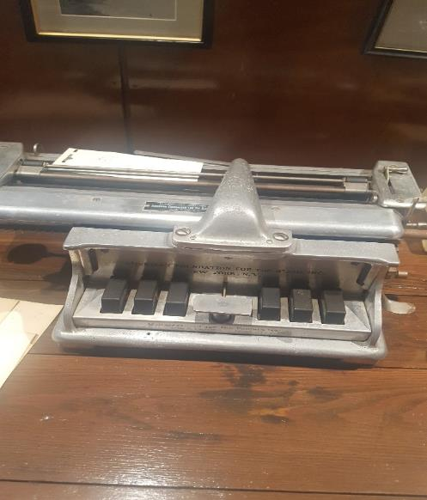
Braillewriters on display at the Governor Morehead School for the Blind.

Challenges
- The Gregg already had exhibits planned for the main exhibit galleries for the original 2020 date and the 2021 date.
- Curator staff time available to work on the exhibit would be very limited.

Opportunities
- The project idea grew out of a prior year’s Raleigh Universal Access & the Arts Day. Enjoying refreshments and conversation at “Drinking about Accessibility” at Imurj after that meeting, I got a chance to talk with Sina Bahram who is on the board of advisors for the GMS. As he described the braillewriters, he and I got super-excited about an exhibit of them outside of GMS.
- The additional year will allow a better curation of the items. Gregg staff will provide some curation, but the exhibit will be presented in display cases at the Raleigh Convention Center, potentially with greater exposure to more people.

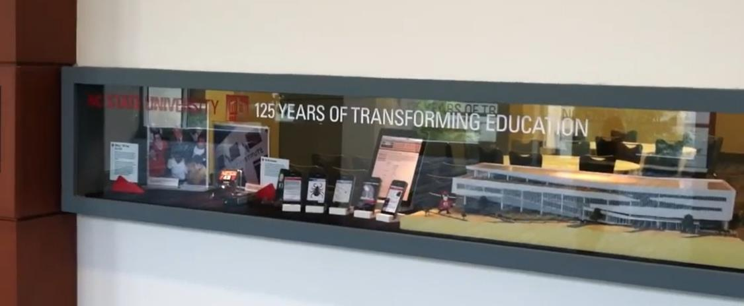
A display window at the Raleigh Convention Center.

Marbles Kids Museum

Ashley Peay-Bettini, Director of Learning Engagement
Organization Mission: Marbles sparks imagination, discovery and learning through play.

Project Goal
Bring knowledge about accessibility to the Full Team (especially Guest Experience Team) by organizing educational opportunities with the focus on working with guests with different disabilities. I will organize 2-3 learning opportunities by May 31, 2020.

Lemons
Meeting with Human Resources about training didn’t go as expected. I found out that lining up trainings would be much more of a process than I had thought and that these trainings wouldn’t fit into my timeline.

Lemonade
Team Excitement: During conversations with the Guest Experience Team at “5-minute chats” excitement grew rapidly. The team wanted to know more about serving guests with disabilities and were forthcoming with their lack of knowledge and comfort-levels when serving our special guests.
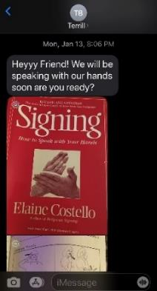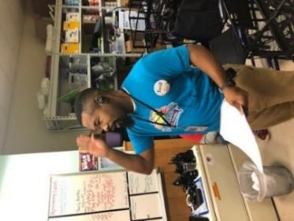
One team member, Terrill, began teaching himself American Sign Language (ASL), registered for an ASL class at Wilson Community College, and began sharing common ASL signs with the team (pictured to the above signing “Hello” in American Sign Language).

Awareness
I became much more aware of our needs as an organization and began looking at programming differently. One simple change that we made was to provide different table heights for our facilitated programming – offering different points of entry for guests and allowing better family interactions for guests in wheelchairs, etc. Due to my new awareness, I was able to bring the conversation of accessibility to the forefront of conversations around new exhibits, website modifications and programming and special events.

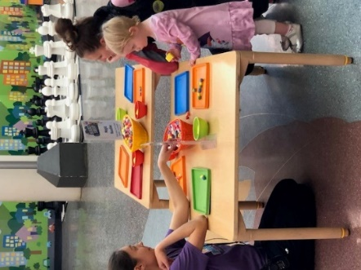
Adjusted table heights in use.

North Carolina Arts Council

Kathleen Collier, Visual Arts Director
Organization Mission: Founded in 1967 with the democratic vision of “arts for all citizens,” the North Carolina Arts Council sustains and grows the arts for the benefit of North Carolinians and their communities.

Project Goal
Create a resource guide for arts organizations and artists which outlines best practices for developing accessible virtual arts programs, events, and online communications.

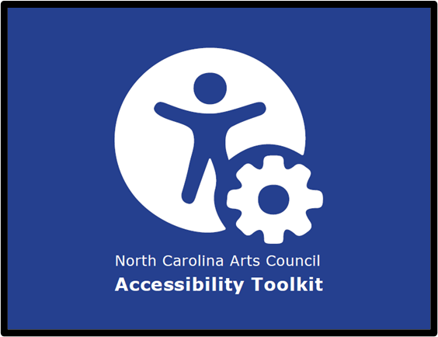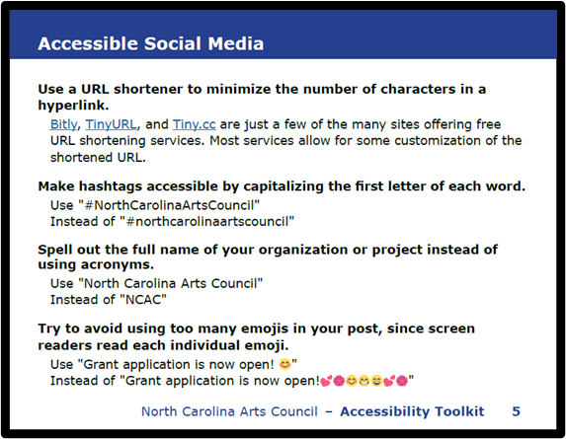

Lemons
Learned from Experience: I decided to create a resource guide after learning from my own mistakes and experiences in developing online programming. It is important to build into your original program budget resources for accessibility, such as third party live-streaming captioning, ASL interpreters, other modes of communication such large print materials, etc.
A Lot of Information: When deciding what resources and best practices to include, I focused primarily on web and social media platforms that arts organizations and artists already use for virtual events. This is a beginner’s guide to best practices for online programming, but the goal is to illustrate how many of these practices are easy to implement and should be regular standards for all future online communications and events.
Interface: Resource guide will be developed as a PDF document that will be uploaded to the North Carolina Arts Council’s website and may be shared with arts partners across the state.

Lemonade
Organizational Excitement: Staff at the North Carolina Arts Council are excited about the document; we hope it will be a useful resource for arts partners as more organizations implement online programming due to the impact of COVID-19. I also believe this will be a helpful resource in the future/after COVID-19, as online arts programming is becoming more popular especially as a means of actively promoting audience engagement and inclusion.
Personal and Professional Growth: Researching best practices for online programming was very enlightening, and it has made me realize how much accessibility needs to be considered in the brainstorming phases of all types of online communications and programs. It is amazing how many of these best practices can easily be implemented if you give yourself and/or your organization enough time for planning and implementation.
A downloadable copy of the NC Arts Council Accessibility Toolkit will be made available on the NC Arts Council website: ncarts.org. To request a copy via email, please contact kathleen.collier@ncdcr.gov

North Carolina Museum of Art

Melissa Roth, Manager of Visitor Engagement
Organization Mission: The North Carolina Museum of Art serves the people of North Carolina and all visitors as a premier destination for compelling encounters with art. The NCMA is committed to exemplary scholarship and innovative educational enrichment. We invite interactions among diverse communities, foster collaborative partnerships, and seek to activate the creative potential in everyone.

Project Goal
The NCMA will become more universally accessible this year because I will identify three to five adult groups or individuals providing services for or living with disabilities and organize accessible guided tour experiences for those groups. After, I will follow up for feedback to learn where we excelled and how we can improve.
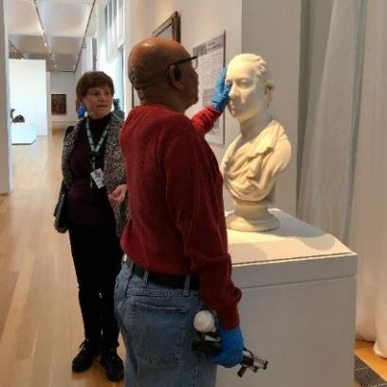
Visitors participating in a touch-tour of sculptures at the North Carolina Museum of Art.

Highlights
Coordinated a tour with ASL interpretation with the NC Department of Health & Human Services in celebration of Deaf Awareness Month.
Collaborated with the NC Department of Natural & Cultural Resources (DNCR) Rural Outreach, State Library, and Arts Council to introduce NCMA’s Traveling Trunks for check out at rural libraries.
Partnered with the North Carolina Library for the Blind and Physically Handicapped to offer two days of tactile tours for patrons of the library.

Lessons Learned
Outreach Matters: Personally reaching out to groups to invite them to visit established familiarity and trust. One month after a group visited, they reached out to me to request ASL interpretation for a public event.
The Museum Experience Extends Beyond the Gallery Walls: The work I did with DNCR to share the Traveling Trunks with rural libraries provided seniors living in rural communities with an opportunity to connect with art and reminisce with loved ones.
More than a Museum Tour: Tour participants develop a deeper understanding about art, the time allows for an opportunity to socialize and connect with others.
Want to learn more about accessible tours at the North Carolina Museum of Art? Please check out this blog post: https://ncartmuseum.org/blog/view/getting_in_touch_with_art

North Carolina Symphony

Jason Spencer, Director of Education
Organization Mission: Our mission is to be North Carolina’s state orchestra—an orchestra achieving the highest standard of artistic quality and performance standards, and embracing our dual legacies of statewide service and music education.

Project Goal
Identify select musicians to receive training and visit/perform in special education classrooms and disability centers across the triangle during the 2019-2020 season.

Challenges
- Scheduling: Finding a mutually agreeable date and time that works for musician, teacher, and school/center
- Communication: Communicating with the teacher and musician to ensure everyone is aware of what to expect
- Training: Identifying someone to train and prep musicians for what to expect during performance

Outcomes
September 2019: Double bassist Erik Dyke was joined by special guest Andy Pidcock for a program for two special education classes at Brogden Middle School in Durham (pictured below).
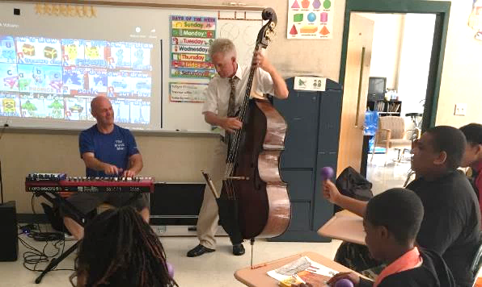
Hornist Rachel Niketopoulos was joined by Music Director Grant Llewellyn and special guest Andy Pidcock in a program for ages 3-8 at the Tammy Lynn Center for Developmental Disabilities in Raleigh (pictured below).

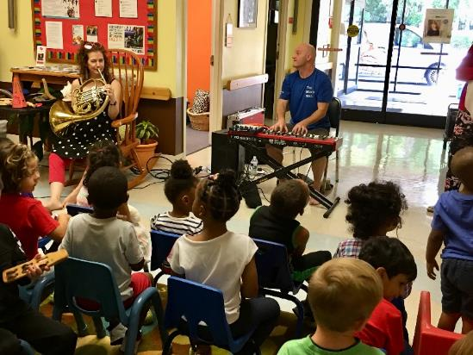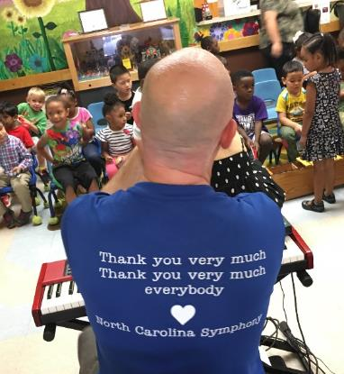

March 2020: The NC Symphony Woodwind Quintet was scheduled to visit the Murdoch Developmental Center in Butner for a 30-minute program for their entire school. Due to COVID-19, this program has been postponed to the 2020-2021 season.

Unintended Outcome
In collaboration with the NC Department of Instruction and the music teacher at the Murdoch Developmental Center (Evelyn Snyder), we will be presenting a webinar this summer discussing sensory friendly programming in relation to social and emotional learning (SEL) in the classroom. The webinar will be intended for K-12 teachers and focus on sensory friendly – what it means, how NCS created its first sensory friendly concert, and how teachers can adapt classroom instruction to be inclusive for all.

Women’s Theatre Festival

Johannah Maynard Edwards, Executive Artistic Director
Organization mission: To create, produce, and promote extraordinary theatre by women and all marginalized genders

The Project
I will make my organization more universally accessible by steering our production, Freakshow, centering disability culture and artists with disabilities in the creative process, offering a range of accessibility services, and facilitating production team in integrating accessible choices into the work.

About Freakshow
Freakshow is a play by Carson Kreitzer that humanizes the “freaks” of the traveling freakshows common at the turn-of-the-last-century. In this play, the members of the freakshow – people who have been used, objectified, and cast aside because of a disability or deformity – create a family, achieve financial autonomy, and reclaim power.

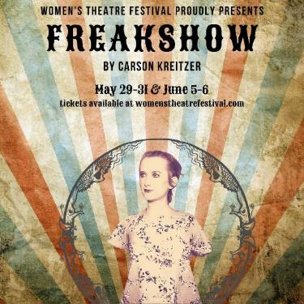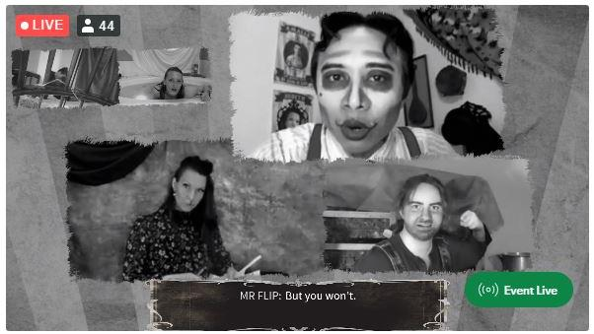
Production Poster Video-still from live stream of show.

Highlights
- Hired an actress with physical disability to play the lead role of a character without arms or legs, centering her lived experience with higher pay rate.
- Prioritized casting and staffing production with artists who identify as (dis)abled.
- Advertised and provided accommodations such as alternative format auditions.
- Presented production with open-captioning integrated into the aesthetic design and made the captions designer and operators full production team members (CaptionPoint).
- Supported production team with an accessibility coordinator (Elena Velasco). Brought in a diversity & inclusion consultant for facilitated conversations surrounding identity. Utilized theatrical intimacy training and techniques to create rehearsal safe space.

Challenges & Surprises
The onset of COVID-19 meant that, in order to bring this production to life, we had to move it completely online with actors rehearsing and performing from remote locations. This meant that some of the accessibility offerings (sensory friendly relaxed performances, audio description, touch tours) were no longer an option. However, by figuring out how to bring a production vividly to life in patrons’ homes, we removed the barrier of getting to the theatre creating a universally accessible experience in an unexpected way. Moving forward, we’ll be adding livestream and remote options for patrons and participants along with traditional live performance.
You can read more about Freakshow in our digital playbill and check back at www.womenstheatrefestival.com soon for recorded performances of Freakshow.

Learning Community Achievements:
A Year of Highlights
The learning community members met every month from July 2019 through June 2020 and were asked to chart their learning and progress on the Great Wall of Access (pictured below). Here is a year of highlights from all our members to show the wide variety of ways to bring accessibility to an organization.
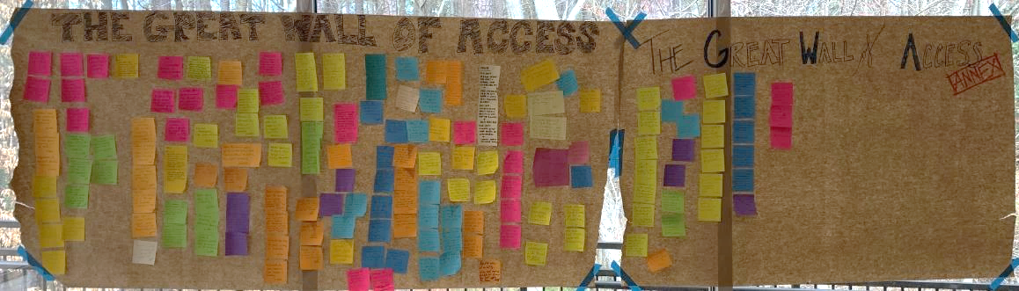
AUGUST
- Presented information about the Leadership Exchange in Arts & Disability Conference to Learning Team, IT, HR, Marketing, Community Engagement, and Exhibits Team.
- Brought up accessibility at theater department faculty meeting.
- Hosted intern from Governor Morehead School for the Blind.
SEPTEMBER
- Presented first-ever sensory friendly concert.
- Advocated for adjusting label/exhibition design to make more accessible.
OCTOBER
- Emailed theater department to try to get the main stage production to have audio description.
- Had our first audio described performance!
NOVEMBER
- Discussed accessibility as part of our new strategic plan.
- Attended Wake County All Access Day and brought our gallery educators.
DECEMBER
- I checked and ensured our office renovation will be accessible for people with disabilities so we can welcome everybody!!
- Added “Access Coordinator” position to project budgets.
- Attended Arts Access event and learned how braille typewriters work.
JANUARY
- Inspired customer-facing team member to begin taking ASL classes, who now shares learning with co-workers.
- Told Communications Department about the need to capitalize words in hashtags.
- Helped promote a sensory friendly production of The Wiz.
- Familiarized myself with assistive listening devices used for tours. Then, showed a docent how to use for any group requesting them.
FEBRUARY
- Volunteered for Raleigh Little Theatre’s sensory friendly performance.
- Cast multiple actors with intersectional access and identity needs for upcoming production.
MARCH
- Site visit to Arts & Health at Duke to learn more about accessibility programs there.
- Met with an artist with disability about future project.
APRIL
- Discussed accessibility with the marketing team as we develop our new website and the idea of filming our social story.
- Began captioning training videos so that a new volunteer who is Deaf can train to become a docent.
- We began working with a funder and artist for ways to include more tactile activities and programming around her exhibition.
MAY
- Working with NC’s Department of Public Instruction and others to create a professional development webinar for teachers this summer focusing on social-emotional learning and sensory friendly curriculum.
- More work on how to make virtual performance and rehearsal a sustainable practice for our industry to continue centering folx for whom leaving the home is a barrier to participation.
JUNE
- Encouraged some specific arts leaders to include disability in their diversity statements.
- Confirmed museum’s accessibility shows up correctly on Google Map's new accessibility feature.
- Scheduled bi-weekly meeting with manager of interpretation to discuss accessibility and diversity.

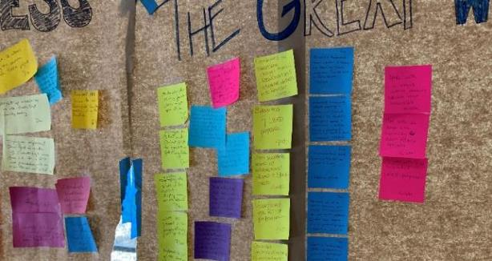
A close-up of The Great Wall of Access.

Learning Community Members

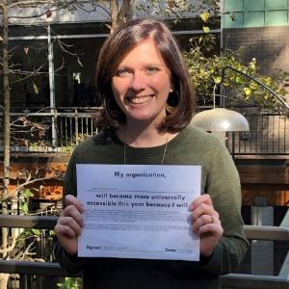
Kathleen Collier
Kathleen is the director of visual arts at the North Carolina Arts Council. She manages the Visual Arts and Arts in Accessibility, Healthcare & Aging organizational grant programs and Artist Fellowship program. Kathleen serves as the accessibility coordinator for the Arts Council. Prior to joining the Arts Council in 2018, she served as the coordinator of pre-college programs at NC State University’s Design Lab for K-12 Education where she managed art and design programs for high school and middle school audiences.
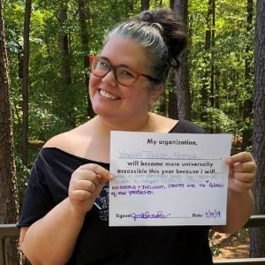
Johannah Maynard Edwards
Johannah is the executive artistic director of the Women’s Theatre Festival. She began making theatre when she was 15 and co-founded her first company, p.i.e., when she was 19. She has directed, devised, and produced countless theatrical productions in NYC, Minneapolis, and the Triangle. She’s an outspoken advocate and consultant for access and inclusion in theatre and has created a resource guide for presenting sensory friendly theatre. She also serves on the newly formed SETC Equity Diversity Inclusion + Access Task Force.
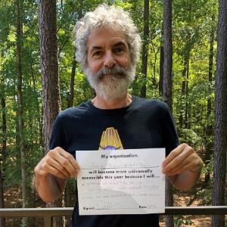
Daniel Ellison
Daniel is an attorney in private practice, concentrating in arts law. He is past-president of the Gregg Museum of Art and Design and continues to chair its accessibility committee. He is in his third year as a member of the Arts Learning Community for Universal Access and is a trained audio describer. He teaches three courses in the Duke University Theater Studies Department: “Legal Issues for the Performing Arts,” “Creating Arts Access for People with Disabilities,” and “Introduction to Non-profit Arts & Cultural Institutions.” Through that course he developed the Durham Audio Described Art Project.
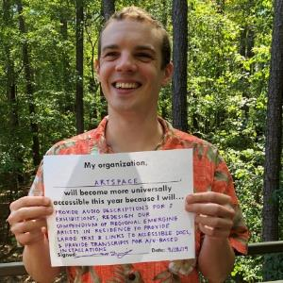
Brett Morris
Brett is Artspace's program coordinator. He has years of experience in producing, handling, curating, and installing artwork and is truly in his element when he is out in the galleries preparing exhibitions and interacting with the public. When he’s not busy installing artwork, you can find him working with Brittany Carlson, the education and outreach manager, to bring quality educational programs to a community that he values greatly. Brett is also a skilled photographer, printmaker, and draftsman, and has exhibited his artwork throughout the Triangle.
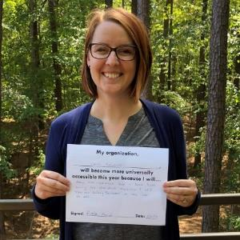
Krista Nance
Krista has served as registrar at CAM Raleigh since 2019. She has helped create some of CAM’s most memorable exhibitions, all focused on universal access, including, Viva Viclas: The Art of the Lowrider Motorcycle and Justin LeBlanc: Probable Normal Hearing and Corey Pemberton: creature comfort. She has led CAM’s participation in the learning community as accessibility manager, broadening the scope and reach of CAM’s sensory programming since 2019. Previously, Krista held the position of registrar and assistant curator at the Vanderbilt University Fine Arts Gallery.
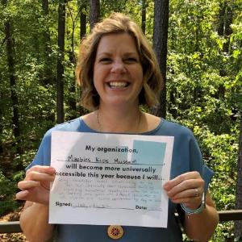
Ashley Peay-Bettini
Ashley is the director of learning engagement for Marbles Kids Museum. In this role, Ashley oversees special events programming, camps, classes, and field trips. Ashley also develops and facilitates all arts programming for Marbles’ Art Loft Exhibit. As a part of Marbles’ Create Innovate initiative, Ashley schedules and develops program activities for the Daily program, Artrageous. In this position, Ashley also oversees Full Circle programming which works with Title I families and hosts Family Fun Nights – a sensory friendly program for Marbles’ guests with disabilities and special needs.
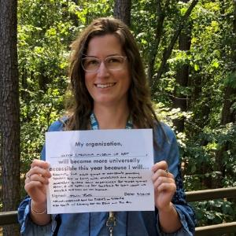
Melissa Roth
Melissa is the manager of visitor engagement at the North Carolina Museum of Art (NCMA). She first got involved in accessibility while working at CAM Raleigh, where she planned educational programs for students and adults living with disabilities. She joined the NCMA staff in 2017 and successfully added accessibility and inclusion as an official part of her position. As a member of the Visitor Experience department, Melissa strives to make each visitor feel welcome and comfortable. She coordinates specialized tour experiences for adult groups coming from community organizations, care facilities, and private groups.
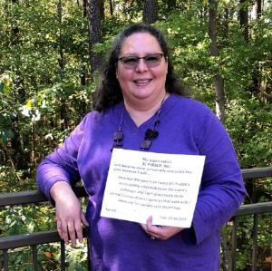
Cecilia Saloni
Cecilia has been involved in El Pueblo’s annual event La Fiesta del Pueblo since 2003, joining the staff in 2005. In 2014, Cecilia became El Pueblo’s operations manager, overseeing general operations of the organization as well as logistics for all major events including La Fiesta del Pueblo. As a member of the Arts Learning Community for Universal Access since 2017, she has been working to improve the accessibility of La Fiesta del Pueblo every year, adding more accommodations for people with disabilities and improving the accessibility webpage of the event.

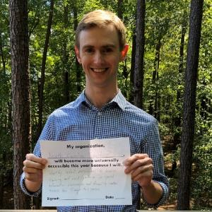
Jason Spencer
Jason is director of education for the North Carolina Symphony, which conducts one of the most extensive education programs of any U.S. orchestra. In this role, he oversees the planning and administration of more than 120 education programs and activities around the state each year. Additionally, he assists with various sensory friendly initiatives, including musician visits to special education classrooms and developmental centers across North Carolina. He currently serves on the North Carolina Symphony’s Sensory Friendly Advisory Committee in addition to being a member of the Arts Learning Community for Universal Access.

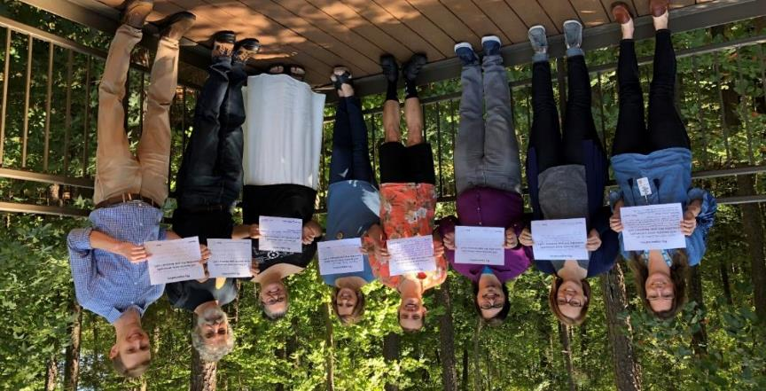
Some of the 2019-2020 Arts Learning Community for Universal Access at their September meeting.

Document Accessibility Information
This document from the 2019-2020 Arts Learning Community for Universal Access was created with the following parameters to increase the accessibility for all readers:
Large-Print (18-pt or more): The use of large-print fonts increases readability for readers who have certain vision impairments.
Sans-Serif Font (Arial): The use of sans-serif fonts, like Arial, increases the readability for readers who have vision impairments and/or dyslexia.
Alternate Text for Images: The use of alternate text, or alt-text, allows screen reader software to provide a description of each image in the document for readers using screen reader technology due to visual impairment.
Heading Structure & Hierarchy: The use of heading structures and hierarchy allows readers using screen reader technology to navigate the document in the same way that simply bolded and enlarged text does for readers not using the technology.

LCI Tech, located in Durham, NC, provided guidance on the accessibility of this document.
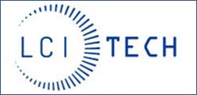
LCI Tech, a division of LCI, is one of the only firms that employ Americans with disabilities to provide digital accessibility services. Learn more at LCITech.com.

