Water/Wastewater Treatment Plant Tour Guidelines

Thank you for your interest in touring the City of Raleigh’s Water\Wastewater Treatment
Plant. We look forward to providing you with an interesting and informative experience.

STEPS
Prior to Tour
1. Complete the Tour Request Form
a. Select the date(s) you want to tour (Minimum 2 weeks advance notice)
b. Please print clearly and legibly
2. Please read and initial the Tour Guidelines (page 4 of 4).
3. Return the completed Tour Request Form and Tour Guidelines, and Attendee
List. You will receive a tour confirmation and directions after all completed
paperwork has been received and approved.

Day of Tour
1. All participants over 18 years of age must bring a valid Passport, Driver’s License
or State/County issued ID card the day of the tour.
2. Bring completed Release of Liability Forms from all Attendees [required].
Please return Tour Request Form, initialed Tour Guidelines, and Attendee List by
email, mail, or fax to:

For Wastewater Plant Tours please contact Ed Buchan: 919-996-3471 or Edward.buchan@raleighnc.gov

For Water Plant Tours please contact Susy Spencer: 919-996-4581 or susanna.spencer@raleighnc.gov

Treatment Plant Tour Guidelines

Tours are scheduled Monday through Friday; 9:00 am to 2:00 pm; No weekend or holiday tours available. Tours are available at the following facilities:

Dempsey E. Benton Water Treatment Plant | 2315 Benson Road, Garner
Walking tour (1.5 hours; 20 person maximum)
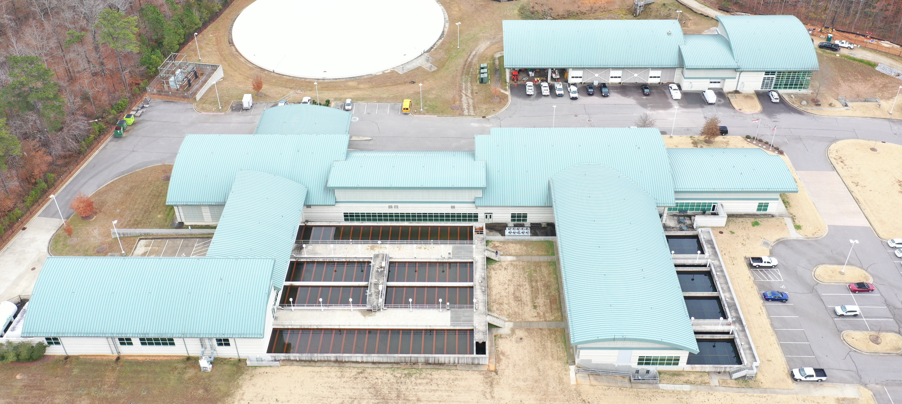

- Withdraws water from Lake Benson
- Maximum capacity of up to 20 million gallons per day
- Construction competed in 2010

Smith Creek Wastewater Treatment Plant | 8505 Ligon Mill Road, Wake Forest
Walking tour (1 hour; 20 person maximum)
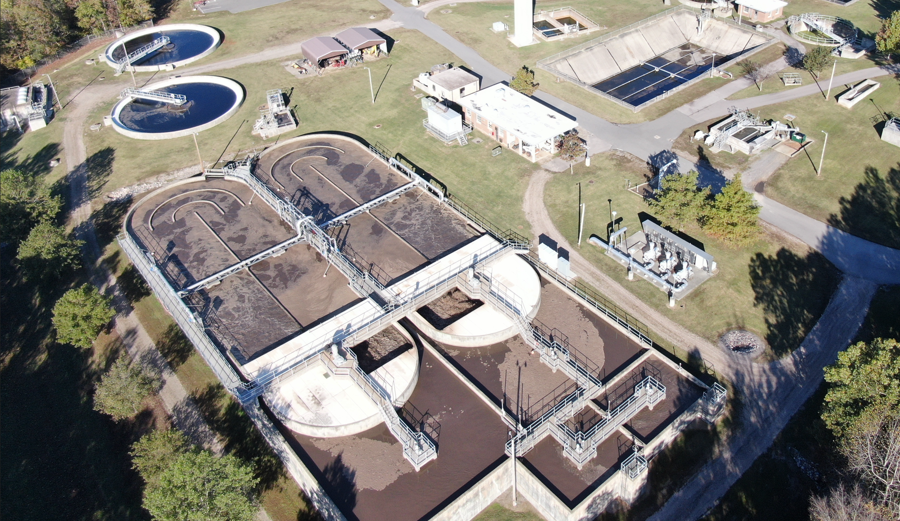
- Originally served Wake Forest and transferred to Raleigh Water on July, 2005
- Maximum capacity of 3.0 million gallons a day
- Received the Platinum VII Award issued by the National Association of Clean Water Agencies in 2012.

Little Creek Wastewater Treatment Plant | 1419 Hwy 39, Zebulon
Walking tour (1 hour; 20 person maximum)
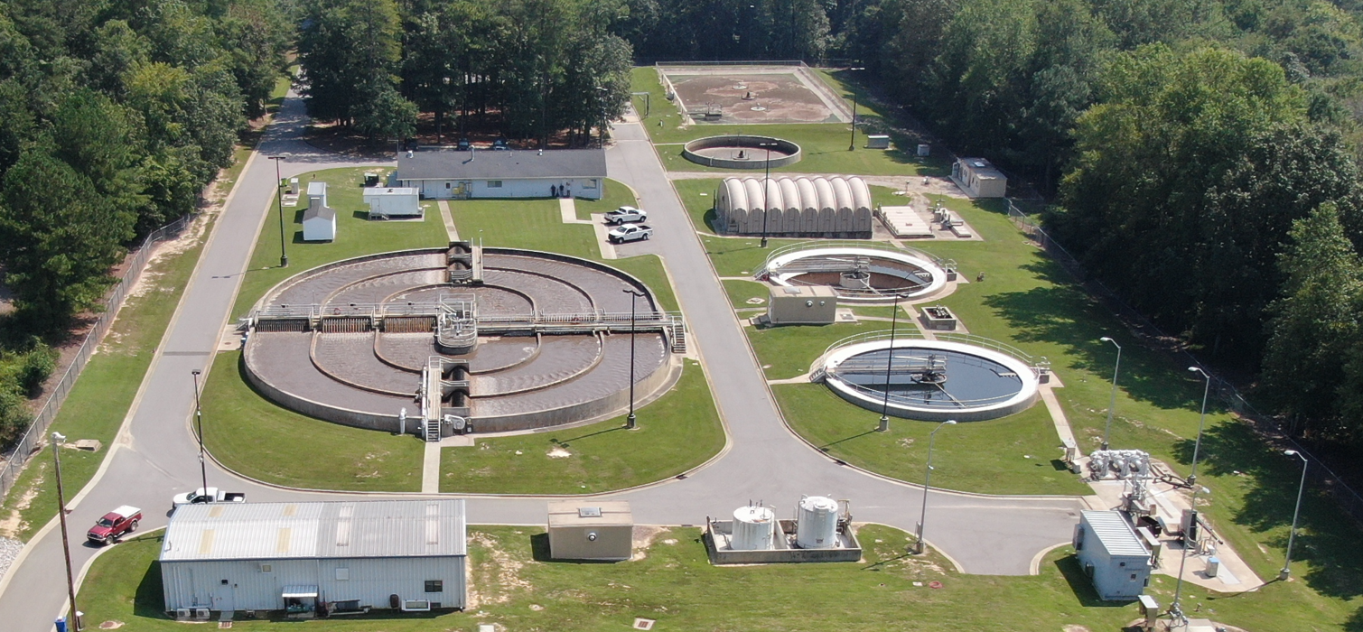
- Originally served Zebulon and transferred to Raleigh Water on October 1, 2006
- Maximum capacity of 1.85 million gallons a day
- Received the Platinum VI Award issued by the National Association of Clean Water Agencies in 2012

Tour Guidelines

To ensure a safe and rewarding visit, we ask that you adhere to the following Guidelines. Please read and initial each in the space provided. Please bring the completed form on the day or the tour.

___ No sandals, flip-flops, and backless, open, open-toe or heeled shoes. Everyone must wear
sturdy, close-toe shoes and socks.
___All participants over 18 years of age must bring a valid Passport, Driver’s License or
State/County issued ID card the day of the tour.
___No shorts or short skirts. You must wear long pants or ankle-length skirts.
___Backpacks and cameras are prohibited.
___DO NOT TOUCH any Switches, Buttons or Equipment.
___Tour attendees are not to touch any of the switches, buttons, or equipment at any time.
___Except for emergency calls, DO NOT use cell phones during the tour. Turn off or put on silent.
___No running or shouting. You will be asked to leave for failing to comply.
___Visitors must wash hands thoroughly prior to the tour.
___All visitors must be at least 10 years old, or in the 5th grade. NO EXCEPTIONS. There must be a
ratio of 1:5 – 1 adult per 5 students for all 5th to 12th grade school groups.
___Release of Liability Forms must be signed by parent or guardian of any person under age 18.
___Groups must not exceed 20 persons. Please note that if additional tours are needed, they will not
be scheduled for the same day.
___For your safety, outdoor tours will be canceled during inclement weather. Raleigh Water
personnel reserve the right to cancel and/or reschedule a tour.

